Student Teaching Handbook

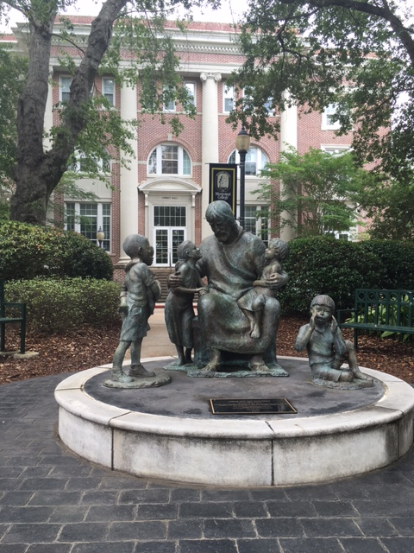
Department of Teacher Education & Leadership
PO Box 4009
Clinton, MS 39058
Revised 08/2023

TABLE OF CONTENTS

Introduction. . . . . . . . . . . . . . . . . . . . . . . . . . . . . . . . . . . . . . . . . . . . . . . . . . . . . . . . . . . . . . . . . . . .3
The Undergraduate Teacher Education Program (TEP) . . . . . . . . . . . . . . . . . . . . . . . . . . . . . . . . . 4
The Undergraduate Licensure Programs . . . . . . . . . . . . . . . . . . . . . . . . . . . . . . . . . . . . . . . . . . . . .5
MC Sequence of Clinical Experiences. . . . . . . . . . . . . . . . . . . . . . . . . . . . . . . . . . . . . . . . . . . . . . .7
The Professional Student Teaching Semester. . . . . . . . . . . . . . . . . . . . . . . . . . . . . . . . . . . . . . . . . .8
Student Teaching Placement Process. . . . . . . . . . . . . . . . . . . . . . . . . . . . . . . . . . . . . . . . . . . . . . . .9
Selection of Professional Internship Sites. . . . . . . . . . . . . . . . . . . . . . . . . . . . . . . . . . . . . . . . . . . 11
The Cooperating Teacher: Qualifications and Guidelines. . . . . . . . . . . . . . . . . . . . . . . . . . . . . . . .12
The University Supervisor: Qualifications and Guidelines. . . . . . . . . . . . . . . . . . . . . . . . . . . . . . .15
Guidelines for Student Teachers. . . . . . . . . . . . . . . . . . . . . . . . . . . . . . . . . . . . . . . . . . . . . . . . . . . 17
Student Teaching Formal Evaluations. . . . . . . . . . . . . . . . . . . . . . . . . . . . . . . . . . . . . . . . . . . . . . .21
MDE Pre-Service Teacher License. . . . . . . . . . . . . . . . . . . . . . . . . . . . . . . . . . . . . . . . . . . . . . . . 24
Legal Status for Interns. . . . . . . . . . . . . . . . . . . . . . . . . . . . . . . . . . . . . . . . . . . . . . . . . . . . . . . . . . 25
Difficulty in the Professional Student Teaching Semester. . . . . . . . . . . . . . . . . . . . . . . . . . . . . . . 26
Dispositions & Dispositions Infractions. . . . . . . . . . . . . . . . . . . . . . . . . . . . . . . . . . . . . . . . . . . . .27
The Licensure Process. . . . . . . . . . . . . . . . . . . . . . . . . . . . . . . . . . . . . . . . . . . . . . . . . . . . . . . . . . .31
Schedule of Praxis Scores. . . . . . . . . . . . . . . . . . . . . . . . . . . . . . . . . . . . . . . . . . . . . . . . . . . . . . . . 32

Appendices
Appendix A—Mission Statements. . . . . . . . . . . . . . . . . . . . . . . . . . . . . . . . . . . . . . . . . . . . . . . . . 34
Appendix B—Tk20 Information . . . . . . . . . . . . . . . . . . . . . . . . . . . . . . . . . . . . . . . . . . . . . . . . . . 36
Appendix C—Notebook Organization . . . . . . . . . . . . . . . . . . . . . . . . . . . . . . . . . . . . . . . . . . . . . .37
Appendix D—Forms
First Days of School. . . . . . . . . . . . . . . . . . . . . . . . . . . . . . . . . . . . . . . . . . . . . . . . . . . . 38
First Days of School Observation . . . . . . . . . . . . . . . . . . . . . . . . . . . . . . . . . . . . . . . . . .39
Daily Student Teaching Schedule . . . . . . . . . . . . . . . . . . . . . . . . . . . . . . . . . . . . . . . . . 40
Weekly Student Teaching Log . . . . . . . . . . . . . . . . . . . . . . . . . . . . . . . . . . . . . . . . . . . .41
Weekly Log of Teaching and Related Activities . . . . . . . . . . . . . . . . . . . . . . . . . . . . . .43
Request to be Absent Form. . . . . . . . . . . . . . . . . . . . . . . . . . . . . . . . . . . . . . . . . . . . . . .43
Appendix E—Teaching Unit & Rubric . . . . . . . . . . . . . . . . . . . . . . . . . . . . . . . . . . . . . . . . . . . . . 44 Appendix F—Statewide Impact on Student Learning Assignment. . . . . . . . . . . . . . . . . . . . . . . . 53
Appendix G—TIAI Rubric. . . . . . . . . . . . . . . . . . . . . . . . . . . . . . . . . . . . . . . . . . . . . . . . . . . . . . . 79
Appendix H—MC Teacher Education Dispositions Evaluation . . . . . . . . . . . . . . . . . . . . . . . . . . 90
Appendix I—Final Student Teaching Evaluation (adapted from TGR) . . . . . . . . . . . . . . . . . . . . .92
Appendix J—Statewide Common Dispositions Instrument . . . . . . . . . . . . . . . . . . . . . . . . . . . . . .98
Appendix K—University Supervisor Evaluation of Cooperating Teacher . . . . . . . . . . . . . . . . . 101
Appendix L—Cooperating Teacher Evaluation of University Supervisor . . . . . . . . . . . . . . . . . .102
Appendix M—Student Teacher Evaluation University Supervisor. . . . . . . . . . . . . . . . . . . . . . . .103
Appendix N—Student Teacher Evaluation of Cooperating Teacher . . . . . . . . . . . . . . . . . . . . . .104
INTRODUCTION

Clinical experiences provide a vital link between the university and the P12 school districts. Clinical experiences give candidates important opportunities to put into practice the theory and knowledge they have gained during their teacher preparation programs.

The geographic location of Mississippi College provides a wide variety of community and school settings for clinical experiences. Our community partners and school districts range from the largest urban school district in Mississippi to much smaller rural districts and community centers working with at-risk and special needs students. Teacher candidates have multiple opportunities to observe and learn from expert teachers about how to work with students from many culturally diverse communities, as well as experience a variety of teaching, learning and behavior styles throughout their various field and clinical experiences.

This handbook provides information for teacher candidates who are entering their Professional Student Teaching Semester, and the cooperating teachers, school personnel, and university supervisors who will be mentoring them during this vital semester of student teaching. Also included are the requirements, guidelines, policies, and procedures of Mississippi College as well as the essential information needed concerning the roles, responsibilities, assessment procedures, and assessment instruments utilized during the Professional Student Teaching semester.

Without our community and P12 school district partners, our teacher preparation programs would not be possible. The Teacher Education & Leadership Department at Mississippi College would like to extend our sincere appreciation to the many community partners and school districts who host our teacher candidates and work with us to constantly improve our programs.

It is our sincere desire that our partnerships are mutually beneficial to all partners. Mississippi College values your input and suggestions. We are here to assist you. Please contact us if you have questions or concerns at any point during this process.

Sincerely,

Dr. Audra Rester
Director of Field Experiences
(601) 925-7396
arester@mc.edu

THE UNDERGRADUATE TEACHER EDUCATION PROGRAM (TEP)
Mississippi's State Board of Education mandates certain requirements for candidates seeking admission to a teacher education program at any of the state's fifteen senior institutions of higher learning. One of these requirements attempts to ensure that teacher education applicants demonstrate at least minimal academic ability. Specifically, at Mississippi College, candidates must meet the following requirements in order to be admitted to the Teacher Education Program (TEP) or to any courses that require TEP admission:
Each applicant for entry into a teacher licensure program shall demonstrate minimum academic ability prior to being admitted to a teacher education program. These are the TEP requirements for admission:
• passed the MC’s writing proficiency test/or ENG 099
• completion of a minimum of 60-hours of course credit with a minimum 3.0 GPA on a 4.0 system; or
• ACT 21 or SAT equivalent; or
• qualifying passing score on the Praxis CORE.
Candidates apply for admission into the Teacher Education Program (TEP) as part of the course requirements for EDU 300, INTRODUCTION TO EDUCATION.

MC Transfer students who have had the course equivalent of EDU 300 at another 4-year institution must make application to the TEP by seeing the Licensure Officer during their first semester at Mississippi College.

After making application to the TEP, candidates are monitored carefully by the School of Education's licensure officer as they progress through MC's teacher preparation program. The candidate's advisor also assists in this monitoring process. However, responsibility rests with the candidate for knowing the rules and regulations related to the teacher preparation program. Until candidates are admitted to the TEP, they may not take any courses, which have program admission as a prerequisite. (SEE STATUS SHEET)

After admission to the TEP, a candidate must maintain at least a 2.75 cumulative grade point average as well as a 2.75 GPA in the area(s) of expected licensure for progression. A grade of C or better is required in all teacher education courses. Teacher education courses, which receive grades of “D” or “F” may be repeated only one time. A failing grade in any two teacher education courses will result in dismissal from the TEP.
After admission to the TEP, candidates must create an account with MDE and complete the Verification of Lawful Presence. Students will upload documentation and have it notarized to be able to apply for an Intern license.

Since standards for progress in the TEP are different from MC’s standard for avoiding academic suspension, a candidate who is ineligible to enter or remain in the TEP may still be eligible to remain a student at Mississippi College in another major.
THE UNDERGRADUATE LICENSURE PROGRAMS

The Department of Teacher Education & Leadership houses undergraduate degree programs leading to educator licensure in the following areas:

- Elementary Education (K-6): Class A License

- Specialized Subject-Area Education (K-12): Class A License
- Art Education
- Music Education - Instrumental
- Music Education - Vocal
- Physical Education

- Secondary Education (7-12): Class A License
- Biology Education
- Chemistry Education
- English Education
- Mathematics Education
- Social Studies Education

- For all Supplemental Endorsement Areas see the Mississippi College MDE Approved Programs for Supplemental Endorsements.

SEQUENCE OF CLINICAL EXPERIENCES

MC Teacher education candidates participate in clinical experiences in the following courses:

Phase One (common clinical experiences for all licensure areas)
- EDU 299/300 Pre-Teaching Field Experience
- EDU 304 Educational Psychology
- EDU 458/460 Classroom Management

Phase Two (clinical experiences vary by licensure areas)
Licensure and subject-specific field experiences are completed within these various methods courses.
- Elementary Education (K-6)
- EDU 320 Principles & Methods of Early Childhood
- EDU 309/334 Early Literacy Block
- EDU 311/312/321/439 Professional Block
- EDU 458 Classroom Management
- Biology/Chemistry Education (7-12)
- BIO/CHE 435 Biology and Chemistry Methods
- English Education (7-12)
- ENG 447 Methods of Teaching Literature to Young Adults
- ENG 455 Methods of Teaching Composition and Grammar
- ENG 398 Writing Center Practicum
- Mathematics Education (7-12)
- MAT 441 Methods for teaching Math in the Secondary School
- Social Studies Education (7-12)
- HIS 435 Social Studies Methods
- Art Education (K-12)
- ART 441 Art in the Secondary School
- Music Education (K-12)
- MUS 323 Music Education in the Elementary School
- MUS 325 Vocal Music Education in the JH and High School
- Physical Education (K-12)
- KIN 306 PE for Children
- KIN 307 PE for the Secondary School
- KIN 386 Adapted Physical Education
- All Secondary (7-12) and Specialized (K-12) Subjects
- EDU 460 Classroom Management

Phase Three (common clinical experiences for all licensure areas)
- Directed Teaching (Professional Student Teaching Semester)
- EDU 421,422,423,424 Elementary Education (K-6)
- EDU 431,432,433,434 Secondary Education (7-12)
- EDU 471,472,473,474 Specialized Subject-Area Education (K-12)

THE PROFESSIONAL STUDENT TEACHING SEMESTER

At the undergraduate level the candidate’s professional education program at Mississippi College culminates with professional internship during the Professional Student Teaching Semester (PS).

Every candidate seeking a Mississippi teaching license in any area is required to complete a Professional Student Teaching Semester. This culminating experience affords candidates an opportunity to apply much of what they have learned in their content and professional education courses to actual classrooms in public or state-approved private schools in Mississippi.
Candidates are admitted to and retained in the Professional Student Teaching Semester according to the following criteria.

The candidate must:
1. be admitted to the Teacher Education Program for at least one full semester prior to the semester of Professional Student Teaching.
2. have completed EDU 299.
3. not have any grades of (I) incomplete.
4. complete any outstanding coursework and have grade(s) on file in the Registrar's Office before the Professional Semester begins. In keeping with university policy, the
last 33 hours of the program must be completed at Mississippi College.

5. have at least a 2.75 GPA in the area(s) of expected certification as well as a cumulative GPA of 2.75
6. have completed (with a minimum grade of C) all Professional Education and subject matter courses except EDU 421, 422, 423, and 424 (elementary candidates only).
7. have completed (with a minimum grade of C) all Professional Education and subject
matter courses except EDU 431,432,433, and 434 (secondary education candidates
only).

8. have completed (with a minimum grade of C) all Professional Education and subject matter courses except EDU 471, 472, 473, and 474 (specialized subject-area education
candidates only).
Due to departmental scheduling issues, secondary education candidates (7-12) and specialized subject-area education candidates (K-12) may be allowed to apply for the Professional Student Teaching Semester once they have completed at least three-fourths of the required courses in his/her area of specialization. This exception is made on a case by case basis and should be approved by the candidate’s advisor, the Director of Field Experiences, and the Chair of the Department of Teacher Education & Leadership.

COMPOSITION OF THE PROFESSIONAL SEMESTER
Elementary Education: Directed Teaching, K-6
EDU 421,422,423,424: Professional Student Teaching Semester for Elementary Education majors

Secondary Education: Directed Teaching, 7-12
EDU 431,432,433,434: Professional Student Teaching Semester for 7-12 majors

Specialized Subject-Area Education: Directed Teaching, K-12
EDU 471,472,473,474: Professional Student Teaching Semester for K-12 majors

Only these courses should be taken during the Professional Student Teaching Semester unless an appeal is made to and granted by the Field Experiences Appeals Committee. Careful planning and a close working relationship between candidate and advisor can help achieve this goal.
All professional interns are expected to complete a minimum of fifteen (15) weeks of internship.
Elementary Education (K-6) Student Teachers receive one placement and should complete three weeks of full-time teaching.
Secondary Education (7-12) and Specialized Subject-Area Education (K-12) Student Teachers will receive two placements and should complete two weeks of full-time teaching at each placement for a total of four weeks of full-time teaching.

STUDENT TEACHING PLACEMENT PROCESS

1. Prior to the beginning of each school year, the Office of Field Experiences sends a Memorandum of Understanding signed by the Dean of the School of Education to the Superintendent of Schools for each Partner School District to be signed and returned to the Office of Field Experiences. This Memorandum of Understanding represents an agreement between Mississippi College and each P12 Partner School District and specifies the terms in which an MC teacher candidate can participate in field experiences within the district. This Memorandum of Understanding is renewed each school year, kept on file in the Office of Field Experiences, and must be current in order for a request to be made for an MC candidate to be placed in a partner district.

To be eligible to serve as a Cooperating Teacher P12 classroom teachers must meet the following requirements:
- Hold a teaching position in a partner district with whom Mississippi College has an active signed Memorandum of Understanding on file in the Office of Field Experiences.
- Hold a current, valid Teaching License from the Mississippi Department of Education in the licensure area for which the Student Teacher is seeking.
- Have completed at least three (3) years of teaching experience and is in at least his/her fourth year of teaching.
- Be recognized by the Cooperating Teacher’s School Administrator as an exceptional teacher as defined by positive teaching evaluations and successful student achievement reports.
- Complete online mandatory Teacher Intern Assessment Instrument (TIAI) and Mississippi Educator Code of Ethics (MCoE) training once every three years.
- Participate in additional training on MC’s campus once every three years.

2. Prior to the beginning of each semester, the Licensure and Certification Officer checks TEP and Student Teaching requirements for all upcoming Prospective Student Teachers to ensure eligibility for the candidate to register for EDU 458- Classroom Management for Elementary Teachers or EDU 460- Classroom Management for Secondary Teachers, which must be taken the semester prior to student teaching.

3. Once a candidate has been certified as eligible to register for the Classroom Management Course (EDU 458/460), the candidate is able to register for either EDU 458- Classroom Management for Elementary Teachers or EDU 460- Classroom Management for Secondary Teachers. This course contains much of the information and training required for Professional Student Teaching Semester.

During the semester prior to Student Teaching and to receive a student teaching placement, the Prospective Student Teacher must:
- Attend one of the mandatory Prospective Student Teaching Meetings conducted by the Director of Field Experiences and the Licensure and Certification Officer.
- Complete and submit all required paperwork by the required date to the Licensure and Certification Officer during individual counseling sessions.
- Insurance: Candidates must show proof of liability insurance during orientation week or prior to entering a K-12 classroom during senior year.
- Transportation to and from the teacher education candidate’s placement site is the sole responsibility of the teacher education candidate. Most schools have designated parking spaces for teacher education candidates. Check with the school secretary regarding parking space.
- Submit proof that a background check conducted by CastleBranch, an outside background agency with whom Mississippi College has contracted, has been ordered.
    - Official confirmation of a cleared background check (no legal violations)
must be received by Mississippi College before any student teaching, field experiences, internships, or practicums can be started/completed.
- Complete the online application and upload the Student Teaching Autobiography in Tk20.
- Complete state-mandated Teacher Intern Assessment Instrument (TIAI) online training and submit Certificate to the Office of Field Experiences.
- Complete state-mandated Mississippi Educator Code of Ethics (MCoE) online training and submit Certificate to the Office of Field Experiences.

4. When all required paperwork has been received in the Office of Field Experiences, all required information has been uploaded to Tk20, proof of successful background approval is received, and completion of state-mandated online training has been completed, the Office of Field Experiences will request a placement from the desired partner district by sending an electronic Placement Request Form. Additionally, hard copies of the Placement Request forms and associated individual Student Teaching Application materials for each Student Teacher requesting a placement in the district will be mailed to each partner district.

5. After receiving Placement Materials from MC, the representatives of each Partner District will:
- Approve the Placement Request.
- Contact individual School Administrators where placements are being requested and forward Placement Materials to them to assist in matching Student Teachers
with Cooperating Teachers.
- School Administrators will review Placement Requests and Student Teaching application materials and match each Student Teacher with a corresponding Cooperating teacher who meets MC’s eligibility requirements.
- Once Student Teaching Placements have been made, the School Administrator sends the completed Placement Request Forms back to the representative of the Partner District and final approval is granted by the District.
- Once the District Office has approved Student Teaching Placements, completed Placement Request Forms are returned to the Office of Field Experiences.

6. When Placement Request Forms are received in the Office of Field Experiences, applications are sent to all Cooperating Teachers and information concerning online mandatory training is sent to Cooperating Teachers. Applications and proof of online training should be returned to the Office of Field Experiences prior to the Student Teaching placements being finalized.

7. Once Placements are finalized, Student Teachers are notified of their placements and University Supervisors are assigned.
SELECTION OF PROFESSIONAL FIELD-BASED, CLINICAL SITES FOR STUDENT TEACHING

Professional Student Teaching Placements are a joint effort of the Office of Field Experiences and MC’s Partner School Districts. It is the policy of Mississippi College to place Student Teachers in Partner Districts within Copiah, Hinds, Lincoln, Madison, Rankin, Warren, and Yazoo counties. Partner Districts must have a current Memorandum of Understanding on file in the Office of Field Experiences in order to be able to host MC Student Teachers. Student Teachers will be placed in public or private schools, which are accredited by the appropriate agencies and with which MC has a current partnership agreement.

Professional student teaching is a minimum of 15 weeks in duration. Elementary Education (K-6) candidates complete one 15-week placement in a public school district. Since Specialized Subject-Area Education (K-12) candidates and Secondary Education (7-12) candidates have two equal placements, one placement must be in a public school, and the second placement may be in an approved and accredited local private school with which MC has a partnership agreement. It is expected that our Partnership Schools be reasonably accessible for visitation by the University Supervisor and are directed by administrators willing to cooperate with and provide experiences acceptable to the Mississippi College Department of Teacher Education.

Secondary Education (7-12) student teachers and Specialized Subject-Area (K-12) student teachers may not be placed at high schools which they attended. Elementary Education (K-6), Secondary Education (7-12), and Specialized Subject-Area Education (K-12) student teachers may not receive placements at a school where their children are enrolled or their close family members are employed.

THE COOPERATING TEACHER
Qualifications
To be eligible to serve as a Cooperating Teacher P12 classroom teachers must meet the following requirements:
- Hold a teaching position in a partner district with whom Mississippi College has an active signed Memorandum of Understanding on file in the Office of Field Experiences.
- Hold a current, valid Teaching License from the Mississippi Department of Education in the licensure area for which the Student Teacher is seeking.
- Have completed at least three (3) years of teaching experience and is in at least his/her fourth year of teaching.
- Be recognized by the Cooperating Teacher’s School Administrator as an exceptional teacher as defined by positive teaching evaluations and successful student achievement reports.
- Complete online mandatory Teacher Intern Assessment Instrument (TIAI) and Mississippi Educator Code of Ethics (MCoE) training once every three years.
- Participate in additional training on MC’s campus once every three years.

The Cooperating Teacher must be classified as a highly competent teacher with at least three years of teaching experience who demonstrates expertise in the classroom. It is of critical importance that the cooperating teacher be skilled in interpersonal relationships and be interested in mentoring the Student Teacher.

Guidelines
Student Teachers report that the person most important in their Student Teaching experience is their cooperating teacher. For this reason, Cooperating Teachers should be selected by their administrators on the basis of professional preparation and success as a teacher. The Cooperating Teacher should be adaptable enough to adjust the classroom situation for receiving the Student Teacher as a viable working member. In meeting the responsibilities as a Cooperating Teacher, the following activities are suggested:

1. Before the Student Teacher arrives the Cooperating Teacher may wish to announce that another teacher will be assisting in the teaching of the class for several weeks.

2. It is suggested that the Student Teacher be inducted into the job of Student Teaching gradually. During the first week or so the Student Teacher may be used as an assistant to the Cooperating Teacher by being responsible for such tasks as calling roll, grading papers, reading announcements, and giving individual assistance to students. This will allow the Student Teacher time for observation. In addition, it is a good idea for the Student Teacher to become familiar with instructional materials and their location, to begin planning the first activities with students, and to learn as much as possible about the students with whom he/she will work.

3. Some Student Teachers will be able to assume responsibility for teaching sooner than others. As Student Teachers demonstrate the necessary competency and confidence, teaching responsibilities should be increased. Student Teachers should be given full-time teaching responsibilities for at least 3 weeks for Elementary Education (K-6) Student Teachers and at least 2 weeks in each
placement for Secondary Education (7-12) Student Teachers and Specialized
Subject-Area (K-12) Student Teachers.

Full-time teaching includes full responsibility for all planning, instruction, and evaluation which is involved in carrying out the duties associated with teaching on a daily basis. This is not meant to imply that the Student Teacher should receive no assistance from the Cooperating Teacher. The responsibility for overall planning and the execution of the plans for the day, however, should be delegated to the Student Teacher. As noted, full-time teaching should be for a minimum of 2 weeks for each of the two placements (4 weeks) for 7-12 and K-12 student teachers and a 3-week placement for an elementary student teacher with only one 15-week placement. Following each period of full-time teaching, work should taper off so that the Student Teacher may spend a day observing other
teachers.

4. The University Supervisor is available to the Cooperating Teacher for assistance in mentoring the Student Teacher. The relationship of the Cooperating Teacher and the University Supervisor should be one of mutual support. They should meet to discuss the progress of the Student Teacher. The University Supervisor will make a minimum of four visits to the school, observing the Student Teacher for two or more class periods on at least three occasions.

5. The Student Teacher should learn from the Cooperating Teacher the school district policies concerning regulations and procedures regarding (for example) discipline, reports that must clear the principal's office, and procedures and forms for using special school equipment.
6. The Student Teacher should be encouraged to learn about teaching responsibilities outside the classroom. Student Teachers should be given the opportunity to: assist with the sponsoring of clubs, attend PTA meetings, attend in-service days, assist with hall duty, observe parent-teacher conferences when appropriate, etc.
7. The Cooperating Teacher should submit the required forms on TK20 at the scheduled time(s).

COOPERATING TEACHER EVALUATIONS
The Cooperating Teacher will assess the Student Teacher on Tk20 using the following formal assessment instruments:
- Preliminary Evaluation (completed after the first 2 weeks of each placement)
- Teacher Intern Assessment Instrument (TIAI)
  - Formative Assessment
  - Summative Assessment
- MC Teacher Education Dispositions Evaluation
- Statewide Common Dispositions Instrument
- Final Student Teaching Evaluation

The Cooperating Teacher will assess the University Supervisor on Tk20 using the following formal assessment instrument:
- Cooperating Teacher Assessment of the University Supervisor

IN SUMMARY, some specific functions of the Cooperating Teacher are listed below:

- Prepare the students for a second teacher in the classroom.
- Orient the Student Teacher to the physical facilities, special services, and resources available in the school (textbooks, audio-visual equipment, duplicating equipment, library, lunchroom, restroom, etc.)
- Provide the Student Teacher with a tentative schedule, grade book, school handbook, desk, and storage area.
- Plan initial activities that will allow the Student Teacher to become involved in the classroom routine immediately.
- Guide the Student Teacher in analyzing and evaluating observations.
- Provide for increased teaching responsibilities as the Student Teacher shows evidence of ability to assume them.
- Assist the Student Teacher in performing routine duties and record keeping.
- Establish a time for a weekly conference during which the Student Teacher’s progress will be discussed.
- Provide daily feedback on the Student Teacher's classroom performance.
- Help the Student teacher analyze each lesson taught, determining strengths and weaknesses.
- Work closely with the University Supervisor to avoid giving contradictory
information to the Student Teacher.
- Check daily lesson plans and long-range plans well in advance (at least three days) of their intended use.
- Schedule time (one day only) toward the end of the placement for the Student
teacher to observe in other classrooms.
- Encourage the Student Teacher's positive attitude about the teaching profession.
- Complete all assessments on TK20 at the scheduled times.

THE UNIVERSITY SUPERVISOR

Qualifications
University Supervisor must meet the following requirements:
- Be a faculty member of the Department of Teacher Education & Leadership or be approved by Mississippi College as an Adjunct Faculty Member.
- Hold at least the Master’s Degree in the area for which the University Supervisor is providing supervision.
- Hold a current, valid Teaching License from the Mississippi Department of Education in the licensure area for which the Student Teacher is seeking.
- Have a substantial amount of successful classroom teaching experience.
- Complete online mandatory Teacher Intern Assessment Instrument (TIAI) and Mississippi Educator Code of Ethics (MCoE) training once every three years.
- Participate in University Supervisor training on MC’s campus once every semester.
- Receive satisfactory evaluation reports from the Student Teacher and University Supervisor.

Guidelines
The primary role of the University Supervisor is to provide needed support for both the Student Teacher and the Cooperating Teacher so that the student teaching experience is a success. As a representative of the Department of Teacher Education & Learning at Mississippi College, the University Supervisor serves as a liaison between the school in which the Student Teacher is placed and the university. The following activities are suggested for University Supervisors:

- Meet with Student Teacher before he/she begins each placement at the assigned P12 school. At this meeting the Student Teacher should be given any additional instructions concerning their assignment. Also, the University Supervisor should convey his/her expectations regarding format of lesson plans, submission of forms, and any other information deemed important.

- Visit Student Teachers at least four times during each Student Teaching placement.
- University Supervisors are expected to stay for at least two classes (or lessons) on these visits and to provide written feedback to the Student Teachers.
- Observations should be spaced over the entire Student Teaching period and not clustered toward the end of the experience.
- Each observation should be followed by a conference with the Student Teacher and the Cooperating Teacher where strengths and weaknesses are discussed.
- It is extremely important for the University Supervisor (and the Cooperating Teacher as well) to keep a chronologically arranged WRITTEN record of the Student Teacher's progress.

- If a Student Teacher is experiencing difficulty, University Supervisors must provide specific feedback and suggestions for improvement. These suggestions should also include a time frame within which the improvement is to be expected and an opportunity for allowing the Student Teacher to respond to the suggestions in writing.

- Maintain an open and cooperative relationship with the Partner School and its staff.

- Confer regularly with the Cooperating Teacher to discuss the progress of the Student Teacher.
- Periodically throughout the Professional Student Teaching Semester the
University Supervisor and Cooperating Teacher should "compare notes"
regarding the performance of the Student Teacher.
- This procedure should help to avoid unnecessary surprises at the end of the semester.
- Both Student Teacher and Cooperating Teacher should be encouraged to consult with the University Supervisor as soon as concerns arise.

- Confer with the School Administrator as needed regarding the progress of the Student Teacher.

- Provide the necessary assistance to Student Teachers in lesson planning, instructional methods and classroom management.

- Provide regular progress reports to Student Teachers. Student Teachers experiencing significant difficulties should be counseled as early as possible and referred to the Professional Dispositions Committee.

- The University Supervisor should submit the required forms on TK20 at the scheduled time(s).

UNIVERSITY SUPERVISOR EVALUATIONS
The University Supervisor will assess the Student Teacher on Tk20 using the following formal assessment instruments:
- Teacher Intern Assessment Instrument (TIAI)
- Formative Assessment
- Summative Assessment

- Teaching Unit
- Teacher Work Sample
- Professional Internship Notebook Rubric (mid-term)
- Final Student Teaching Evaluation
- MC Teacher Education Dispositions Evaluation
- Statewide Common Dispositions Instrument

GUIDELINES FOR STUDENT TEACHERS

The Professional Student Teaching Semester is designed to be an interesting, helpful, and rewarding phase of professional preparation. The student teacher is both a quasi-member of the faculty of the school to which he/she has been assigned and a student of Mississippi College. In performing this dual role, the student teacher is expected to fulfill the following responsibilities and requirements.

- Become actively involved in the instructional program of the school through observation, teaching, conferences, and other activities. The pattern for any given student teacher’s involvement will vary according to the needs and abilities of each individual student teacher, the length of the placement, and the organization of the P12 school or classroom. Usually, however, student teachers will begin their assignment by observing their cooperating teacher for several days. They will then gradually begin to assume the full-time teaching load of the teacher. Student Teachers should maintain a full-time teaching load for the specified period of time. Once this full-time teaching has been completed, Student Teachers will then begin to turn back the teaching responsibilities to the cooperating teacher. Elementary student teachers should maintain a full-time teaching load for at least 3 weeks during one semester-long placement. Secondary and Specialized Subject student teachers should maintain a full-time teaching load for at least 2 weeks for each placement for a total of 4 weeks of full-time teaching.

- Write comprehensive lesson plans and participate in planning conferences with the Cooperating Teacher and the University Supervisor. Mississippi College requires that all student teachers MUST HAVE WRITTEN LESSON PLANS for all classes that they teach, using the format prescribed by the university supervisor and cooperating teacher. These plans need to include the lesson's goals, objectives, materials needed for instruction (e.g. technology resources, presentation materials, etc.), plan of instruction, questions used to promote critical thinking (where appropriate), differentiation for individual needs, assignments (where appropriate), formal and informal assessments, and plans for self-evaluation and reflection.

Lesson plans need to be given to the cooperating teacher at least three days in advance of their proposed use. This allows the student teacher time to integrate any feedback from the cooperating teacher into the lesson. If it is the policy of the school, student teachers may be required to turn in lesson plans to the principal for review. Lesson plans should be clearly and precisely written or typed. They should be chronologically arranged in a three-ring notebook and available for review by the university supervisor,
cooperating teacher, or school administrator.

Each student teacher is expected to maintain a notebook for the primary purpose of keeping a record of the student teaching experience. In addition to lesson plans, the notebook should contain a reflection for each lesson taught, information regarding students, a record of conferences and observations with the university supervisor and cooperating teacher, materials gathered during student teaching and other information deemed appropriate and beneficial by the university supervisor or the cooperating teacher. The university supervisor will review the notebook during visits/conferences with the student teacher. The student teacher should also make it a point to confer with the cooperating teacher after a presentation (i.e., lesson, demonstration, etc.) in an effort to secure valuable input on the perceived effectiveness of the presentation. This notebook will be evaluated by TEL faculty at the mid-term student teaching meeting on MC’s campus.

- Participate in non-instructional activities such as PTA meetings, staff development, faculty and other professional meetings, and the extra-curricular activities of the school. The student teaching experience includes activities that go beyond the regular hours of the school day. Student teachers should participate in extra-curricular activities involving the faculty.

- Maintain a professional attitude about responsibilities. The student teacher, in carrying out tasks, must be cooperative and patient, work within the policies of the school, and accept the responsibilities of a teacher as defined by the school in which he/she is working. Personal and professional conduct and appearance should reflect the role of a teacher. The student teacher must also maintain a professional relationship with Mississippi College and meet all responsibilities and obligations in a punctual manner. If the student teacher approaches work with such an attitude, he or she can expect to be treated as a professional by the cooperating teacher and other teachers within the school.

- Demonstrate Professional Dispositions as measured by the Professional Education Dispositions for Teacher Candidates Assessments. Teacher education candidates at Mississippi College are expected to demonstrate appropriate skills and behaviors in the college classroom as well as when completing field placements. As a teacher education candidate in the Department of Teacher Education and Leadership at Mississippi College, professional dispositions will be measured with two instruments: 1. The MC Teacher Education Dispositions Evaluation and 2. The Statewide Common Dispositions Instrument, which measures the student teacher’s commitment to the Mississippi Educator Code of Ethics.

- Participate in conferences with the university supervisor and the cooperating teacher. The student teacher should be observed formally a minimum of seven times during the fifteen-week student teaching experience. The university supervisor will visit the school where the student teacher is assigned a minimum of four times during the professional semester and observe the student teacher teaching at least three times. The cooperating teacher will complete at least four formal observations of the student teacher. The university supervisor in cooperation with the student teacher and the cooperating teacher will determine the specific purpose and procedure for these visits. During observational visits the university supervisor will view one or more lessons or classes. Following the observations, written reports will be discussed with the student teacher and (whenever possible) with the cooperating teacher. The student teacher should make arrangements ahead of time to provide for a time and place after the university supervisor's observation(s) where conferences can be held.

- Observe teachers other than the cooperating teacher. It is recommended that student teachers arrange to observe teachers in other grade levels or teachers who teach in areas that might be different from their assigned classroom. This allows student teachers to have a better understanding of the total school program and understand the development of students. Student teachers may wish to wait until the last few days of their student teaching experience to complete observations of other teachers. No more than one or two days should be spent observing other teachers.

- Purchase a TK20 Account. Student Teachers are required to have an active Tk20 account for the Professional Student Teaching Semester. All evaluations and assignments will be submitted through this account.

- Submit to a Background Check through Castlebranch.com. Official confirmation of a cleared background check (no legal violations) must be received by MS College before any student teaching, field experiences, internships, or practicums can be started/completed.

- Produce one Comprehensive Teaching Unit. The student teacher will write at least one comprehensive teaching unit on a unit of study agreed upon by the cooperating teacher and university supervisor.

- Complete one Teacher Work Sample. Once during the professional semester, the student teacher will complete a Teacher Work Sample (TWS) based on the Comprehensive Teaching Unit and focusing on the following areas: Instructional Design and Implementation, including plans for differentiated learning experiences (including technology); Plans for Assessment; Instructional Decision-making; Analysis of Learning Results; Reflection and Self-Evaluation.

- Prepare for the Teacher Intern Assessment Instrument (TIAI) evaluation. The student teacher will also exhibit the TIAI TEACHING COMPETENCIES (skills) AND INDICATORS. The university supervisor and the cooperating teacher will evaluate the student teacher using the TIAI form at least two times each for a total of four formal observations for each placement using this statewide proprietary instrument. Assessments and observations will be uploaded to TK20, MC’s electronic assessment system.

- Prepare One Daily Student Teaching Schedule. A copy of the class schedule which student teachers will be following should be filled out and returned to the university supervisor by the end of the first week of each placement of student teaching.

- Prepare Fifteen Weekly Student Teaching Logs. Each week student teachers are to record their daily activities on the Student Teaching Log. The log is returned the Friday of each week to the university supervisor.

- Complete One Student Teacher Evaluation of the University Supervisor and one of the Cooperating Teacher for each placement.

- Complete One Self-Evaluation for each placement. At the end of the placement, the Student Teacher will complete a self-evaluation.

- Reporting Issues: In the process of completing field experiences, student teaching, internships, or practicums, candidates shall report any witnessed issues or conflicts that are in violation of the MS Code of Ethics to the Program Coordinator/Advisor. The information will be reported to the Dean, thereafter.

Important Notes:
- Discipline. Disciplinary measures used by the student teacher should conform to the instructions of his/her cooperating teacher. Under no circumstances should student teachers administer or serve as a witness for corporal punishment.

- Substitute Teaching.

Student Teachers are not licensed and their legal authority in the classroom is limited. Therefore, student teachers may not serve as substitute teachers. If the Clinical Instructor member is absent, teacher candidates may assume classroom duties while a substitute is present. In case of an emergency, however, the candidate may stay with the class to which he/she is assigned until a substitute arrives. The Coordinator of Field Experience must approve any exceptions. This is a policy and is intended to protect the cooperating school system and its students as well as the student teacher.

- Student Teachers as Test Administrators for State and National Testing . Student Teachers are not allowed to be a Test Administrator for state and national testing as Mississippi Department of Education requires testing administrators to attend Mississippi Assessment Program (MAP) staff development training. Student Teachers are allowed to Proctor (e.g. Secondary adult in the classroom, walks around and helps answer questions the students have) but shall not have access to anything such as computers, testing tools, etc

- Transportation. Transportation to and from the teacher education candidate’s placement site is the sole responsibility of the teacher education candidate. Most schools have designated parking spaces for teacher education candidates. Check with the school secretary regarding parking space.

- Liability Insurance. Candidates must show proof of liability insurance during orientation week or prior to entering a K-12 classroom during the senior year.

- Dress. Teacher education candidates are professionals and models for students. Candidates are expected to dress professionally. Jeans, shorts and t-shirts are not appropriate dress. Professional clothing such as neat slacks, skirts, blouses and dress shirts or sport shirts are acceptable in all school sites.

- Student Teacher Calendar and Attendance. In most instances Student Teachers will follow the calendar of the school system to which they are assigned and not the calendar of Mississippi College. During the fifteen weeks of full-day internship, the intern reports to the school at the time regular teachers are asked to report. This includes, for example, bus duty, PTA meetings, staff development, after school activities, etc.

Punctuality is an important part of being a professional. It is expected that student teachers arrive on time for all of their responsibilities. Tardiness will be dealt with in a serious manner. Student Teachers are always expected to perform assigned responsibilities except in the case of personal illness or extreme emergency. A Student Teacher must make up any days missed. If enough days do not exist between the last day of Student Teaching and graduation, the Student Teacher will not be allowed to graduate. Details for absences and make-up work are to be arranged with the Director of Field Experiences and the University Supervisor.

IF A STUDENT TEACHER IS UNABLE TO REPORT TO SCHOOL, THE COOPERATING TEACHER AND UNIVERSITY SUPERVISOR ARE TO BE NOTIFIED IMMEDIATELY.

Where there is a strong, justifiable cause for requesting to be absent, a STUDENT TEACHER REQUEST TO BE ABSENT FORM must be completed by the Student Teacher and submitted to the University Supervisor at least five days prior to the projected absence. Any absences during the Professional Student Teaching Semester MUST be made up. Mandatory on-campus meetings scheduled by MC during the semester are not counted as absences.

STUDENT TEACHER FORMAL EVALUATIONS

Evaluation of Student Teachers should be an ongoing, joint effort by the Cooperating Teacher, the University Supervisor, and the Office of Field Experiences. The Cooperating Teacher and the University Supervisor should be as candid as possible with the student teacher and with each other. The student teacher should be made fully aware of his/her strengths or weaknesses.
If either evaluator recognizes substantial weaknesses, written recommendations for improvement must be offered.

The Student Teacher will be assessed using the following formal evaluations:

COOPERATING TEACHER EVALUATIONS
The Cooperating Teacher will assess the Student Teacher on Tk20 using the following formal assessment instruments which include written feedback:
- Preliminary Evaluation
- Teacher Intern Assessment Instrument (TIAI)
- Formative Assessment
- Summative Assessment
- MC Teacher Education Disposition Evaluation
- Statewide Common Dispositions Instrument
- Final Student Teaching Evaluation

The Cooperating Teacher will assess the University Supervisor on Tk20 using the following formal assessment instrument:
- Cooperating Teacher Assessment of the University Supervisor

UNIVERSITY SUPERVISOR EVALUATIONS
The University Supervisor will assess the Student Teacher on Tk20 using the following formal assessment instruments which include written feedback:
- Teacher Intern Assessment Instrument (TIAI)
- Formative Assessment
- Summative Assessment
- Teaching Unit
- Teacher Work Sample
- Professional Internship Notebook Rubric (mid-term)
- Final Student Teaching Evaluation
- MC Teacher Education Disposition Evaluation
- Statewide Common Dispositions Instrument

The University Supervisor will assess the Cooperating Teacher on Tk20 using the following formal assessment instrument:
- University Analysis of the Cooperating Teacher

STUDENT TEACHER GRADING
The Student Teacher will assess the Cooperating Teacher, University Supervisor, the Student Teaching Professional Semester, and himself/herself on Tk20 using the following formal assessment instruments:
- Student Teacher Evaluation of the Cooperating Teacher
- Student Teacher Analysis of the University Supervisor
- MC Undergraduate Survey
- Student Teacher Self-Evaluation
- MC Teacher Education Dispositions Evaluation
- Statewide Common Dispositions Instrument

GRADING
Directed Teaching is a Mississippi College course for which each Student Teacher receives twelve semester hours of credit. It should be emphasized that the twelve hours of credit for the Professional Student Teaching Semester are broken down into four, 3-hour components. This allows the University Supervisor much latitude in assigning grades. While the responsibility for assigning final grades falls upon the Director of Field Experiences and the University Supervisor, the primary source for evaluative data used in assigning grades is the Cooperating Teacher.

Shown below are some general guidelines that the Director of Field Experiences, the University Supervisor, and the Cooperating Teacher will use in reaching an agreement on how the final grades are to be distributed.
An "A" Student Teacher will show consistent predominance of strength and have no outstanding weaknesses. He/she will have shown outstanding growth and achievement in the classroom. He/she will have exhibited evidence of professionalism, qualities of leadership, creativity in teaching, initiative and a spirit of cooperation and respect toward authority.
A "B" Student Teacher will have significantly more strengths than weaknesses. He/she will consistently exhibit good teaching, initiative, and interest. He/she will be well-grounded in methods and academic knowledge in his/her area, giving evidence of effective performance in his/her own situation. He/she will have a healthy respect for those over him/her in the school administrative role.
A "C" Student Teacher will have worked well with the Cooperating Teacher and given evidence of a willingness to learn. He/she should have evidenced some growth in the teaching processes. Neither strengths nor weaknesses will dominate his/her performance. Readiness to meet the ordinary classroom situation will be demonstrated, and he/she will in all likelihood be a good, average teacher. The awarding of a "C" in the Professional Student Teaching Semester does not mean that the candidate will be unable to secure a teaching position.
A "D" Student Teacher will have shown more weaknesses than strengths or shall have evidenced some particularly outstanding weakness. This indicates the general inability to handle his/her own classroom situation. The Student Teacher will not be recommended to take a teaching position. Under certain circumstances he/she will be encouraged to repeat the Student Teaching Semester. Certain corrective processes may indicate that the candidate is ready to repeat the Professional Student Teaching Semester again at a later date.
Assessments will be on-going and continuous throughout the semester through observation, timely submission of records, reports, and lesson plans and through conferences between the intern, cooperating teacher, and university supervisor. The Director of Field Experiences will be included in the conferences if necessary.

The intern will receive 4 (3-hour) grades during the student teaching semester:
- Planning and Preparation/Assessment Plan (examples of assessment evidence: Student Teaching Notebook, Daily Lesson Planning, Teacher Work Sample, TIAI, Weekly Reports, Dispositions Evaluation etc.) (EDU 421, 431, 471)
- Instruction/Implementing Assessment (examples of assessment evidence: TIAI, Classroom Observations, Teacher Work Sample, Weekly Reports, Dispositions Evaluation, etc.) (EDU 422, 432, 472)
- Management of the Learning Environment/ Instructional Decision-Making (examples of assessment evidence: TIAI, Weekly Reports, Dispositions Evaluation, Observation, Teacher Work Sample, Lesson Plans, etc. (EDU 423, 433, 473)
- Professional Responsibilities/Dispositions/ Communication and Interactions/Reflection (examples of assessment evidence: Dispositions Evaluation, Classroom observations, Lesson Plans, TIAI, Weekly Reports, Interviews with Cooperating Teacher, etc.) (EDU 424, 434, 474)

Every aspect of the professional semester will affect the Student Teacher’s final grades!

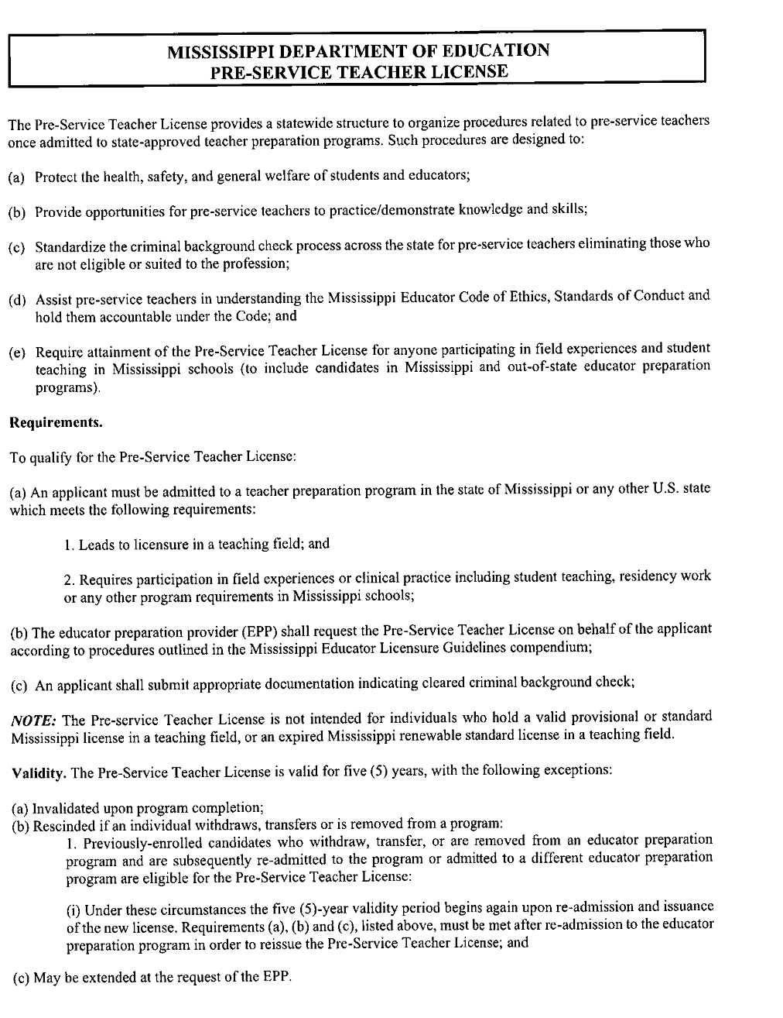
LEGAL STATUS FOR STUDENT TEACHERS
In 1973 the Mississippi legislature passed the following legislation concerning student teachers and interns:
AN ACT TO PROVIDE FOR STUDENT TEACHERS OR INTERNS AND TO PRESCRIBE THEIR DUTIES:
BE IT ENACTED BY THE LEGISLATURE OF THE STATE OF MISSISSIPPI

37-132-1 Definitions: As used in this chapter, "student teacher" or "intern" shall mean a student enrolled in an institution of higher learning approved by the State Board of Education for teacher training and who is jointly assigned by such institution of higher learning and a board of education to student-teach or intern under the direction of a regularly employed certificated teacher, principal, or other administrator. Whenever in this chapter "board of education" is referred to and the school that a student teacher or intern is assigned to does not have a board of education, such term shall refer to the person or governing body that administers such school.
37-132-3 Responsibility of Cooperating Teacher: It shall be the responsibility of a cooperating teacher, in conjunction with the principal or other administrator and the representative of the teacher preparation institution, to assign to the student teacher or intern responsibilities and duties that will provide adequate preparation for teaching. Student teaching may include duties granted to a certificated teacher under the rules and regulations of such board of education and any other part of the school program for which either the cooperating teacher or the principal is responsible.
37-132-5 Powers and Duties of Student Teacher: A student teacher or intern under the supervision of a certificated teacher, principal, or other administrator shall have the protection of the laws accorded the certificated teacher, principal, or other administrator, and shall, while acting as such student teacher or intern, comply with all rules and regulations of the local board of education and observe all duties assigned certificated teachers.

DIFFICULTY IN THE PROFESSIONAL STUDENT TEACHING SEMESTER

- If a Student Teacher is experiencing difficulty in his/her Student Teaching Placement, the University Supervisor should notify the Director of Field Experiences immediately.

- The Director of Field Experiences and the University Supervisor will meet with the Student Teacher to develop a Plan for Improvement (signed by the Student Teacher, University Supervisor, and the Director of Field Experiences) to assist the Student Teacher as he/she works to improve his/her performance.

- The University Supervisor will complete a Professional Dispositions Infraction form describing the difficulties the Student Teacher is experiencing and the Student Teacher will be referred to the Professional Dispositions Committed for an interview.

- The Student Teacher will be monitored carefully by the University Supervisor, Cooperating Teacher, and Director of Field Experiences as he/she works to make improvement based on the Improvement Plan.

- If the Student Teacher shows that he/she cannot succeed in the Professional Student Teaching Semester, the University Supervisor should meet with the Director of Field Experiences to discuss the possible options for the Student Teacher.

- If withdrawal from the student teaching semester is recommended, the University Supervisor and the Director of Field Experiences will meet with the Student Teacher as soon as possible. This will be done after the University Supervisor has had an opportunity to talk with the Cooperating Teacher and observe the candidate.

- If a Student Teacher does not withdraw from Student Teaching Semester and receives his/her first “D” or “F” in an EDU course (in any one of the Directed Teaching courses) he/she must successfully repeat the Student Teaching Semester with no grade less than “C” in order to be recommended for a teaching license.

- If a Student Teacher has more than one “D” in an EDU course (this could be two or more Directed Teaching courses or an EDU course taken earlier in the program), he/she will not be allowed to remain in the Teacher Education Program and will not be recommended for a Mississippi teaching license.

- Any candidate who withdraws from the Professional Student Teaching Semester must be approved by the Professional Dispositions Committee prior to being re-assigned to the Professional Student Teaching Semester at a later time. The Student Teacher must submit an appeal to the Professional Dispositions Committee noting the actions which have been taken to ensure a successful experience.

Professional Education Dispositions for Teacher Candidates Intervention Process

Professional Education Dispositions for Teacher Candidates
Professional Dispositions consist of the attitudes, beliefs, values, and behaviors toward students, families, colleagues and communities exhibited by professional educators in the field of education. Professional Dispositions are guided by values such as caring for others, fairness, honesty, responsibility, and social justice. These attitudes, beliefs, values, and behaviors affect student learning, motivation and development as well as the educator’s own professional growth.
Mississippi College seeks to be recognized as a university known for academic excellence and commitment to the cause of Christ. The Department of Teacher Education & Leadership at MC seeks to help those who are called to teach become leaders, advocates, and professionals who reflect the qualities of a Christian University within the field of education.
Teacher candidates are held to high standards and should demonstrate consistency and excellence through practice, collaboration, and assessment. Teacher candidates are expected to display the highest level of professionalism, outstanding teaching qualities, and leadership in their relationships with others whether they are in the university classroom or during clinical experiences in our partner school districts and agencies.
All teacher education candidates in the Department of Teacher Education & Leadership at Mississippi College are expected to exhibit the following dispositions listed below.

As a teacher education candidate, I will:
• Maintain a professional relationship with all students
• Conduct myself in an ethical manner as set forth by the MS Educator Code of Ethics and Standards of
Conduct
• Demonstrate a high level of professionalism
• Demonstrate an expectation that all students can learn and are a vital part of the learning community
• Demonstrate outstanding content and pedagogical knowledge
• Display sensitivity to the needs of others
• Work cooperatively with peers, instructors, university supervisors, and relevant stakeholders to advance student
learning
• Design or use educational environments and instructional practices to meet all students’ needs, abilities, and
interests
• Understand or thoughtfully use formal and informal evaluation strategies
• Model poise, maturity, and sound judgment
• Engage in continuous self-evaluation and improvement
• Act as a steward of the profession

Disposition Infraction Process
If a Department of Teacher Education course instructor or University Supervisor recognizes disposition related infractions by a candidate, the following procedures will be followed:
1. The University supervisor or course instructor will complete a disposition infraction form and submit it to the Director of Field Experiences.
2. After review of the form(s) between candidate and instructor or University supervisor, the candidate will be asked to sign the form (within 7 days of the submission of the disposition infraction). The signature is not an agreement with or to the infractions but denotes that the candidate has reviewed the form.
3. Notification of the infraction will be sent to the Director of Field Experiences, Department Chair, student advisor, and the members of the standing disposition committee.
4. When two disposition infraction forms on a teacher candidate have been submitted, the disposition committee will meet. (A meeting of the committee may be warranted after one infraction. This will be left to the discretion of the Director of Field Experiences, Dispositions Committee Chair and Department Chair.)
5. The committee will meet with the teacher candidate and review the disposition infractions.
6. The committee’s recommendation will be sent to the candidate. After the conference the candidate must sign the recommendation form within 7 days of the committee’s recommendation. The signature is not an agreement with or to the infractions but denotes that the candidate has reviewed the form.
7. If the Disposition Infraction Committee recommends dismissal, the teacher candidate will be dismissed from the Teacher Education Program (TEP) and must remain out of the TEP for a full semester (Fall or Spring term) prior to applying for readmission to TEP. To be considered for readmission the candidate must show substantial growth in the areas of deficiency identified in the disposition infraction process (see # 12 of Disposition Infractions Process).
8. Upon dismissal from the program the teacher candidate will not be allowed to return to the course(s) that include a field experience component. If the teacher candidate appeals the dismissal (see step 9 of Disposition Infractions Process) he/she may continue in university classes but will not attend any associated field experiences during the appeal process. If the decision of the committee for dismissal is upheld following the appeals process, a grade of “F” will be awarded for the course. The “F” grade is not an appealable grade. The teacher candidate may continue in non-field-experience-based coursework already underway for the current semester. The candidate will not continue in Teacher Education coursework in future semesters at the university.
9. If the candidate intends to appeal the committee’s decision, the candidate will submit a narrative about the incident and their appeal of the decision to the Director of Field Experiences. The Chair will conduct an appeals meeting with the student and will file a report to the student and the committee.

If student appeals further to the Dean:
The candidate will submit their appeal of the decision directly to the Dean. The Dean will conduct a meeting, and a report will be filed.
10. If the Dean upholds the recommendation of dismissal, the teacher candidate has the right to appeal to the Vice-President of Academic Affairs in writing within fifteen (15) calendar days of the receipt of the Dean’s decision. (Please note: University holiday closing dates are not counted in the calendar days).
11. If a teacher candidate is recommended for counseling and not for dismissal, a recommendation will be sent to the Chair of the Department of Teacher Education, the candidate’s advisor, and the Director of Field Experiences.
12. To reapply for admission to TEP, candidates must submit the following information to the Office of Field Experiences:
a. A 1-2 page letter justifying readmission to TEP identifying how previous deficiencies have been rectified.
b. Three letters of recommendation to include one Department of Education Faculty member and one currently employed K-12 educator or administrator. Each letter must include contact information (email address and phone number).
c. A transcript indicating all coursework since being dismissed from TEP.

I have received a copy of the Professional Dispositions Evaluation Tool, The Statewide Dispositions Instrument and the Disposition Infraction process. I have reviewed and understand the information regarding the MC Teacher Education Dispositions Evaluation for Teacher Candidates, the Statewide Dispositions Instrument, and the Disposition Infraction process. I understand that if I receive two (2) disposition infraction forms, I must meet with the Professional Dispositions Committee where a decision will be made concerning my status in the program. A meeting MAY be warranted based on the first disposition infraction.

______________________________________________________ ___________________________________
Teacher Candidate Signature Date

Mississippi College
Dispositions Infraction Form

Candidate Name: ___________________________ Date of Evaluation: ________________________
Course Number: ____________________________ Course Name (s): __________________________
Instructor: _________________________________ Current Semester: _________________________
Major: ___________________________________ Advisor: __________________________________
Supervisors and Faculty, please check the infraction and provide a comment or explanation.
Ratings are based upon class meetings, assignments, appointments, group work and field/clinical experiences.

Responsibilities ___ Submits incomplete assignments/projects or assignments/projects are not submitted by the establish deadlines
Comment:__________________________________________________________________________________________________________________________________________________________________________________

Attendance & Punctuality ___ Is absent for 25% or more of scheduled class time or field experience
(including tardies and early departures)
Comment:__________________________________________________________________________________________________________________________________________________________________________________

Professional Appearance ___ Does not dress appropriately for the classroom environment and field
experiences or demonstrates poor personal hygiene
Comment:____________________________________________________________________________________________________________________________________________________

Demeanor ___ Lacks confidence or displays a critical or negative attitude and may have a
negative effect on the learning environment
Comment:__________________________________________________________________________________________________________________________________________________________________________________

Initiative ___Seldom volunteers for tasks, exhibits little energy, enthusiasm, or effort
Comment:__________________________________________________________________________________________________________________________________________________________________________________

Integrity ___Speaks or behaves inappropriately with others and lacks respect for
confidentiality (including social media)
Comment:__________________________________________________________________________________________________________________________________________________________________________________

Organization ___ Is unprepared, does not have needed materials or resources, and/or utilizes
poor time management
Comment:__________________________________________________________________________________________________________________________________________________________________________________

Flexibility ___ Is unwilling to modify ideas, adapt to changes, and/or is not receptive to the opinions and ideas of others
Comment:__________________________________________________________________________________________________________________________________________________________________________________

Communication ___ Does not use effective oral or written communication, or tone is not professional, or language is informal/inappropriate
Comment:__________________________________________________________________________________________________________________________________________________________________________________
Diversity ___ Is exclusive or displays inappropriate behaviors toward diverse peers or
students (e.g. ethnicity, race, cultural, gender, SES, language, disability, ability level, etc.)
Comment:__________________________________________________________________________________________________________________________________________________________________________________

Leadership ___ Does not display characteristics of leadership when appropriate including
committing to tasks, showing confidence and enthusiasm, offering
suggestions, or contributing useful ideas
Comment:__________________________________________________________________________________________________________________________________________________________________________________

Collaboration ___ Does not work effectively with others by sharing responsibilities,
contributing ideas, or problem solving to accomplish common tasks Comment:__________________________________________________________________________________________________________________________________________________________________________________

Cooperation ___Demonstrates inability or unwillingness to work cooperatively with others

Comment:__________________________________________________________________________________________________________________________________________________________________________________

Responsive Feedback ___Rejects or ignores constructive feedback

Comment:__________________________________________________________________________________________________________________________________________________________________________________

Rapport ___Does not communicate and interact effectively and professionally with
others
Comment:__________________________________________________________________________________________________________________________________________________________________________________

Other ____________________________________________________________________________________________________________________________________________________________________________________________________________________________________

Teacher Candidate Signature: ________________________________ Date: _______________________

Supervisor/Faculty Signature: _______________________________ Date: _______________________

Committee Recommendations:

THE CERTIFICATION (LICENSURE) PROCESS

All Mississippi Department of Education (MDE) licensure requirements are subject to change. Licenses which entitle the holders to teach in the elementary and secondary schools in the State of Mississippi are issued by the Mississippi Department of Education, Office of Educator Licensure, to applicants who complete the requirements for these licenses. Teacher Candidates who complete any of the teacher education programs offered at Mississippi College automatically qualify for Mississippi teaching licensure. Status sheets showing all of the courses required in each of the undergraduate majors in education that are available at MC may be obtained in the MC Department of Teacher Education & Leadership office or from the candidate’s advisor. A candidate for any Mississippi license must complete an on-line Mississippi Educator Licensure Application following a recommendation being submitted by the Office of Field Experiences.

Those students who expect to teach in states other than Mississippi will be held responsible for knowing the facts regarding licensure requirements in those states and should, during the time that they are students at Mississippi College, pursue such courses that will satisfy the licensure requirements of the particular state in which they intend to teach. Appropriate application forms may be obtained from the Mississippi Department of Education in the state where licensure is sought.

All students pursuing a teacher education curriculum and seeking Class A Licensure must take the appropriate test(s) and achieve at or above the minimum scores established by the Mississippi Department of Education before the Dean of Education and/or the Chair of the Teacher Education and Leadership Department recommends that the candidate be licensed to teach. All persons applying for first-time licensure must have appropriate test scores on file with the Mississippi Department of Education and with Mississippi College. The minimum cut-scores as mandated by the MDE for various licensure areas are shown on the following pages.

Traditional Baccalaureate Teacher Education Program Candidate:

A five-year educator license is granted to applicants meeting all licensing requirements and completing a state approved Council for the Accreditation of Educator Preparation (NCATE/CAEP) approved teacher education program from a regionally/nationally accredited Institution of higher learning.

Minimum licensure requirements are as follows:
- Successful completion of an approved Teacher Education Program
- Successful completion of a full semester of student teaching
- Passing Scores from Praxis II Principles of Learning and Teaching Test
- Passing Scores from Praxis II Content Area Test in Degree Area
- Passing Scores from Foundations of Reading Test-Elementary Education Only
- Reading Certification- Secondary and K-12 Only (completed during EDU 460)
Praxis Test Scores and Codes
PRAXIS CORE | Passing Score | Test Code
Reading | 156 | 5713
Writing | 162 | 5723
Math | 130 | 5733
PRAXIS II | Passing Score | Test Code
Elem Ed Curriculum, Instruction & Assessment | 153 | 5017
Principles of Learning K-6 | 160 | 5622
Principles of Learning 7-12 | 157 | 5624
Other | Passing Score | Test Code
Foundations of Reading | 233 | n/a

Endorsement | Passing Score |  | Test Code | UG only | Grad only
Students must take test for major area of study
Added endorsements require the Praxis test OR 12-21 hours of coursework
Administrator K-12 (SLLA) | 151 |  | 6990 |  | √
Art K-12 | 158 |  | 5134
Biology 7-12 | 148 |  | 5236
Business Education 7-12 | 153 |  | 5101
Chemistry 7-12 | 140 |  | 5246
Early Childhood PreK-K | 160 |  | 5024 | √
Economics 7-12 | 150 |  | 5911
Elementary Content Knowledge | 163 |  | 5018 |  | √
Elementary K-6 | 153 |  | 5017 | √
English 7-12 | 167 |  | 5038
English as Second Language K-12 | 149 |  | 5362
French K-12 | 153 |  | 5174
German K-12 | 154 |  | 5183
Health Education K-12 | 149 |  | 5551
Home Economics 7-12 | 153 |  | 5122
Latin K-12 | 152 |  | 5601
Marketing 7-12 | 151 |  | 5561
Math 7-12 | 152 |  | 5165
Math 7-8 (Middle School) | 150 |  | 5164
Music K-12 | 161 |  | 5113
Physical Education K-12 | 145 |  | 5091
Physics 7-12 | 140 |  | 5266
School Counselor K-12 | 153 |  | 5422 |  | √
School Librarian K-12 | 149 |  | 5312
Social Studies 7-12 | 150 |  | 5081
Spanish K-12 | 160 |  | 5195
SPED Mild/Moderate K-12 | 152 |  | 5354
Speech Communication | 143 |  | 5221

Endorsements requiring coursework only |  | UG only | Grad only
Athletic Administration K-12 |  |  | √
Computer Applications K-12
Drama
Driver's Education 7-12
Dyslexia Therapy K-12
General Science K-12
Gifted Ed K-12 |  |  | √
Media Arts K-12
Online Instruction & Design K-12 |  |  | √
Physical Science 7-12
Reading K-12 |  | √
SPED Mild/Moderate K-6 (Elem Ed students only)
STEM K-12 |  |  | √

Those candidates who expect to teach in states other than Mississippi will be held responsible for knowing the facts regarding licensure requirements in those states and should, during the time that they are students at Mississippi College, pursue such courses that will satisfy the licensure requirements of the particular state in which they intend to teach. Appropriate application forms may be obtained from the Mississippi Department of Education in the state where licensure is sought.
APPENDIX A—Mission Statements

MISSISSIPPI COLLEGE
MISSION STATEMENT

Mississippi College, governed by a Board of Trustees elected by the Mississippi Baptist Convention, is a private, co-educational, comprehensive university of liberal arts and sciences and professional studies dedicated to the pursuit of academic excellence. Founded in 1826, Mississippi College is the oldest institution of higher learning and the largest private university in the state of Mississippi. As a Christian institution, Mississippi College values the integration of faith and learning throughout the educational process.
Consistent with its Baptist heritage and relationship to the Convention, Mississippi College provides a quality Christian education for its student population. Students select the University because of the quality of its academic programs, Christian environment, and location. The University strives to recruit students who demonstrate excellence in scholarship, leadership, and church/community involvement. The majority of students come from Mississippi and other southeastern states.
Mississippi College stimulates the intellectual development of its students through the liberal arts and sciences and concentrated study in specialized fields, including preprofessional and professional programs. Furthermore, the university environment promotes the spiritual, social, emotional, and physical development of its students and encourages them to utilize their skills, talents, and abilities as they pursue meaningful careers, life-long learning, and service to God and others. The University emphasizes those undergraduate, graduate, and professional programs which offer opportunities for service. Additionally, the University reflects its responsibility of service to the community through a variety of learning opportunities and numerous cultural enrichment experiences.
Mississippi College is committed to excellence and innovation in teaching and learning. The University seeks to employ and retain faculty who are dedicated to teaching/learning and advising students, who support and engage in scholarship and creative activities that advance knowledge, and who seek to continue their own professional development. The University also seeks to employ and retain staff and administrators who are equally dedicated to supporting these efforts. Furthermore, the University selects employees who reflect Christian values and a commitment to service. Mississippi College is an equal opportunity employer in accordance with Title VII and applicable exemptions.
Official mission statement as adopted by the Board of Trustees 1998

SCHOOL OF EDUCATION
MISSION STATEMENT

The mission of the Mississippi College School of Education is to provide a caring Christian environment which facilitates the acquisition of knowledge in the behavioral sciences, teaching and learning, and health and human sciences. The School of Education provides the general education, professional studies, field and clinical experience, research skill development, and technological foundations required for each graduate and undergraduate program. These components generate the knowledge, dispositions, and skills necessary to render appropriate service to God and others in a professional environment while meeting all local, state, and national performance standards.

DEPARTMENT OF TEACHER EDUCATION
MISSION STATEMENT

The mission of the Department of Teacher Education and Leadership at Mississippi College is to provide collaborative, integrated professional educator preparation which is field connected and focused on teaching and learning; based on best practice which is driven and assessed by high national, state, and local standards which will develop reflective practitioners with the appropriate knowledge, dispositions, and skills to lead the 21st Century educational enterprise in America.

APPENDIX B—Tk20 Information

Directions for Uploading Items to a Binder:
Log in to Tk20

You should be on the “Home Page.”
Begin by clicking on the Field Experience Tab. The field experience box will contain your student teaching binder, click on the link to open your student teaching binder.

In your binder, you will see a tab for every task you are to complete. If a task requires
you to upload an item, you will see the name of the task and the instructions on the left.
On the right you will see the word “Attachment(s):” in bold and in that same box you
will see a “Select” button beside the word “File.”

Click the “Select” button and a popup window will open.
In the “Title*” field, you can type your First/Last name and the name of the file.
In the “Description” field, you can type a description of that file.
Under the section labeled “File,” you will see “Attached Documents,” click the button
“Select File(s)” and then navigate to the file on your computer that you need to upload
and click the name of that file one time.
Click the “Choose” button. You will then see the popup window again.
You MUST click the green “Add” button at the bottom of that window for the file to
attach. (You will see the file uploading and then a quick message which says “Upload Success!” Then you will see the file listed in the “Attached Documents” box
with an X beside it. If you needed to delete that file to make corrections and attach
another one, click the X. The file will be removed and you can repeat the process.)
The pop up window will disappear and you will be back on the original page. Do NOT
click the green “Submit” button until you have uploaded every item in the entire binder.
Click the “Save Draft” button each time you upload an item.

Now you are ready to go to the next tab and repeat the above steps.

APPENDIX C—Notebook Organization

Student Teacher
Notebook Organization

- Class Information
  - Seating chart
  - Class roll
  - Pictures – if possible
  - School calendar – district yearly calendar
  - Daily or weekly class schedule
  - School or classroom discipline policy
  - Class profile

- Lesson Plans
  - Arrange chronologically by subject
  - Reflective, daily self-evaluations
  - Lesson plan format
    - Launch Pad template for elementary
    - K-12 and 7-12 format from university supervisor
  - Lesson plans should be printed and in your notebook for your supervisor to see when visiting
  - Include text references, page numbers, resources, etc. in your lesson plans
  - Include any supplementary materials with lesson plans

- Records
  - Conferences
    - Include any notes from conferences with cooperating teacher and university supervisor
    - Organized by type and date
    - Briefly summarize topic and outcome
  - Evaluations – include copies if possible
  - Observations
    - Name and date of class observed
    - Sketch or describe classroom environment
    - Lesson topic/purpose/grade level
    - Teaching methods
    - Learning activities and materials or resources
    - Evaluation/assessment
    - Management style/techniques used
APPENDIX D—Forms First Days of School Form

This letter confirms that:

____________________________________(Mississippi College student teacher)

Observed and participated in the First Days of School in a K-12 classroom at

_____________________________________(Name of school)

on these dates __________________________________________________.

Signature of School Administrator__________________________________

Signature of Cooperating Teacher___________________________________

Signature of Student Teacher_______________________________________

Request for First Days of School Observation

I am requesting permission from the following school to observe the first two days of school:
Name of School: _______________________________________________

School District: ________________________________________________

City, State:____________________________________________________

Name of Administrator:__________________________________________
School’s Phone Number:_________________________________________
Student Teacher’s Name: ________________________________________
Major: __________________________ Advisor: _____________________
Phone Number:_________________________________________________
____I have received permission to observe at this school for the first two
days of the school year.

Signature: ___________________________________________
DAILY STUDENT TEACHING SCHEDULE
EMAIL THIS FORM TO YOUR
UNIVERSITY SUPERVISOR
THE END OF YOUR FIRST WEEK.

Student Teacher:_________________ Schedule for the Week beginning:________
STUDENT’S PHONE/EMAIL:____________ UNIVERSITY SUPERVISOR:_____________
School where student teaching:_______________ COOPERATING TEACHER:___________
Location where student teaching:________________ School phone:______________________
Time |  |  | ROOM | Monday | Tuesday | Wednesday | Thursday | Friday
Begin | End

WEEKLY STUDENT TEACHING LOG
Summarize Each School Day’s Activities and Complete Back of Form
NAME: |  |  | PHONE:
SCHOOL | GRADE LEVEL/SUBJECT(S) TAUGHT:
COOPERATING TEACHER(S):
FOR THE WEEK OF: |  | TOTAL CLOCK HRS PRESENT:

MON
TUES
WED
THUR
FRI

COMPLETE AND RETURN THIS FORM TO YOUR UNIVERSITY SUPERVISOR AT END OF EACH WEEK
Office of Field Experiences PO Box 4009 Clinton, MS 39058 Phone 601.925.3846 Fax 601.925.3840
WEEKLY LOG OF TEACHING & RELATED ACTIVITIES
For the week ending: _____________________________________
Please include the time you have spent in the following teaching and related activities:
(Round off times to the nearest one-half hour. Travel time should not be included.)
TEACHING ACTIVITY | MON | TUES | WED | THURS | FRI | WEEKLY  TOTAL
Observation of other classes:

Classroom instruction

One-on-one instruction
(tutoring)
Conferences with Cooperating Teacher
Bus, recess, or other duty
(please specify)
Faculty meetings

Parent conferences

Athletic events

Workshops

Preparation for teaching

Other
(please specify)
Please summarize the highlights of the past week. Include those experiences that were especially insightful or meaningful to you.
STUDENT TEACHER REQUEST TO BE ABSENT FORM

Student teachers are expected to be performing their assigned responsibilities at all times except in the case of personal illness or an extreme emergency. For other situations where there is strong, justifiable cause for requesting absence, this form must be completed by the student teacher, signed by the Cooperating Teacher and submitted to the university supervisor for at least 5 days prior to the projected absence. All absences must be made up prior to graduation.

TIME WHICH YOU REQUEST TO BE ABSENT FROM STUDENT TEACHING:
______________________________TO_____________________________________
Month Day Hour Month Day Hour

REASON FOR ABSENCE: (If you are going for a job interview, supply the following information or attach a copy of the letter in which you are asked to come for a job interview).

Name of Administrator_____________________________________________________

Name of School___________________________________________________________

Address and Phone Number_________________________________________________

Reason for absence________________________________________________________

________________________________________________________________________

Your Signature______________________________________Date_________________

Your Phone Number_______________________________________________________
Obtain the following two signatures for approval, then send to Director of Field Experiences

Cooperating Teacher’s Signature _____________________________Date_________________

University Supervisor’s Signature ____________________________ Date_________________

Director of Field Experience’s Signature _____________________ __Date_________________

APPENDIX E—Teaching Unit & Rubric

Teaching Unit: Action Plan (Unit Overview)
Standard(s)
Teaching Unit Topic
Teaching Unit Purpose/
Learning Goal(s)
Teaching Unit Performance Task Objective
(aligned to State Curricula Framework standards)

Level of Bloom’s
Purpose/  Learning Goal(s) | Daily Objectives  (aligned to State Curricula Framework standards) | Level of Bloom’s
DAY 1: | DAY 1: | DAY 1:
DAY 2: | DAY 2: | DAY 2:
DAY 3: | DAY 3: | DAY 3:
DAY 4: | DAY 4: | DAY 4:
DAY 5: | DAY 5: | DAY 5:
Content Knowledge
(may be provided on a separate document)

(continued)
Assessments
Informal Assessments | Formal Assessments
Daily Assessments & Measures  (1 per Lesson) | Performance Task and Rubric  (1 per Teaching Unit)
DAY 1: | PERFORMANCE TASK:
DAY 2:
DAY 3:
DAY 4: | PERFORMANCE TASK RUBRIC:
DAY 5:
Unit Test
(1 per Teaching Unit)
 | UNIT TEST:

Teaching Unit: Daily Lesson Plans

Teacher_____________________________________ Lesson Date_____________
Content Area_______________ Grade_____ Teaching Unit Topic______________
Lesson Components
Standard(s)
Purpose/Learning Goal(s)
Objective(s) and
Level of Bloom’s
Assessment
Materials
Handouts
Technology
Lesson Procedures
Introduction
(Motivation, questions, purpose for the lesson and/or unit, etc.)
Presentation of Content
(Explanation, modeling, demonstration, questions, etc.)
Learning Activities
(Guided Practice, group interaction, questions, independent practice, assessment, etc.)
Closure
(Reflection, questions, recap of today’s learning, purpose for tomorrow, etc.)
Additional Information
(if applicable)
Differentiation
(Describe differentiation used during the lesson OR label in the lesson itself when used)
Researched-based Strategies
(Describe any research-based pedagogical strategies used during the lesson OR label in the lesson itself when used)
Parent/Guardian Connection
(Describe any parent/guardian connection or use of family/community resources during the lesson OR label in the lesson itself when used)
Lesson Reflection
Self-Reflection
(After the lesson, include reflections of positive and negative experiences, student engagement, student outcomes, teacher performances, changes to be made for improvement in future lessons, etc.)

Teaching Unit Design
Category | Unacceptable-0 | Needs Improvement-1 | Meets Standard-2 | Exceeds Standard-3 | Score/Comments
1. Standards/  Teaching Unit Topic  CAEP 1.1; INTASC 7; TGR 1 | Standards are not included OR the unit topic is not developmentally appropriate for students | Standards are not from the appropriate state curricula frameworks OR unit topic does not match standards | Standards are from the appropriate state curricula frameworks AND unit topic matches standards | In addition to meets standard, appropriate state curricula standards are included for more than one subject area
2. Teaching Unit Purpose/ Learning Goals  CAEP 1.1; INTASC 7; TGR 1 | Teaching unit purpose is not included OR does not reflect broad learning goals of the unit | Teaching unit purpose reflects broad learning goals of the unit BUT does not match state curricula frameworks | Teaching unit purpose matches state curricula frameworks and unit topic AND is written to reflect broad learning goals of the unit | In addition to meets standard, teaching unit purpose/learning goals are written in a sequential and orderly progression
3. Performance Task Objective AND Daily Lesson Obj.(s)  CAEP 1.1; INTASC 7; TGR 2 | Objectives are not included OR do not relate to state curricula frameworks | Objectives align with state curricula frameworks BUT are not observable or measurable OR do not match the purpose/learning goals | Objectives match state curricula frameworks AND are observable and measurable AND match the purpose/learning goals | In addition to meets standard, objectives are stated at different instructional levels based on individual needs of students at different levels of Bloom’s Taxonomy
4. Content Knowledge  CAEP 1.3; INTASC 4; TGR 1 | Content Knowledge/ specific items are not included OR do not relate to state curricula frameworks | Content Knowledge/ specific items align with state curricula frameworks BUT are not adequate for learners to meet one or more unit objectives | Content Knowledge/specific items are adequate for learners to meet all unit objectives | In addition to meets standard, details such as definitions, examples, diagrams, charts, illustrations, etc. are included
5. Performance  Task  CAEP 1.2; INTASC 6; TGR 3 | The performance task is not included OR it does not relate to the state curricula frameworks | The performance task is aligned with state curricula frameworks BUT does not measure performance task objectives OR does not provide learners opportunities to show real world application of the desired understandings, objectives, and knowledge | The performance task is aligned with and measures performance task objectives AND provides learners opportunities to show real-world application of the desired understandings, objectives, and knowledge | In addition to meets standard, the performance task allows students opportunities to demonstrate understandings by providing options and a variety of performance methods and products

Category | Unacceptable-0 | Needs Improvement-1 | Meets Standard-2 | Exceeds Standards-3 | Score/Comments
6. Performance  Task Rubric  CAEP 1.2; INTASC 6; TGR 3 | The performance task rubric is not included;  OR the rubric does not align with the performance task | The performance task rubric is aligned with the performance task and is properly constructed (i.e. scores are not skipped, there are no indicators with a score range such as 1-2 points, each indicator is clearly described, etc.) | The performance task rubric aligns with the performance task and measures unit objectives, by including all necessary categories and indicators written in an organized AND sequential manner | In addition to meets standard, the performance task rubric is written in student-friendly language AND designed to be used by the learner for self-evaluation
7. Formal Assessment (Unit Test)  CAEP 1.2; INTASC 6; TGR 3 | Unit test is NOT included or test is included BUT questions do not relate to the state curricula frameworks | All of the questions on the unit test are aligned with the state curricula frameworks BUT the test/quiz does not use a variety of question types (multiple choice, matching, true/false, short answer, discussion, etc.) | All of the questions on the unit test are aligned with the state curricula frameworks. The test/quiz uses a variety of question types (multiple choice, matching, true/false, short answer, discussion, etc.) | In addition to meets standard, the questions on the unit test are written on different levels of Bloom’s Taxonomy so that they assess students’ knowledge and skills at different levels
8. Informal  Assessment (Daily Assessments)  CAEP 1.2; INTASC 6; TGR 3 | Informal assessments are NOT included OR do not measure daily objectives | Informal assessments are included AND measure daily objectives | A variety of informal assessments are included that measure daily objectives AND allow students to show mastery of knowledge/skills in a variety of ways | In addition to meets standard, a checklist to record data for each informal assessment is included
9. Bloom’s  Taxonomy  CAEP 1.4; INTASC 8; TGR 2 | Different levels of Bloom’s Taxonomy are NOT included in the objective(s) or assessments | Different levels of Bloom’s Taxonomy are included BUT one or more is not accurately matched to the objective(s) or assessment(s) | Different levels of Bloom’s Taxonomy are included AND are accurately matched to the objective(s) and assessment(s) | In addition to meets standard, a variety of higher-order Bloom’s Taxonomy levels (Analysis, Synthesis, and Evaluation) are included
10. Student Use of Technology  CAEP 1.5; INTASC 8; TGR 6 | Students are NOT provided an opportunity to use technology during the unit | Students are using technology, BUT it is used mainly in activities for remembering or understanding concepts or skills NOT related to unit objectives. Examples: online games, etc. | Students are using technology for an activity or project which is aligned with the unit objectives | In addition to meets standard, students are using technology in an activity or project utilizing higher-level skills such as analyzing, synthesizing, evaluating
Teaching Unit Design TOTAL
Teaching Unit Daily Lesson Plan
Category | Unacceptable-0 | Needs Improvement-1 | Meets Standard-2 | Exceeds Standards-3 | Score/Comments
11. State Standard(s) and Purpose/ Learning Goal(s)  CAEP 1.1; INTASC 7; TGR 1 | The lesson plan does not include a daily purpose/learning goal  and/or curriculum standard | The lesson plan includes a daily purpose/learning goal and curriculum standard BUT they do not match | The lesson plan includes a daily purpose/learning goal related to the curriculum standard | In addition to meets standard, more than one content area of curriculum standards is included AND incorporated in the lesson plan | 1 | 2 | 3 | 4 | 5
12. State Standard(s) and Daily Lesson Objective(s)  CAEP 1.1; INTASC 1; TGR 1 | The lesson plan does not include daily lesson objective(s)  AND/OR curriculum standard | The lesson plan includes daily lesson objective(s)  and curriculum standard BUT they do not match OR daily objective(s) are not measurable, student-oriented, developmentally appropriate, and written in clear and understandable terms | The lesson plan includes daily lesson objective(s)  related to the curriculum standard AND objectives are measurable, student-oriented, developmentally appropriate, and written in clear and understandable terms | In addition to meets standard, more than one content area of curriculum standards are included AND daily lesson objectives are included at different levels of Bloom’s Taxonomy
13. Introduction  CAEP 1.1; INTASC 5; TGR 1 | The lesson plan does not include an introduction | The lesson plan includes an introduction that is ineffective OR does not relate to the daily purpose/learning goals | The lesson plan includes an introduction that relates to the daily purpose/learning goals | In addition to meets standard, the introduction is effective, motivating, and engaging for students
14. Presentation of Content  CAEP 1.4; INTASC 8; TGR 4 | The lesson plan includes only one instructional strategy/resource for presenting content | The lesson plan includes more than one instructional strategy/resource for presenting content BUT some strategies/resources are not appropriate for learners OR do not include explanation, modeling, and/or demonstration | The lesson plan includes a variety of instructional strategies/resources for presenting content; strategies/resources are appropriate for the learners AND include explanation, modeling, and/or demonstration | In addition to meets standard, technology is incorporated effectively into the presentation of content

Category | Unacceptable-0 | Needs Improvement-1 | Meets Standard-2 | Exceeds Standards-3 | Score/Comments
15. Learning Activities  CAEP 1.4; INTASC 8; TGR 4 | The lesson plan does not include learning activities for guided practice prior to independent practice | The lesson plan includes at least one opportunity for guided practice prior to independent practice BUT learning activities may not match the lesson purpose/learning goals | The lesson plan includes multiple opportunities for guided practice and questions to check for understanding prior to independent practice AND all learning activities match the lesson purpose/learning goals | In addition to meets standard, students are actively involved in all learning activities AND questions are divergent and thought-provoking
16. Independent/ Group Practice  CAEP 1.2; INTASC 2; TGR 2 | The lesson plan does not include an independent/group practice activity | The lesson plan includes an independent/group practice activity BUT it does not relate to the daily objective and/or daily purpose/learning goals | The lesson plan includes an independent/group practice activity related to the daily objective and daily purpose/learning goals AND matches the developmental level of the learners | In addition to meets standard, learners are given opportunities to complete the independent/group practice activity using a variety of options
17. Student  Engagement/ Differentiation  CAEP 1.4; INTASC 2; TGR 2 | The lesson plan does not show opportunities for student engagement OR the opportunities do not lead to understanding of the content | The lesson plan shows opportunities for student engagement BUT the opportunities are not meaningful OR could lead to learner misunderstanding of the content | The lesson plan shows opportunities for student engagement AND the opportunities are meaningful, leading to understanding of the content AND include activities differentiated for levels of learners | In addition to meets standard, the lesson plan includes opportunities and activities differentiated for all levels of learners, specifically designed to meet individual educational needs
18. Daily Assessment  CAEP 1.4; INTASC 2; TGR 2 | The lesson plan does not include an assessment of the daily objective | The lesson plan includes an assessment but it does not match the daily objective | The lesson plan includes an assessment that is developmentally appropriate, effective, and matches the daily objective | In addition to meets standard, multiple informal assessments are included throughout the plan which differentiate for different learning levels and styles
19. Closure  CAEP 1.1; INTASC 5; TGR 1 | The lesson plan does not include closure activities | The lesson plan includes closure activities but they are ineffective AND/OR do not match the daily purpose/learning goals | The lesson plan includes closure activities that are effective and related to the daily purpose/learning goals | In addition to meets standard, the closure activities encourage students to reflect upon knowledge acquired from the lesson

Category | Unacceptable-0 | Needs Improvement-1 | Meets Standard-2 | Exceeds Standards-3 | Score/Comments
20. Overall Lesson Plan Structure  CAEP 1.1; INTASC 7; TGR 1 | The lesson plan is unorganized and does not include details OR there are many spelling and grammatical errors | The lesson plan is written in an organized manner BUT is not properly sequenced OR few details are included OR there are 3-5 spelling and grammatical errors | The lesson plan is written in an organized and sequential manner AND details are included | In addition to meets standard, the lesson plan is thorough and well planned AND includes step-by-step procedures in full detail
Daily Lesson Plan Scores
Teaching Unit Daily Lesson TOTAL:
Teaching Unit Design TOTAL:
Teaching Unit TOTAL:

APPENDIX F—Statewide Impact on Student Learning Assignment and Rubric

STATEWIDE IMPACT ON STUDENT LEARNING ASSIGNMENT

Purpose
The Impact on Student Learning assignment gives the teacher candidate the opportunity to:
- Determine the impact of instruction on all students’ learning,
- Use assessments to make research-based informed decisions about instruction,
- Analyze and communicate students’ performance results, and
- Reflect on teaching performance.

Quality of Work
- The assignment should exemplify professionalism and effective writing and/or communication skills. This includes correct grammar, usage, and mechanics
- All necessary documentation is provided within the assignment.
- Overall, the assignment demonstrates evidence of organization and well planning.

Overview of the Method – Impact on Student Learning
The teacher candidate will use the assigned internship placement class and/or a group of students to determine the impact of his/her teaching on student learning. The teacher candidate will use multiple assessments and teaching strategies aligned with learning objectives in a unit and/or group of lessons. After collecting data from multiple assessments, the teacher candidate will analyze the data to determine the impact on student learning.

Assessment Information

- Pre-assessments measure students’ understanding and performance on a set of skills and objectives. Results from pre-assessments are used to inform, plan, and guide instruction. Need to include your pre-assessment tool and data results.

- Formative assessments focus on students’ understanding and performance of the skill(s) during instruction. Data from formative assessments influence instruction. Need to have two formative assessment results.

- Post-assessments (summative) evaluate students’ understanding and performance of a set of skills or objectives at the conclusion of the unit and/or lessons. Post-assessments can include a variety of formats. Need to include post-assessment tool and data results.

Unit/Lesson Plans
Prior to planning the unit and/or lessons, the teacher candidate will conduct at least one pre-assessment. After conducting the pre-assessment/s, the teacher candidate will record the pre-assessment/s data in a spreadsheet and analyze this data to inform the planning of the unit/or lessons.

Contextual Factors
The teacher candidate will collect contextual factors about students, the school, and the learning community. The teacher candidate will analyze the contextual factors to inform the unit and/or lesson planning.

Adjusting Instruction to Meet Student Needs
During instruction, administer multiple formative assessments and evaluate the data from these assessments to adapt instruction throughout the unit and/or lessons. Document how data from formative assessments were used to effectively plan, implement, and change instruction when necessary.

After implementing the unit and/or lessons, the teacher candidate will administer a post-assessment (summative) to determine the impact of instruction on student learning. The teacher candidate will record the post-assessment (summative) data in a spreadsheet and analyze the data to determine areas taught effectively, areas for improvement, and to determine if all students in the class were provided with equitable learning experiences.

The teacher candidate will analyze data from pre-assessments, formative assessments, and post- assessments (summative) to determine the impact on student learning for the unit and/or lessons.

Assignment Components

Contextual Factors

Purpose for Step 1:
Consider the learning environment and contextual factors that may have an impact on the teaching-learning process. Discuss characteristics about the school, classroom, and individual student needs that should be considered as instructional plans are developed. List accommodations/modifications that will be made to instructional planning and implementation based on contextual information of the assigned classroom.

Task:
Discuss the relevant contextual factors including community and school information, classroom information, student characteristics, and accommodations/modifications for planning, instruction, and assessment/s. Include any supports and challenges that impact instruction and student learning. Discuss any implications and accommodation/modifications needed for instruction based on contextual factors.

Prompt:
In the discussion on contextual factors, include the following:
1.1. Community and school information
  - Discuss the community and school information:
    - geographic location
    - community/school population (diversity, race, ethnicity, culture, gender, etc.)
    - socio-economic status (SES; ex: free/reduced lunch, Title I school, etc.)
    - type of school (locale, grade levels, and any other pertinent characteristics)
Consider additional areas for discussion, which could include Community support for education and
Other factors in the environment that impact education.
  - 1.2. Classroom information
  - Discuss the classroom information:
    - physical features and arrangement of the classroom
    - availability of technology, equipment, and resources
    - extent of parental/guardian involvement
    - grouping practices (whole group, small group, pairs, etc.)
  - Consider additional areas for discussion, which could include but are not limited to how groups were determined, classroom rules and routines, scheduling, and additional teachers/students that enter or leave the room on a regular basis.
1.3. Student characteristics – Related to the Students and Learning Environment
  - Discuss the following required areas for student characteristics:
    - grade/age level
    - gender
    - race/ethnicity/culture
    - special needs
    - achievement/developmental/skill levels
    - language (English, ESL, ELL)
    - interests, learning differences, and any other pertinent information
  - Consider additional areas for discussion, which could include but are not limited to background information and/or characteristics of specific students that should be considered when planning and implementing instruction.

Learning Goals and Objectives for Unit and/or Group of Lessons

Purpose for Step 2:
Plan appropriate and challenging learning purposes/goals and develop measurable and observable objectives for the unit of study or group of lessons. Consider different levels of Bloom’s Taxonomy and Depth of Knowledge (DOK) when planning measurable objectives.

Task:
Using the Mississippi College- and Career-Readiness Standards (MCCRS), establish a topic for the unit or group of lessons and an overall learning purpose/goal. Once the unit or group of lessons learning purpose/goal is established, determine daily learning purposes/goals for each day in the unit or group of lessons.

Note: Develop measurable and observable objectives for each day. Ensure that all objectives are measurable, student-oriented, developmentally appropriate, and written in clear and understandable terms. Daily objectives should be written at different levels of Bloom’s Taxonomy/DOK. Example: A unit or lessons should not have daily objectives all written on the Knowledge level of Bloom’s Taxonomy or DOK 1. Vary the levels of Bloom’s Taxonomy/DOK used in the unit or lessons to challenge students on different levels.

Prompt:
In your discussion, include the following:
2.1. MCCRS chosen standard(s) and unit or group of lessons topic and learning goals
  - List the chosen standard(s) from the MCCRS content area of study.
  - List the topic for the unit or group of lessons. If the unit or group of lessons addresses only part of the MCCRS standard(s), explain what part of the standard(s) is to be addressed and the rationale for addressing only part of the standard(s) in the unit topic.
  - Describe the unit or group of lesson plans purposes/goals and how it relates to the MCCRS standard/s.
  - Justify your reasoning for choosing the overall unit or group of lesson plans purpose/goal.
  - Consider additional areas of discussion, which could include but are not limited to how the overall learning goal supports previous goals and/or will support future learning goals.
  - Consider using a chart/table for Step 2. An example is provided after section 2.2.

2.2. Appropriateness of objectives
  - Describe how objectives are aligned with MCCRS and connect to and help students make sense of the real world.
  - Discuss why the objectives are appropriate in terms of the students’ development, pre-requisite knowledge, skills, experiences, and other needs of students as indicated in the Contextual Factors.
  - Consider additional areas of discussion, which could include but are not limited to the use of instructional strategies to promote learning through the students’ cognitive, linguistic, social, emotional, and physical developments.

For Step 2 of the Assignment for Impact on Student Learning, provide a chart/table to illustrate the relationship between each daily objective and Bloom’s Taxonomy Level/DOK. You may choose to use a table such as the one below for this step of the assignment.

Unit or Lesson Plans Overview

Grade and Subject Area
MSCCRS Standard
Unit or Lesson Topic
Unit or Group of Lessons Purpose/Goal
Day | Objective/s | Bloom’s/DOK Level | Assessment (Will be completed in Step 3)
1
2

3

Assessment

Purpose for Step 3:
Plan assessments that align with the chosen MCCRS standard, unit or group of lessons, and daily objectives that will be used to monitor student progress toward the purposes/goals and objectives.

Task:
Design an assessment plan to monitor student progress toward mastering objectives. Plan a pre-assessment, a variety of formative assessments, and a post-assessment (summative). Discuss how students’ progress was monitored and how assessment results were communicated to students.

Prompt:
In your discussion, include the following:
- 3.1. Assessment plan overview
  - Provide an overview of the assessment plan. The purpose of this overview is to depict the alignment between purposes/goals, objectives, and assessments to meet the individual needs of students based on contextual factors as identified in Step 1.
  - Provide a chart/table to illustrate the relationship between each purpose/goal, daily objective, and daily assessment. You may continue the table that you used for Step 2 of assignment (example below).

Assessment Plan Overview
 | Objective |  | Bloom’s /DOK Level | Assessment | Accommodations/Modifications (if needed)
Pre-assessment
Formative Assessments
Post-assessment (Summative)

  - Vary assessments by type. Instead of giving a quiz or the same type of assessment every day, use a variety of assessments.
  - Make sure each daily assessment assesses the objective for that day. Example: If your daily objective asks students to list and describe each stage of the water cycle, then your assessment should be something that requires them to do exactly that.

  - Describe the need for the accommodations/modifications based on individual needs of students based on contextual factors, for each accommodation/modification to an assessment listed. If no accommodation/modification is necessary for an assignment, state that.
  - Include accommodations/modifications that may be made to the pre- and post-assessments (summative) to meet the needs of individual students based on the contextual factors.
  - Consider additional areas of discussion, which could include but are not limited to alignment to objectives and includes a rationale for each accommodation/modification based on individual needs of students or contextual factors.

Example: The following daily assessment DOES assess the daily objective.

Daily Purpose | Daily Objective | Daily Assessment
Physical characteristics of cats | The student will (TSW) compare and contrast physical characteristics of 2 different species of cats. | Create a Venn diagram of 2 different species of cats from around the world comparing and contrasting physical attributes. (Graded for accuracy)

Example: The following daily assessment DOES NOT assess the daily objective.

Daily Purpose | Daily Objective | Daily Assessment
Physical characteristics of cats | TSW compare and contrast physical characteristics of 2 different species of cats. | Draw a picture of one species of cat and include in your picture physical features for that species of cat.

- 3.2. Pre-assessment and post-assessment (summative assessment)
  - Include copies of the pre-assessment and post-assessment (summative) and scoring guides (example: scoring rubric, answer key, etc.). Include any prompts, and/or student directions that may be needed.
  - Provide descriptions of the pre- and post-assessments (summative), how they are aligned with daily objectives, and when they will be administered.
  - Establish criteria that will be used to determine mastery for pre- and post-assessments (summative) that indicate high expectations (example: mastery = 75% or higher on the assessment).
  - Describes how the assessments are constructed to both minimize bias and to ensure valid conclusions are drawn based on student performance on assessments.
- 3.3. Daily assessments (formative assessments)
  - Include evidence of the daily assessments (formative assessments) that will be used each day (examples: quizzes, journal prompts, exit tickets, observation checklists, etc.) and scoring guides (answer key, checklist, rubric, etc.).
  - Use multiple methods of assessments by type (example: Avoid using a journal prompt each day.).
  - Describe how student progress using daily assessments will be tracked during the unit.
  - Explain the reasoning for selecting the daily assessments that will be used during the unit or lessons.
  - Consider additional areas of discussion, which could include but are not limited to describing how specific assessments address individual differences.
3.4. Assessment data
  - Create a student assessment data table for tracking individual student progress on the pre-assessment, two formative (daily) assessments, and the post-assessment (summative) in an organized and easy to read format.
  - Establish criteria for determining mastery or non-mastery on the assessment for each assessment in your data table. (Example: mastery = 75% or higher on the assessment). Describe this after your table.
  - Ensure that each daily assessment reflects mastery or non-mastery of the daily objective and is recorded on the table. An example of a table is provided below, but your data might be presented in a different format.
  - Consider additional areas of discussion, which could include but are not limited to how students will be given opportunities to review and communicate about their own progress and learning.

The type of data you collect will determine the best format for presenting it.

Example of a Student Assessment Data Table

Student Names | Pre-Assessment |  | Informal Assessment #1  (Day 1 Objective) |  | Informal Assessment #2  (Day 2 Objective) |  | Post-Assessment |  | Learning Gains from Pre- to Post-Assessment
 | % | Mastery or Non-Mastery | % | Mastery or Non-Mastery | % | Mastery or Non-Mastery | Mastery or Non-Mastery | % | Mastery or Non-Mastery
Student 1
Student 2
Class
Percentages

3.5 Communication of assessment results
  - Discuss a plan for communicating individual assessment expectations to the students.
  - Discuss a plan for communicating individual assessment results and feedback to students. Include how students will know they are progressing throughout the unit and upon completion of the unit.
  - Describe a plan for encouraging students to monitor their own progression throughout the unit or lesson and take responsibility for their own learning.
  - Consider additional areas of discussion, which could include but are not limited to a variety of strategies for communicating feedback to all students.

Instructional Design

Purpose for Step 4:
Consider the contextual factors, characteristics of the classroom, individual students, and design appropriate instruction that utilizes research-based strategies and technology to help students master objectives for the unit of study.

Task:
Provide the instructional unit or group of lessons or an overview of the unit or group of lessons. Describe the pre-assessment results and implications based on the pre-assessment results. Describe instructional strategies that engage students in critical thinking, problem solving, and provide differentiated instruction to meet the needs of diverse students as outlined in Step 1 (contextual factors). Describe research-based strategies and technology that will be used throughout the lesson. Describe a plan for communicating individual student progress to parent/guardians.

Prompt:
In your discussion, include the following:
4.1. Accommodations/modifications to instruction based on pre-assessment data analysis
  - Analyze student performance relative to the learning goals and objectives, after administering and evaluating the pre-assessment.
  - Create a table to help analyze the data. In the table, record students’ responses (correct or incorrect) or scores to individual questions on the pre-assessment or to groups of questions based on the objective assessed.
  - Determine patterns in the data that will show implications for making accommodations/modifications to instruction once student responses are recorded.
  - Describe any pattern found that will guide instruction. Examples of patterns that may be shown in the data may include:
    - Fewer than half of the students correctly answered a certain question or cluster of questions assessing a specific objective.
    - Most students correctly answered a question or cluster of questions assessing a specific objective.
    - A particular subgroup of students performed in a certain way (list it) that
would require certain accommodations/modifications (remediation or
enrichment).
- Consider including a research-based findings/contextual information for the instructional accommodations/modifications for whole group, for subgroups, and individual students.

4.2. Differentiation
  - Describe at least one example from your unit or group of lessons plans where you developed a meaningful and authentic learning experience that includes differentiation. Describe how you differentiated the instruction to accommodate developmental and individual needs of each learner in the group.
  - Ensure that the activity is learner-centered and provides differentiation to meet the specific needs of individual students as described in the contextual factors (e.g. ELL, inclusivism, cultural relevance, special needs. . .).
  - Consider providing citations of research-based strategies/procedures (citation for a source of a peer-reviewed journal article, textbook, etc.) that describes the instructional strategy used in the unit or group of lessons.
4.3. Technology – teacher candidate
  - Describe how technology is used to facilitate and analyze student learning (learning management systems, interactive websites, virtual learning, videoconferencing, digital learning, interactive tutorials, mentoring, and collaboration including the use of social networks in instruction).
  - Describe how the use of technology will facilitate higher level skills such as analyzing, synthesizing, and evaluating and not just by playing games online.
  - Consider additional areas of discussion, which could include but are not limited to how multiple forms of current technology are used by the TC to research, learn, create, communicate, and track student learning.
4.4. Technology – student use
  - Describe how students use technology for learning and understanding. Students should use technology to research, create, communicate, and present. Students should use technology to facilitate higher level skills such as analyzing, synthesizing, and evaluating and not just by playing games online.
  - Consider additional areas of discussion, which could include but are not limited to how multiple forms of current technology are used by the students to research, learn, create, and communicate.
  - 4.5. Plan for parent/guardian communication
- Describe the plan for disseminating general information about the unit or group of lessons and how specific information about individual student progress was provided to parents/guardians.(Include what information was provided to parents/guardians and how it was shared with them (i.e. technology, phone-app, paper copy).
  - Provide copies of any parent/guardian communication (such as a newsletter) created for the unit or group of lessons.
  - Consider providing examples of communication with parents and/or guardians that fosters a sense of trust that acknowledges their contributions to the students’ education.

Instructional Decision-Making

Purpose for Step 5:
Reflect on professional practices including differentiating instruction, modifying instruction, and communicating with students.

Task:
Describe how teaching strategies were modified during instruction based on student behavior, questions, responses, and/or performance. Describe how learning experiences were differentiated or modified based on formative assessment data analysis. Describe communication with students regarding their progress.

Prompt:
In your discussion, include the following:
5.1. Instructional modifications based on needs of students
  - Describe and provide an example of how teaching and/or learning strategies were modified from the original plan to meet the needs of students based on student performance during instruction. (Examples: changing from groups of 4 to pairs, modifying an activity from the original lesson plan, deleting something from the lesson plan or adding something to the lesson plan, etc.)
  - Justify your reasoning for making this accommodation/modification and give specific student behaviors, questions, and/or responses that prompted you to make the accommodation/modification.
  - Describe how the accommodation/modification led students toward meeting objectives.
  - Consider providing specific examples of student behaviors, questions AND responses that justify the instructional modification(s).

5.2. Instructional differentiation or modifications based on formative assessments
  - Describe how formative assessment data were analyzed.
  - Provide at least one example of how assessment data analysis led to differentiate or modify a specific learning experience of a previously planned activity to accommodate differences in developmental and/or educational needs of students.
  - Consider including multiple examples of research-based modifications of instruction to accommodate individual needs of students.

Analysis of Student Learning

Purpose for Step 6:

Use assessment results to analyze student learning.

Task:
Use assessment data to analyze student learning. Analyze student learning gains for the whole class, subgroups, and individual students. Provide evidence of impact on student learning and draw conclusions on overall student learning gains.

Prompt:
In your discussion, include the following:
- 6.1. Data Analysis -Student Assessment Data
Record student scores/progress on all assessments using your student assessment data table created in Step 3. Calculate the percentage (out of 100) for each assessment (where applicable) AND calculate the percentage of mastery for the entire class. Describe the data results based on the following categories: whole class, subgroups (ex: gender, performance/ability level, language, age range, etc.), and individuals.

  - Whole Class - Consider the following:
- Analyze the degree to which mastery was attained by the entire class.
- What did your analysis of the students’ learning gains tell you about the degree of mastery of each objective?
- What did the analysis of the learning gains tell you about the degree to which your overall purpose was achieved?
- Discuss specific evidence from pre- and post-assessment (summative) data to support your response.
  - Subgroups – Consider the following:
- Select a group characteristic (ex: performance/ ability level, language, age-range, etc.). Provide a rationale for the selection of this characteristic.
- Compare pre- and post-assessment (summative) results for the subgroup chosen. Summarize what the data show about student learning gains and include specific evidence used to support your response.
  - Individual Students – Consider the following:
      - Select two students who demonstrated different levels of performance and explain why it is important to understand and analyze the learning of these students.
    - Use pre-assessment, formative, and post-assessment (summative) data with examples of the student’ work to draw conclusions about the extent of these students’ learning gains.
  - Include samples of student work. Copies of pre-assessments, formative assessments, and post-assessments (summative) should be included.
  - Consider additional areas of discussion, which could include but are not limited to reflections on how the overall learning experiences were monitored throughout the unit or group of lessons.
6.2. Evidence and interpretation of impact on student learning
  - Describe evidence of impact on student learning gains in terms of numbers of students who achieved, made progress, or failed to master objectives using pre- and post-assessment (summative) data.
  - Include evidence of specific instruction/activities during the unit that may have led to that impact on student learning gains noted in pre- and post-assessment data.
  - Draw conclusions on overall student learning gains using all assessment data.
  - Provide evidence that includes details and reasoning for conclusions drawn.
  - Consider additional areas of discussion, which could include but are not limited to multiple hypotheses for why students did or did not achieve mastery on the post-assessment.

Reflection

Purpose for Step 7:

Reflect on student success/levels of mastery. Discuss implications for future instructional design, teaching, and professional development.

Task:
Reflect on student learning and possible reasons for high or low success/levels of mastery. Discuss implications for future instructional design, teaching, and professional development you engaged in or plan to seek to engage in to improve your performance as a teacher.

Prompt:
In your discussion, include the following:
7.1. Reflection on high success/levels of mastery
  - Select the objective(s) for which students were most successful. Provide two or more possible reasons for student success.
  - Reflect on factors that might have had an impact on student learning (including the purposes, objectives, instruction, and assessments along with student characteristics and other contextual factors) in your discussion.
  - Discuss how planning and implementation of instruction could have led to student success.
  - Consider next steps for progression/next steps for instructional design and teaching for the targeted students with high student success.
7.2. Reflection on low success/levels of mastery
  - Select the objective(s) for which students were least successful. Provide two or more possible reasons for the lack of student success.
  - Reflect on factors that might have had an impact on student learning (including the purposes, objectives, instruction, and assessments along with student characteristics and other contextual factors) in your discussion.
  - Consider additional areas of discussion, which could include but are not limited to research-based methods for planning and instructional strategies to continue to enhance student learning in the future to positively impact student learning.
7.3. Implications for future instructional design and teaching
  - Provide ideas for redesigning purposes/goals, objectives, instruction, and/or assessments in future teaching, and provide a rationale explaining why these ideas for modifications would improve student learning.
  - Include implications for redesigning the current unit or group of lessons and explain any implications that can be generalized to planning and teaching overall.
  - Consider providing research-based evidence to support your claims.

7.4. Implications for professional development
  - Describe at least two professional learning goals that emerged from your implementation and review of the unit or group of lessons.
  - Identify two specific steps to meet these learning goals, including professional development, to improve your teaching, planning, and assessing in the area(s) identified.
  - Consider identifying research based professional development to improve practice.

STATEWIDE IMPACT ON STUDENT LEARNING RUBRIC

Indicator | Unacceptable  0 | Needs Improvement  1 | Meets Standard  2 | Exceeds Standard  3
Contextual Factors
1.1. Community and school information  The teacher candidate (TC) discusses the following information about the community and school:  Geographic location;  Community/school population;  Socio-economic status; and  Type of school (locale, grade levels, and other pertinent characteristics).  CAEP R1.1; INTASC 2; TGR 7 | The TC does not discuss information for any of the areas about the community and school and/or the provided information is inaccurate. | The TC provides an incomplete or inaccurate description of characteristics of the community and school for any of the following areas: Geographic location;  Community/school population;  Socio-economic status; and Type of school (locale, grade levels, and other pertinent characteristics). | The TC provides an accurate and comprehensive description for each of the following: information about the community and school:  Geographic location;  Community/school population;  Socio-economic status; and Type of school (locale, grade levels, and other pertinent characteristics). | The TC provides an accurate and comprehensive description for each of the following information about the community and school: Geographic location;  Community/school population;  Socio-economic status; and Type of school (locale, grade levels, and other pertinent characteristics).  The TC also discusses the following:  Community support for education and  Other factors in the environment that impact education.
1.2. Classroom Information  The teacher candidate (TC) describes classroom factors including physical features, technology resources, parental/guardian involvement, and grouping practices (whole group, small group, pairs, etc.)  CAEP R1.1,R1.3; INTASC 3; TGR 7 | The TC describes inaccurate classroom factors related to the following: physical features, technology resources, parental/guardian involvement, and grouping practices (whole group, small group, pairs, etc.). | The TC provides an accurate but incomplete description of the following classroom factors or the TC provides a narrow scope of descriptions for the following classroom factors: physical features,  technology resources, parental/guardian involvement, and grouping practices (whole group, small group, pairs, etc.). | The TC provides an accurate and comprehensive description for each of the following factors:  physical features,  technology resources, parental/guardian involvement, and grouping practices (whole group, small group, pairs, etc.). | The TC provides an accurate and comprehensive description for each of the following factors: physical features,  technology resources, parental/guardian involvement, and grouping practices (whole group, small group, pairs, etc.).  The TC also describes how groups were determined, classroom rules and routines, scheduling, and additional teachers/students that enter or leave the classroom on a regular basis.
1.3. Student Characteristics  The teacher candidate (TC) describes each of the following student characteristics that impact students and the learning environment including  grade/age level, gender, race/ethnicity/ culture, special needs, achievement levels, language, interests, and learning differences  CAEP R1.1; INTASC 1, 2; TGR 2 | The TC describes inaccurate or incomplete classroom and student characteristics that impact students and the learning environment including grade/age level, gender, race/ethnicity/ culture, special needs, achievement levels, language, interests, and learning differences. | The TC provides an accurate but incomplete description of the following student characteristics that impact students and the learning environment including grade/age level, gender, race/ethnicity/ culture, special needs, achievement levels, language, and interests, and learning differences. | The TC provides an accurate and comprehensive description for each of the student characteristics that impact students and the learning environment including grade/age level, gender, race/ethnicity/ culture, special needs, achievement levels, language, interests and learning differences. | The TC provides an accurate and comprehensive description for each of the student characteristics that impact students and the learning environment including grade/age level, gender, race/ethnicity/ culture, special needs, achievement levels, language, and interests, and learning differences.  The TC also includes background information from parents/guardians and/or teachers that is helpful in better understanding student characteristics.
Learning Goals and Objectives for Unit and/or Group of Lessons

2.1. MCCRS and Unit or Group of Lessons Topic and Learning Goals  The teacher candidate (TC) identifies MCCRS/s that correlate with the unit or group of lessons topic and overall unit purposes/goals and describes and justifies the lesson plans learning purposes/goals.  *MCCRS refers to the Mississippi College- and Career-Readiness Standards  CAEP R1.3; INTASC 7; TGR 1 | The TC does not identify MCCRS/s that correlate with the unit or group of lessons topic and overall unit purposes/goals and does not describe the lesson plans learning purposes/goals | The TC identifies MCCRS/s that correlate with the unit or group of lessons topic and overall unit purposes/goals but does not describe the lesson plans learning purposes/goals. | The TC identifies MCCRS/s that correlate with the unit or group of lessons topic and overall unit purposes/goals and describes the lesson plans learning purposes/goals. | The TC identifies MCCRS/s that correlate with the unit or group of lessons topic and overall unit purposes/goals and describes the lesson plans learning purposes/goals.  The TC also includes a chart/table that clarifies the standards and topics and describes how the overall learning goal supports previous goals and/or will support future learning goals.
2.2. Appropriateness of Objectives  Daily objectives, aligned with MCCRS, connect to the real world and are appropriate for the students’ development, prerequisite knowledge, skills, experiences, and/or other needs of students as indicated in the Contextual Factors.  CAEP R1.1, R1.3; INTASC 1; TGR 2 | Daily learning goals and objectives are not aligned with MCCRS and do not reflect a connection to the real world or to the TC’s research on community, school, or classroom factors. The objectives do not consider students’ development, characteristics, experiences, skills, or prior learning. | Daily learning goals and objectives, aligned with MCCRS, reflect a connection to the real world and the TC’s research on community, school, and classroom factors but does not take into consideration knowledge of students’ development, characteristics, experiences, skills, or prior learning. | Daily learning goals and objectives, aligned with MCCRS, reflect a connection to the real world and to the TC’s contextual information/findings on factors including, but not limited to, knowledge of student’ development, characteristics, experiences, skills, and prior learning. | Daily learning goals and objectives, aligned with MCCRS, reflect a connection to the real world and to the TC’s contextual information/findings on factors including, but not limited to, knowledge of students’ development, characteristics, experiences, skills, and prior learning.  The TC also includes objectives that demonstrate differentiation using Bloom’s/DOK levels.
Assessment Plan
3.1. Assessment Plan Overview  The teacher candidate (TC) provides an Assessment Plan Overview Table that includes varying daily assessments with Bloom’s/DOK levels that match objectives and includes accommodations/modifications based on individual needs of student or contextual factors.  CAEP R1.3; INTASC 6; TGR 3 | The TC does not include an Assessment Plan Overview Table or assessments do not align with the daily objectives or accommodations/ modifications are not included or are not based on individual student needs or contextual factors. | The TC provides an Assessment Plan Overview Table that is incomplete and does not include all daily assessments that match daily objectives AND/OR accommodations/modifications are not included based on individual student needs or contextual factors. | The TC provides an Assessment Plan Overview Table that includes varying daily assessments with Bloom’s/DOK levels that match objectives and includes accommodations/ modifications based on individual needs of student or contextual factors/findings. | The TC provides an Assessment Plan Overview Table that includes varying daily assessments with Bloom’s/DOK levels that match objectives and includes accommodations/ modifications based on individual needs of student or contextual factors/findings.  The TC also discusses the alignment of assessments to objectives and includes a rationale for each modification based on individual needs of students or contextual factors/findings.
3.2. Pre-Assessment and Summative Assessment  The teacher candidate (TC) provides descriptions of the pre- and post-assessments, noting when assessments will be administered, and criteria used to establish mastery.  CAEP R1.3; INTASC 6; TGR 3 | The TC does not describe how the pre-assessment and summative assessment are administered, or how the assessments are aligned with daily objectives, or the criteria used to establish mastery, or the TC does not include copies of these assessments and scoring guides (rubrics, answer keys, etc.), | The TC provides incomplete descriptions of how the pre-assessment and summative assessment are administered, how the assessments are aligned with daily objectives, or the criteria used to establish mastery.  Copies of the pre- and post-assessments and scoring guides (rubrics, answer keys, etc.) are included. | The TC describes how the pre-assessment and summative assessment are administered, how the assessments are aligned with daily objectives, and the criteria used to establish mastery. The TC includes copies of these assessments and scoring guides (rubrics, answer keys, etc.), and descriptions of when assessments will be administered. | The TC describes how the pre-assessment and summative assessment are administered and the criteria used to establish mastery. The TC includes copies of these assessments and scoring guides (rubrics, answer keys, etc.), and descriptions of when assessments will be administered.  The TC also describes how the assessments are constructed to both minimize bias and to ensure valid conclusions are drawn based on student performance on assessments.
3.3. Daily Assessments  (Formative Assessments)  The teacher candidate (TC) describes the use of multiple methods and approaches for assessing student learning and provides a rationale for each assessment and an explanation of progress monitoring.  CAEP R1.3; INTASC 6; TGR 3 | The TC does not provide a description of the use of multiple methods and approaches for assessing student learning, the rationale for each assessment, or explanation of progress monitoring. Copies of 1-2 formative assessments are not included. | The TC provides an incomplete or inaccurate description of the use of multiple methods and approaches for assessing student learning, the rationale for each assessment, or explanation of progress monitoring. Copies of 1-2 formative assessments (include scoring guides if applicable) are not all included or do not vary in type. | The TC describes the use of multiple methods and approaches for assessing student learning and provides a rationale for each assessment and an explanation of progress monitoring. Copies of 1-2 formative assessments (include scoring guides if applicable) are included. | The TC describes the use of multiple methods and approaches for assessing student learning and provides a rationale for each assessment and an explanation of progress monitoring. Copies of 1-2 formative assessments (include scoring guides if applicable) are included.  The TC also describes how specific assessments address individual differences. (INTASC 6k)
3.4. Assessment Data  The teacher candidate (TC) provides an assessment data table that documents individual performance on a pre-assessment, 1-2 formative assessments, and a summative assessments. Mastery criteria for each assessment is included for all students.  CAEP R1.3; INTASC 6; TGR 3 | The TC does not provide an assessment data table for keeping track of student performance on a pre-assessment, 1-2 formative assessments, and a summative assessments. | The TC provides an incomplete or unorganized assessment data table for keeping track of student performance on a pre-assessment, 1-2 formative assessments, and a summative assessments. | The TC provides an assessment data table that documents individual student’s performance on a pre-assessment, 1-2 formative assessments, and a summative assessments. Mastery criteria for each assessment is included for all students. | The TC provides an assessment data table that documents individual student’s performance on a pre-assessment, 1-2 formative assessments, and a summative assessments. Mastery criteria for each assessment is included for all students.  The TC also discusses how students will be given opportunities to review and communicate about their own progress and learning. (INTASC 6q)
3.5. Communication of Assessment Results  The teacher candidate (TC) describes a plan for communicating assessment expectations, results, and descriptive feedback that is timely and effective to all students. The plan submitted includes a method for learners to monitor their own progression through the unit.  CAEP R1.3; INTASC 6; TGR 3 | The TC does not provide a plan for communicating assessment expectations, results, or feedback. | The TC provides a plan for communicating assessment expectations, results, and feedback to all students, but the plan lacks a method for students to monitor their own progression through the unit. | The TC describes a plan for communicating assessment expectations, results, and descriptive feedback that is timely and effective to all students. The plan submitted includes a method for students to monitor their own progression through the unit. | The TC describes a plan for communicating assessment expectations, results, and descriptive feedback that is timely and effective to all students. The plan submitted includes a method for students to monitor their own progression through the unit.  The TC also includes a variety of strategies for communicating feedback to all students.
Instructional Design
4.1. Accommodations/modifications to Instruction Based on Pre-Assessment Data Analysis  The teacher candidate (TC) analyzes pre-assessment data to determine accommodations  /modifications to instruction with descriptions of the accommodations/  modifications for the whole group, subgroups of students, or for individual students.  CAEP R1.3; INTASC 7; TGR 2 | The TC does not analyze pre-assessment data or use the results to identify patterns of student performance relative to learning goals and objectives and does not describe instructional modifications for the whole group, subgroups of students, or for individual students | The TC analyzes pre-assessment data and uses the results to identify patterns of student performance relative to learning goals and objectives but does not describe instructional modifications for the whole group, subgroups of students, or for individual students. | The TC analyzes pre-assessment data and uses the results to identify patterns of student performance relative to learning goals and objectives and describes instructional modifications for the whole group, subgroups of students, or for individual students. | The TC analyzes pre-assessment data and uses results to identify patterns of student performance relative to learning goals and objectives and describes instructional modifications for the whole group, subgroups of students, or for individual students.  The TC also provides a research-based findings/contextual information for the instructional accommodations/  modifications for whole group, for subgroups, and individual students.
4.2. Differentiation  The teacher candidate (TC) provides evidence of research-based strategies or procedures to differentiate learning for all students.  CAEP R1.1; INTASC 2; TGR 4 | The TC does not include  evidence of research-based strategies or procedures to differentiate learning for all students. | The teacher candidate (TC) provides evidence of research-based strategies or procedures to differentiate learning for all students based on students’ skill levels, learning differences, multiple intelligences, and does not reference specific individual student characteristics as described in the contextual factors’ sections. | The teacher candidate (TC) provides evidence of research-based strategies or procedures to differentiate learning for all students based on students’ skill levels, learning differences, multiple intelligences, and references specific individual student characteristics as described in the contextual factors’ sections. | The teacher candidate (TC) provides evidence of research-based strategies or procedures to differentiate learning for all students based on students’ skill levels, learning differences, multiple intelligences, and references specific individual student characteristics as described in the contextual factors’ sections.  The TC also provides citations that the instructional strategies are research-based.

4.3. Technology – Teacher Candidate  The teacher candidate (TC) describes how technology is used to facilitate, create, track, analyze, and communicate student learning (learning management systems, interactive websites, virtual learning, videoconferencing, digital learning, interactive tutorials, collaboration including the use of networks in instruction, etc.). The TC describes how the use of technology will facilitate higher level skills such as analyzing, synthesizing, and evaluating.  CAEP R1.3, R2.3; INTASC 8; TGR 6; ISTE 5, 6, 7 | The TC did not use technology in the lesson plans to facilitate, create, track, analyze, and communicate student learning. The TC does not describe how the use of technology will facilitate higher level skills such as analyzing, synthesizing, and evaluating. | The TC describes how technology and learning management systems are used to facilitate, create, track, analyze, and communicate student learning student learning but does not describe how the use of technology will facilitate higher level skills such as analyzing, synthesizing, and evaluating. | The TC describes how technology and learning management systems are used to facilitate, create, track, analyze, and communicate student learning.  The TC describes how the use of technology will facilitate higher level skills such as analyzing, synthesizing, and evaluating. | The TC describes how technology and learning management systems are used to facilitate, create, track, analyze, and communicate student learning.  The TC describes how the use of technology will facilitate higher level skills such as analyzing, synthesizing, and evaluating.  The TC also describes how multiple forms of current technology are used to research, learn, create, communicate, and track student learning.
4.4 Technology –Student Use  The teacher candidate (TC) describes how technology is used by students to research, create, communicate, and present. The TC explains how students used technology to analyze, synthesize, and evaluate.  CAEP R1.3, R2.3; INTASC 8; TGR 6; ISTE 6 | The TC does not describe how technology is used by students to research, create, communicate, and present and does not explain how students used technology to analyze, synthesize, and evaluate. | The TC describes how technology is used by students to research, create, communicate, and present but does not explain how students used technology to analyze, synthesize, and evaluate. | The TC describes how technology is used by students to research, create, communicate, and present.  The TC explains how students used technology to analyze, synthesize, and evaluate. | The TC describes how technology is used by students to research, create, communicate, and present.  The TC explains how students used technology to analyze, synthesize, and evaluate.  The TC also describes how students used multiple forms of current technology to research, learn, create, communicate, and track student learning.
4.5. Plan for Parent/Guardian Communication  The teacher candidate (TC) describes the plan for communicating with parents/ guardians about unit/lesson information, explains how individual student progress was shared with parents/guardians, and provides evidence of parent/guardian communication.  CAEP R1.1, R1.4; INTASC 9, 10; TGR 9; ISTE 7 | The TC describes an incomplete plan for disseminating unit information and explaining how individual student progress was shared with parents/ guardians. The TC does not provide evidence of communication with parents or guardians. | The TC describes an incomplete plan for disseminating unit/lesson information or explaining how individual student progress was shared with parents/guardians but does provide evidence of some communication with parents/ or guardians. | The TC describes the plan for disseminating unit/lesson information, explains how individual student progress was shared with parents/ guardians, and provides evidence of parent/guardian communication. | The TC describes a plan for disseminating unit/lesson information and communicating student progress to parents and/or guardians. The TC provides multiple pieces of evidence of consistent communication with parents or guardians.  The TC also provides examples of communication with parents and/or guardians that fosters a sense of trust that acknowledges their contributions to their students’ education.
Instructional Decision-Making
5.1. Instructional Modifications Based on Needs of Students  The teacher candidate (TC) describes and provides specific examples of student behaviors, questions, and/or responses that justifies the instructional modification/s.  CAEP R1.3; INTASC 6; TGR 2 | The TC does not describe modifications to instruction that are congruent with learning objectives or does not provide a complete rationale for those modifications based on student performance; or the TC does not provide a description of how the modification led students toward meeting objectives. | The TC describes modifications to instruction that are congruent with learning objectives but does not provide a complete rationale for those modifications based on student performance. The TC provides an incomplete description of how the modification led students toward meeting objectives. | The teacher candidate (TC) describes and provides specific examples of student behaviors, questions, OR responses that justifies the instructional modification/s. | The teacher candidate (TC) describes and provides specific examples of student behaviors, questions, AND responses that justifies the instructional modification/s.
5.2. Instructional Differentiation or Modifications Based on Formative Assessments  The teacher candidate (TC) describes how formative assessment data are analyzed and used to make modifications to differentiate instruction to accommodate differences in developmental and/or educational needs of students.  CAEP R1.3; INTASC 6; TGR 3 | The TC does not describe the use of formative assessment data or does not include examples of data-based modifications to instruction. | The TC gives an incomplete description of the use of formative assessment data and includes an example of modifications to instruction to accommodate individual differences in developmental and/or educational needs of students but does not cite student data as the basis for the modification. | The TC describes how formative assessment data are analyzed and used to make modifications to differentiate instruction to accommodate differences in developmental and/or educational needs of students. | The TC describes how formative assessment data are analyzed and used to make modifications to differentiate instruction to accommodate differences in developmental and/or educational needs of students.  The TC also includes multiple examples of research-based modifications of instruction to accommodate individual needs of students.
Analysis of Student Learning
6.1. Data Analysis  The teacher candidate (TC) analyzes student data from the assessment data table and provides an analysis of the data as to mastery attained for the whole class, group characteristic of subgroups with a rationale for the selection of this characteristic, and at least two students who demonstrated different levels of performance with samples of student work.  CAEP R1.3; INTASC 6; TGR 3 | The TC does not provide analyses for either whole class, subgroups, or individuals. Student work samples from each category are missing. | The TC provides an incomplete analysis. The TC provides analyses for either whole class, subgroups, or individuals. Student work samples from each category are provided. | The TC analyzes student data from the assessment data table and provides an analysis of the data as to mastery attained for the whole class, group characteristic of subgroups with a rationale for the selection of this characteristic, and two students who demonstrated different levels of performance with samples of student work. | The TC analyzes student data from the assessment data table and provides an analysis of the data as to mastery attained for the whole class, group characteristic of subgroups with a rationale for the selection of this characteristic, and two students who demonstrated different levels of performance with samples of student work.  The TC also reflects on how the overall learning experiences were monitored throughout the unit or group of lessons.
6.2. Evidence and Interpretation of Impact on Student Learning  The teacher candidate (TC) uses pre- and post-assessment data to describe and draw conclusions about the impact on student learning including student learning gains in terms of numbers of students who achieved, made progress, or failed to master objectives.  CAEP R1.3; INTASC 6; TGR 3 | The TC does not use pre- and post-assessment data to describe and draw conclusions about the impact on student learning including student learning gains in terms of numbers of students who achieved, made progress, or failed to master objectives | The TC uses pre- and post-assessment data to describe impact on student learning including student learning gains in terms of numbers of students who achieved, made progress, or failed to master objectives but does not draw conclusions about the impact on student learning. | The TC uses pre- and post-assessment data to describe and draw conclusions about the impact on student learning including student learning gains in terms of numbers of students who achieved, made progress, or failed to master objectives. | The TC uses pre- and post-assessment data to describe and draw conclusions about the impact on student learning including student learning gains in terms of numbers of students who achieved, made progress, or failed to master objectives.  The TC also provides multiple hypotheses for why students did or did not achieve mastery on the post-assessment.
Reflection
7.1. Reflection on High Success/ Levels of Mastery  The teacher candidate (TC) selects objective/s for which students were most successful and discusses factors including the purpose/s, objectives, instruction, assessments, student characteristics, and other contextual factors during the planning and implementation that might have successfully impacted student learning.  CAEP R1.4; INTASC 9; TGR 8 | The TC selects objective/s for which students were most successful but does not discuss factors that might have successfully impacted student learning (including purposes, objectives, instruction, and assessments along with student characteristics and other contextual factors). | The TC selects objective/s for which students were most successful and provides limited discussion of the factors that might have successfully impacted student learning (including purposes, objectives, instruction, and assessments along with student characteristics and other contextual factors). | The TC selects objective/s for which students were most successful and provides a thorough discussion on the factors that might have successfully impacted student learning (including purposes, objectives, instruction, and assessments along with student characteristics and other contextual factors). | The TC selects objective/s for which students were most successful and provides a thorough discussion on the factors that might have successfully impacted student learning (including purposes, objectives, instruction, and assessments along with student characteristics and other contextual factors).  The TC also includes the progression/next steps for instructional design and teaching for the targeted students with high student success.
7.2. Reflection on Low Success/ Levels of Mastery  The teacher candidate (TC) selects objective/s for which students were the least successful and discusses factors that might have had an impact on student learning.  CAEP R1.4; INTASC 9; TGR 8 | The TC selects objective/s for which students were the least successful but does not provide a discussion of factors that might have had an impact on student learning (including the purposes, objectives, instruction, and assessments along with student characteristics and other contextual factors). | The TC selects objective/s for which students were the least successful and provides a limited discussion of factors that might have had an impact on student learning (including the purposes, objectives, instruction, and assessments along with student characteristics and other contextual factors). | The TC selects objective/s for which students were the least successful and provides a thorough discussion on the factors that might have had an impact on student learning (including the purposes, objectives, instruction, and assessments along with student characteristics and other contextual factors). | The TC selects objective/s for which students were the least successful and provides a thorough discussion on the factors that might have had an impact on student learning (including the purposes, objectives, instruction, and assessments along with student characteristics and other contextual factors).  The TC also cites and describes research-based methods for planning or instructional strategies that could be utilized in future to positively impact student learning.
7.3. Implications for Future Instructional Design and Teaching  The teacher candidate (TC) discusses ideas for redesigning learning goals, objectives, instruction, and/or assessments in future teaching AND provides a rationale explaining why the modifications will improve student learning.  CAEP R1.4; INTASC 9; TGR 8 | The TC does not discuss ideas for redesigning purposes, objectives, instruction, and assessments in future teaching. | The TC discusses ideas for redesigning purposes, objectives, instruction, and assessments in future teaching BUT they are inappropriate or there is no rationale provided explaining why these modifications would improve student learning. | The TC discusses ideas for redesigning learning goals, objectives, instruction, and/or assessments in future teaching AND provides a rationale explaining why the modifications will improve student learning. | The TC discusses ideas for redesigning learning goals, objectives, instruction, and/or assessments in future teaching AND provides a rationale explaining why the modifications will improve student learning.  The TC also cites and describes research-based evidence that supports these ideas.
7.4. Implications for Professional Development  The teacher candidate (TC) discusses two professional learning goals that emerged from the implementation and review of the unit/group of lessons and identified specific steps including professional development to improve teaching and planning in these areas.  CAEP R1.4; INTASC 9; TGR 8 | The TC does not discuss professional learning goals or ideas for professional development to improve teaching. | The TC discusses one professional learning goal to improve teaching that emerged from insights learned from teaching the unit. | The TC discusses two professional learning goals that emerged from the implementation and review of the unit/group of lessons and identified specific steps including professional development to improve teaching and planning in these areas. | TheTC discusses two professional learning goals that emerged from the implementation and review of the unit/group of lessons and identified specific steps including professional development to improve teaching and planning in these areas.  The TC also identifies research based professional development to improve practice.

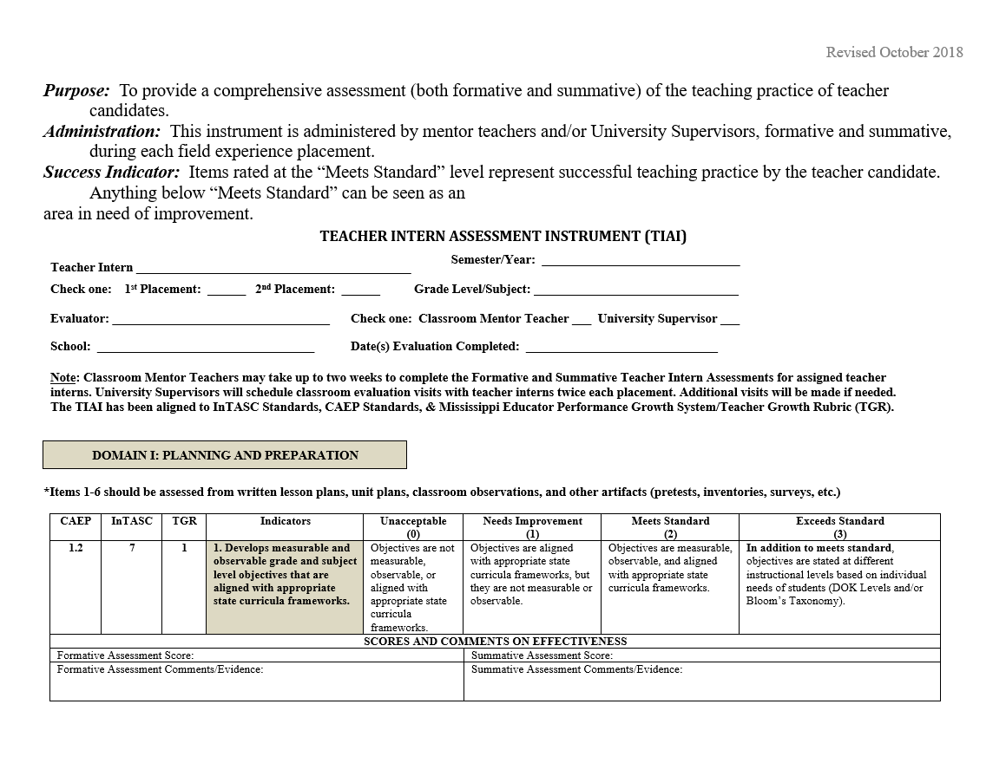
APPENDIX E—Teacher Intern Assessment Instrument (TIAI)
APPENDIX G—Teacher Intern Assessment Instrument

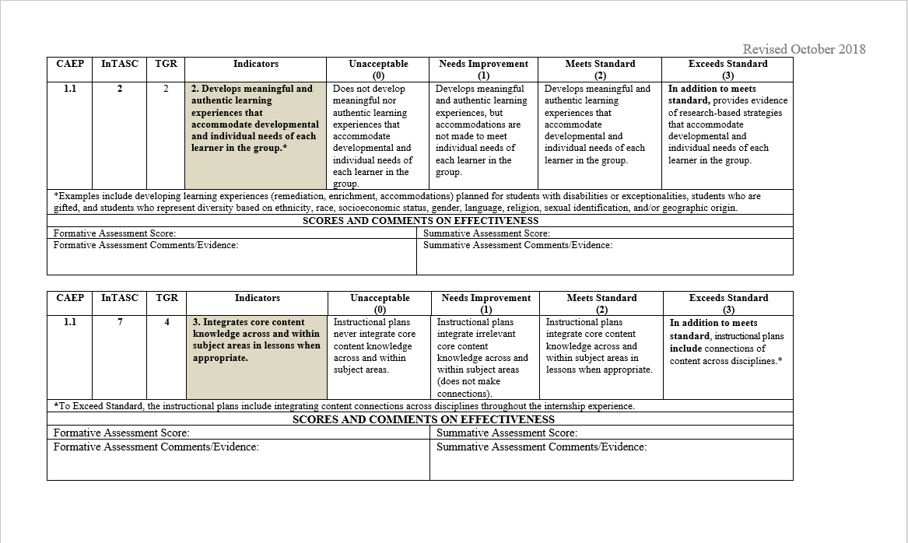
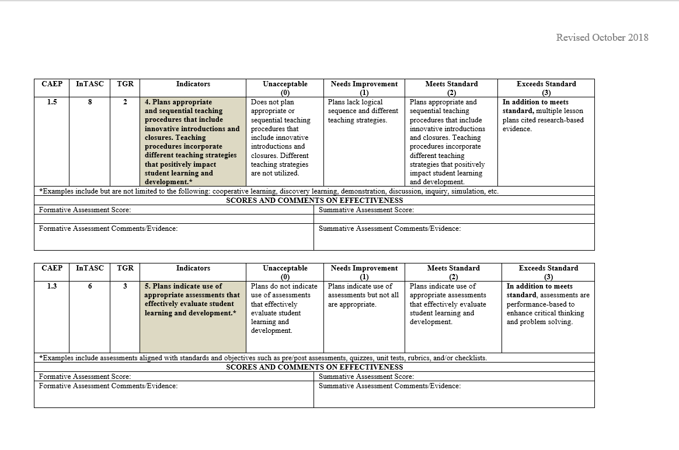

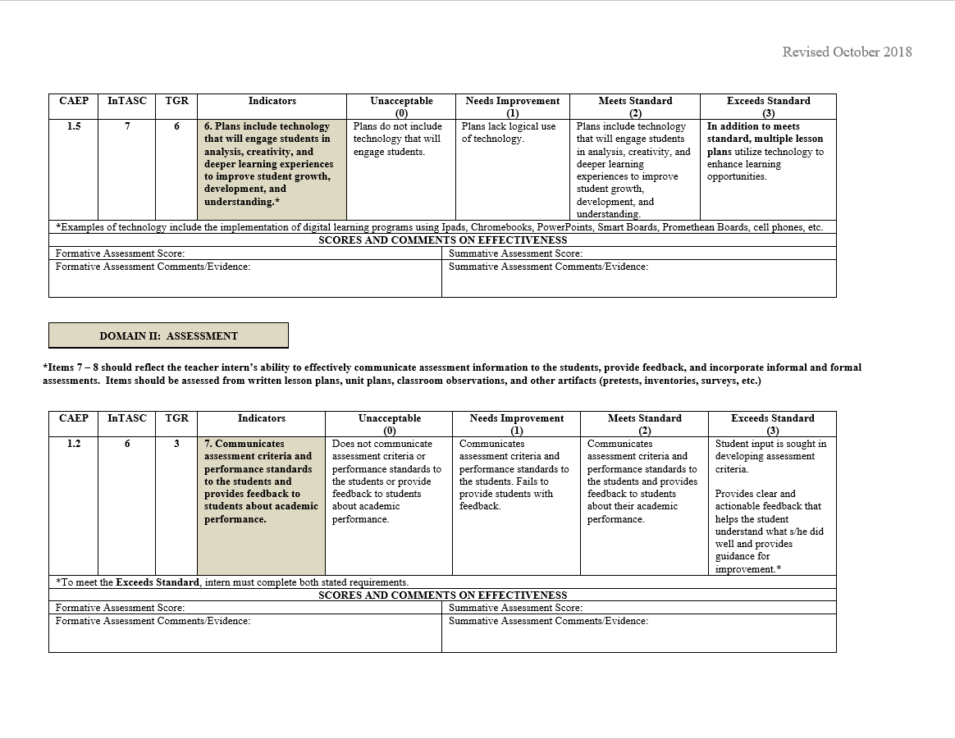

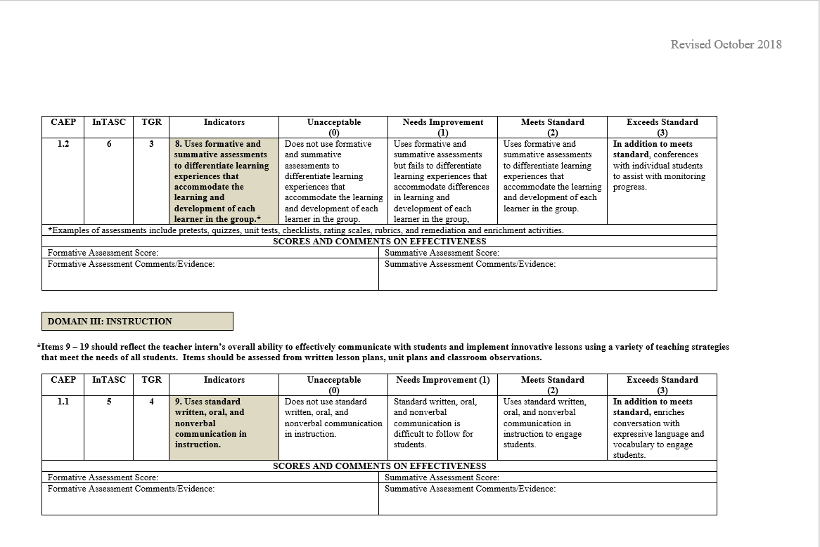
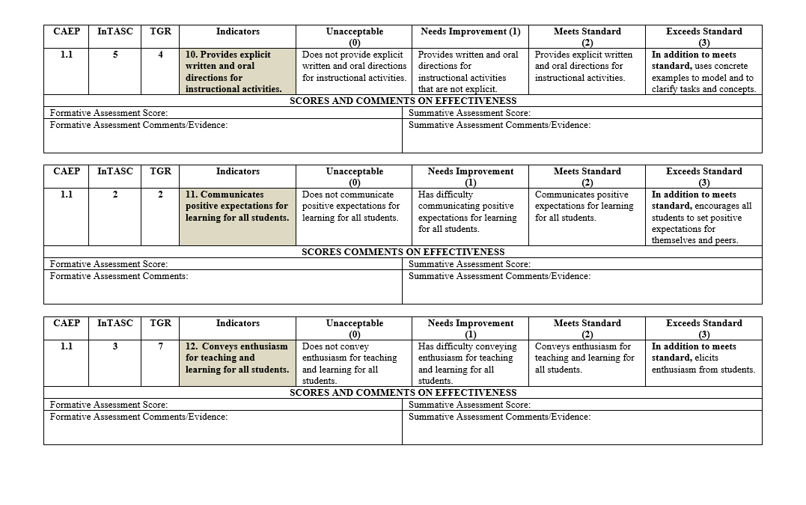
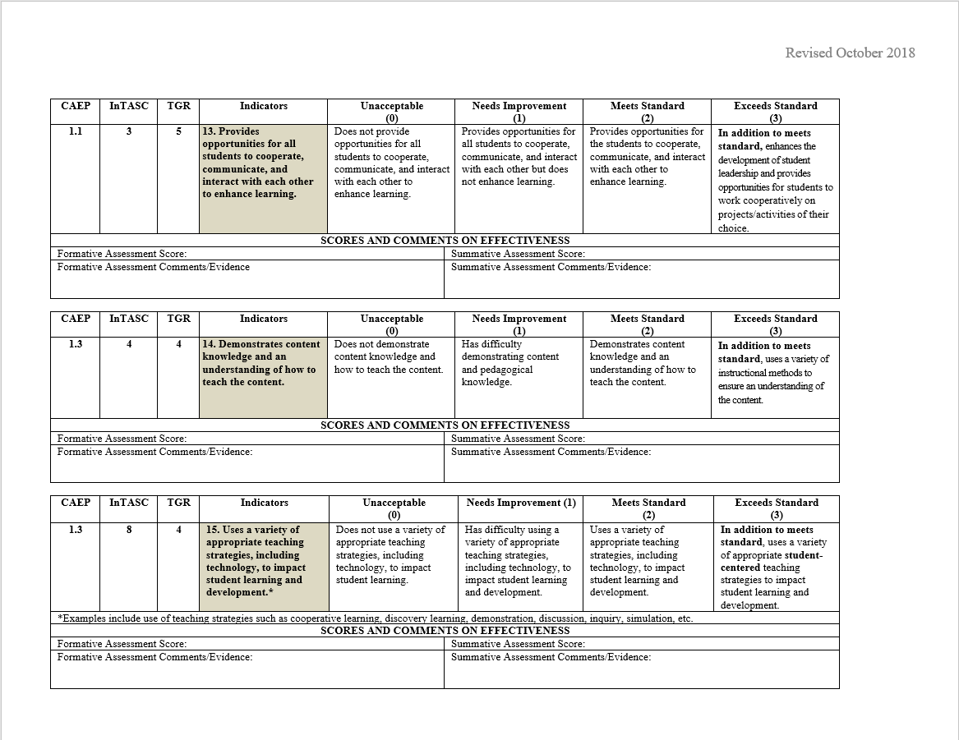
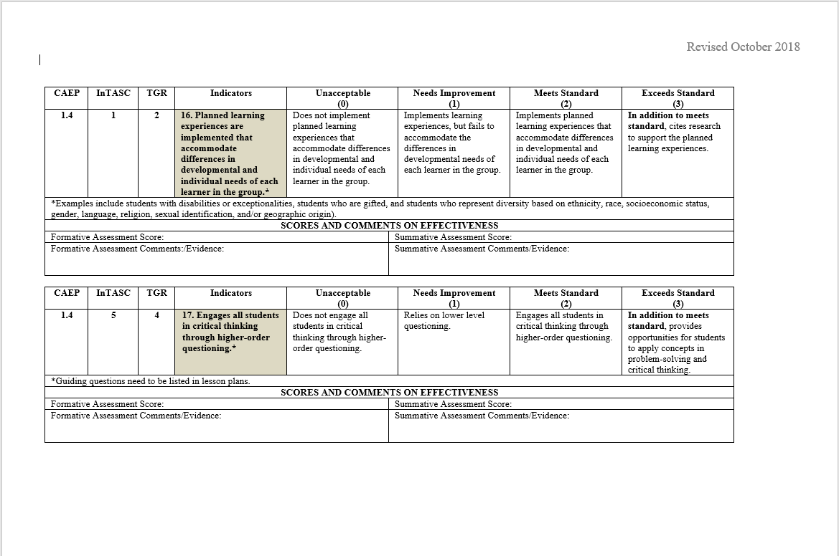
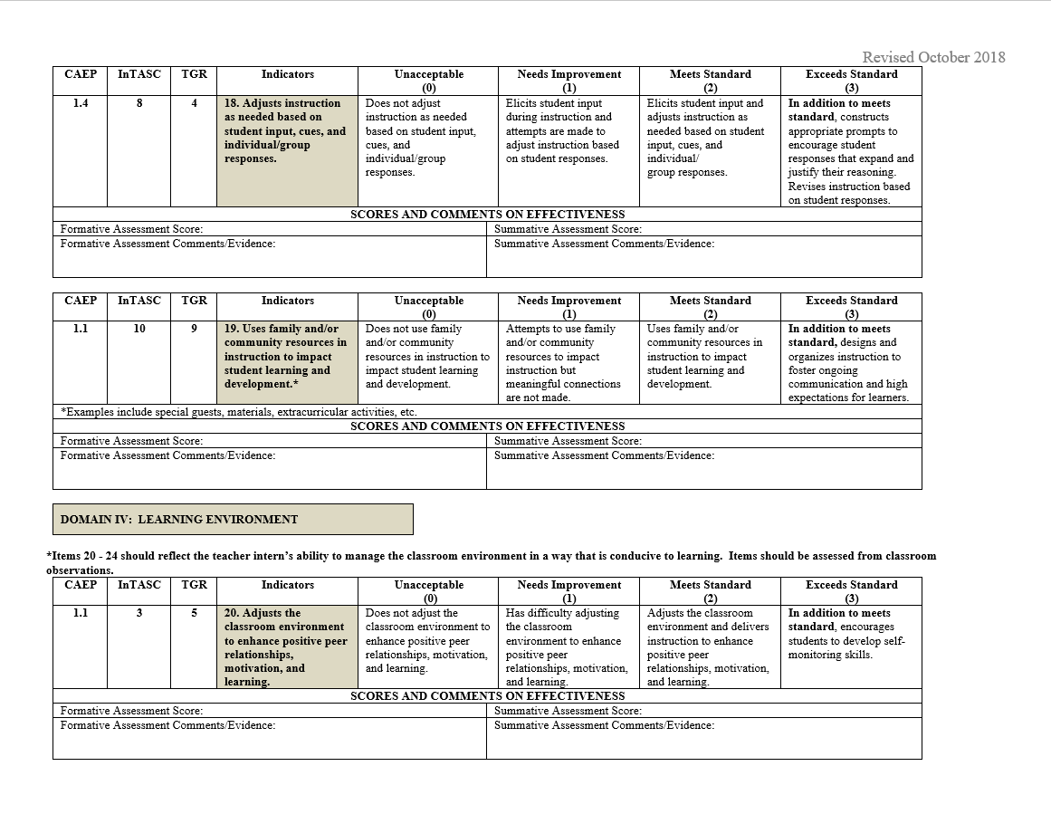
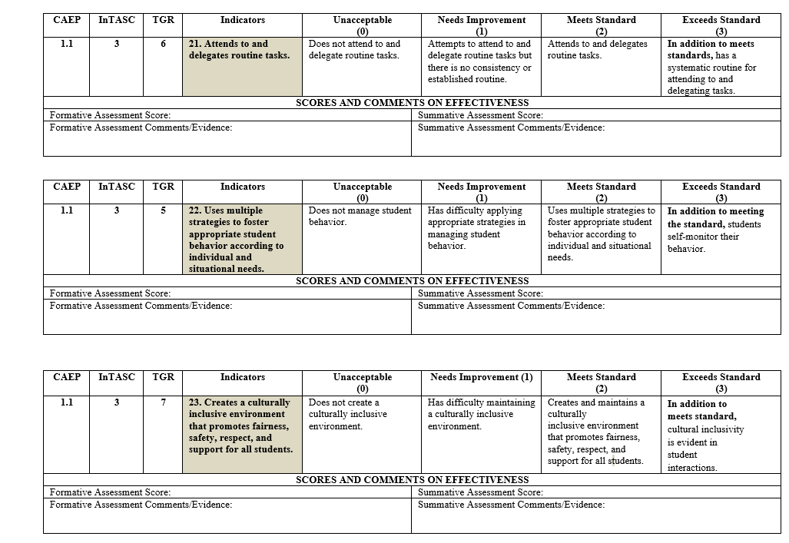
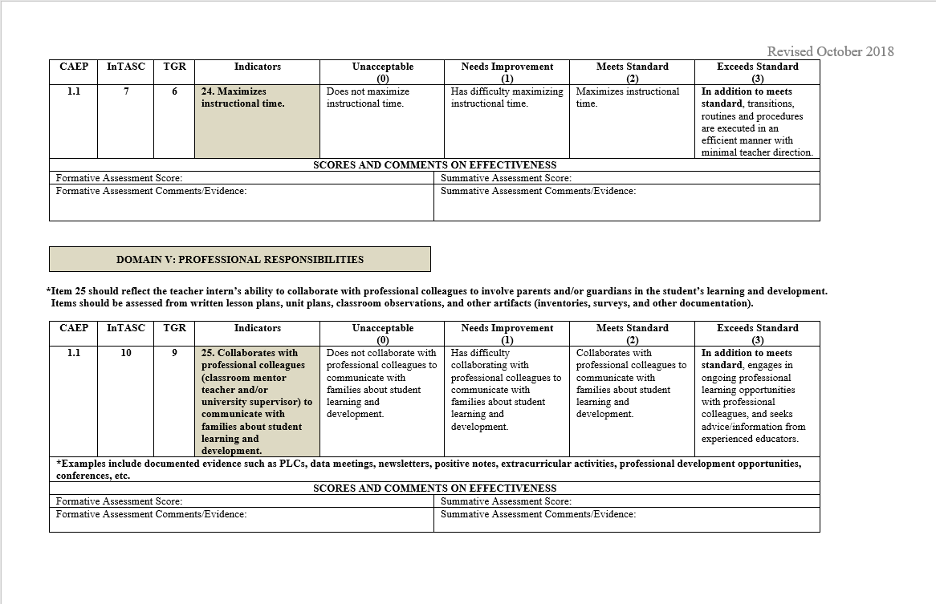
APPENDIX H—MC Teacher Education Dispositions Evaluation

Mississippi College Teacher Education Dispositions Evaluation
Directions: Each semester a teacher candidate is enrolled in an EDU course, he/she will complete this rubric as an overall assessment of their knowledge, skills, and dispositions in teacher education and
Candidate Name ___________________________________ Date of Evaluation__________________ Course Number___________Course Name(s)________________________ Instructor ______________ Current Semester_______________Major _____________________Advisor_____________________
preparation. Upon completion and submission of the rubric, course instructors will review and provide feedback. A conference between the instructor and candidate will be planned for improving those areas where the candidate rates unacceptable from instructor or self-evaluation.
Ratings are based upon class meetings, assignments, appointments, group work and clinical experiences.
Indicators | Unacceptable (1) | Expected (2) | Above Expectations (3) | N/A | SCORE
I. PROFESSIONALISM
1. Responsibilities | Candidate submits incomplete  assignments/projects or  assignments/projects are not submitted by the established deadlines. | Candidate submits all completed  assignments/projects by the established deadlines. | In addition to expected, candidate regularly exceeds minimal criteria involved in assignments/projects and/or precedes established deadlines.
2. Attendance & Punctuality  MC Policy 2.10 | Candidate is absent for 25% or more of scheduled class time or field experience (including tardies and early departures). | Candidate is absent 1% - 24% of scheduled class time or field experience (including tardies and early departures). | In addition to expected, candidate is absent 0% of scheduled class time or field  experience (including tardies and early departures).
3. Professional  Appearance | Candidate does not dress appropriately for the classroom environment and field experiences or demonstrates poor personal hygiene. | Candidate dresses appropriately for the classroom environment and field experiences and demonstrates proper personal hygiene. | In addition to expected, candidate dresses professionally for the classroom  environment and field experiences and demonstrates proper personal hygiene.
4. Demeanor | Candidate lacks confidence or displays a critical or negative attitude and may have a negative effect on the learning environment. | Candidate is generally self-confident and displays a positive and agreeable attitude. | In addition to expected, candidate is self confident and is a positive influence on others and the learning environment.
5. Initiative | Candidate seldom volunteers for tasks, exhibits little energy, enthusiasm, or effort. | Candidate generates and pursues  opportunities to expand knowledge, skills, and abilities, makes connections with previous learning and other situations, and asks questions showing intellectual interests. | In addition to expected, candidate  volunteers for tasks, seeks to extend understanding through higher level thinking, and seeks opportunities for continual improvement and change.
6. Integrity | Candidate speaks or behaves  inappropriately with others and lacks respect for confidentiality (including social media). | Candidate speaks and behaves appropriately with others and maintains confidentiality (including social media). | In addition to expected, candidate keeps all school matters confidential in the classroom and field experience and upholds all standards of the Mississippi Educator Code of Ethics (including social media).
II. TEACHING QUALITIES
7. Organization | Candidate is unprepared, does not have needed materials or resources, and/or utilizes poor time management. | Candidate is prepared for class/field  experiences, has all needed materials or resources, and displays  effective time management. | In addition to expected, candidate plans for class/field experiences proactively by working ahead on future assignments or making alternate plans in the field.

8. Flexibility | Candidate is unwilling to modify ideas, adapt to changes, and/or is not  receptive to the opinions and ideas of others. | Candidate displays a willingness to modify ideas, adapt to changes, and is receptive to the opinions and ideas of others. | In addition to expected, candidate seeks out and makes innovative changes with ease.
9. Communication | Candidate does not use effective oral or written communication, or tone of communication is not professional, or language is informal/ inappropriate. | Candidate uses effective oral and written communication that is clear and professional with correct spelling and grammar. | In addition to expected, candidate uses an extensive vocabulary appropriate for the intended audience.
10. Diversity | Candidate is exclusive or displays inappropriate behaviors toward diverse peers or students (e.g. ethnicity, race, cultural, gender, SES, language,  disability, ability level, etc.) | Candidate is inclusive and displays appropriate behaviors toward diverse peers or students (e.g. ethnicity, race, culture, gender, SES, language, disability, ability level, etc.) | In addition to expected, candidate models behaviors that show evidence of reflection and efforts to learn from peers’ or students’ diversities.
11. Leadership | Candidate does not display  characteristics of leadership when appropriate including committing to tasks, showing confidence and  enthusiasm, offering suggestions, or contributing useful ideas. | Candidate displays characteristics of  leadership when appropriate including committing to tasks, showing confidence and enthusiasm, offering suggestions, and contributing useful ideas. | In addition to expected, candidate makes professional decisions, inspires others, and uses creativity and innovation to enhance the learning environment.
12. Collaboration | Candidate does not work effectively with others by sharing responsibilities, contributing ideas, or problem solving to accomplish common tasks. | Candidate works effectively with others by sharing responsibilities, contributing ideas, and problem solving to accomplish common tasks. | In addition to expected, candidate  purposefully creates a collaborative atmosphere and engages others in a spirit of teamwork.
III. RELATIONSHIPS WITH OTHERS
13. Cooperation | Candidate demonstrates an inability or unwillingness to work cooperatively with others. | Candidate demonstrates an ability and willingness to work cooperatively with others. | In addition to expected, candidate  consistently works cooperatively with others to create an optimal learning environment.
14. Responsive to Feedback | Candidate rejects or ignores  constructive feedback. | Candidate positively accepts constructive feedback and demonstrates evidence of suggested changes. | In addition to expected, candidate  consistently seeks out constructive feedback from others and proactively refines practice.
15. Rapport | Candidate does not communicate and interact effectively and professionally with others. | Candidate demonstrates an ability to communicate and interact effectively and professionally with others. | In addition to expected, candidate  consistently communicates and interacts effectively and professionally with others, establishes a positive rapport, and exhibits caring and respect.
TOTAL

Instructor’s signature: _____________________________________________ Date:________________________________
Candidate’s signature: _____________________________________________ Date:________________________________
Comments:

APPENDIX I—Final Student Teaching Evaluation
Mississippi College Student Teacher Final Evaluation

Scoring Levels for all Domains | Unacceptable  1 | Needs Improvement  2 | Meets Standard  3 | Exceeds Standards  4
Domain I: Lesson Design
1. Lessons are aligned to standards and represent a coherent sequence of learning  (InTASC 7)  III-Planning for Instruction  SCORE_____ | Include student learning outcomes and instructional activities that:  - Are not aligned to current MS CCRS  - Are not part of a coherent sequence of learning with meaningful connections made to previous and future learning | Include student learning outcomes and instructional activities that:  - Are partially aligned to current MS CCRS  - Are part of an ineffective sequence of learning with few connections made to previous and future learning | Include student learning outcomes and instructional activities that:  - Are fully aligned to current MS CCRS  - Are part of a coherent and focused sequence of learning with meaningful connections made to previous and future learning | Include student learning outcomes and instructional activities that:  - Are fully aligned to current MS CCRS  - Are part of a coherent and focused sequence of learning with meaningful connections made to previous and future learning  - Reflect collaboration with other school staff within and across disciplines to enrich learning
2. Lessons have high levels of learning for all students  (InTASC 1)  I-The Learner and Learning  SCORE_____ | Provide assignments and activities that contain the following components:  - No scaffolding that builds student understanding  - Little or no evidence that the teacher knows each student’s level  - Little or no differentiation based on student’s abilities and learning styles  - Little or no evidence of student-centered learning  - Few connections to students’ prior experiences or learning | Provide assignments and activities that contain the following components:  - Minimal scaffolding that builds student understanding  - Limited evidence that the teacher knows each student’s level and/or tracks each student’s progress toward mastery  - Limited student-centered learning  - Adequate connections to students’ prior experiences or learning | Provide assignments and activities that contain the following components:  - Appropriate scaffolding that effectively builds student understanding  - Ample evidence that the teacher knows each student’s level and tracks each student’s progress toward mastery  - Differentiation based on students’ abilities and learning styles  - Student-centered learning whenever appropriate  - Relevant connections to students’ prior experiences or learning | Provide assignments and activities that contain the following components:  - Appropriate scaffolding that effectively builds student understanding  - Ample evidence that the teacher knows each student’s level and tracks each student’s progress toward mastery  - Differentiation based on students’ abilities and learning styles  - Student-centered learning whenever appropriate  - Relevant connections to students’ prior experiences or learning  - Opportunities for students to choose challenging tasks and instructional materials
Domain II: Student Understanding
3. Assists students in taking responsibility for learning and monitors student learning  InTASC 6  III-Instructional Practice  SCORE_____ | - Communicates the lesson goals and the content in a way that is not accessible to most students  - Inadequately monitors student progress  - Provides inadequate opportunities for students to self-assess and correct their own errors  - Provides students with little or no feedback | - Communicates the lesson goals and the content in a way that is accessible for most students  - Uses formative assessments to adequately monitor student progress  - Provides adequate opportunities for students to self-assess and correct their own errors  - Provides students with adequate feedback | - Communicates the lesson goals and the content in a way that is accessible for every student at his/her level  - Uses formative assessments to effectively monitor student progress  - Provides effective opportunities for students to self-assess and correct their own errors  - Provides students with clear, specific, actionable, and timely feedback  - Creates opportunities for students to apply teacher and peer feedback to improve performance and accelerate learning | - Communicates the lesson goals and the content in a way that is accessible for every student at his/her level  - Uses formative assessments to effectively monitor student progress  - Provides ample and effective opportunities for students to self-assess and correct their own errors  - Provides students with clear, specific, actionable, and timely feedback  - Creates opportunities for students to apply teacher and peer feedback to improve performance and accelerate learning  - Provides opportunities for students to demonstrate connections between what they are learning and how it advances their personal and professional goals/interests

4. Provides multiple ways for students to make meaning of content  (InTASC 5)  II-Content Knowledge  SCORE_____ | Does not move or moves few students to deeper understanding of content through various techniques including:  - A variety of explanations and multiple representations of concepts  - Extended productive discussion  - Effective questioning to support students’ attainment of the learning goals  - Making connections to other content across disciplines  - Independently connecting lesson content to real-world application | Moves most students to deeper understanding of content through various techniques including:  - A variety of explanations and multiple representations of concepts  - Extended productive discussion  - Effective questioning to support students’ attainment of the learning goals  - Making connections to other content across disciplines  - Independently connecting lesson content to real-world application | Moves almost all students to deeper understanding of content through various techniques including:  - A variety of explanations and multiple representations of concepts  - Extended productive discussion  - Effective questioning to support students’ attainment of the learning goals  - Making connections to other content across disciplines  - Independently connecting lesson content to real-world application | Moves all students to deeper understanding of content through various techniques including:  - A variety of explanations and multiple representations of concepts  - Extended productive discussion  - Effective questioning to support students’ attainment of the learning goals  - Making connections to other content across disciplines  - Independently connecting lesson content to real-world application
Domain III: Culture and Learning Environment
5. Manages a learning-focused classroom community  (InTASC 8)  III-Instructional Practice  SCORE_____ | - Creates inadequate and/or inconsistent routines and expectations for students to voice opinions and ask and answer questions  - Inadequately monitors student behavior  - Provides inadequate collaborative learning opportunities for students  - Ensures some or few students are active participants in their learning | - Creates adequate routines and expectations for students to safely voice opinions and ask and answer questions  - Adequately monitors student behavior  - Provides adequate collaborative learning opportunities for students  - Ensures most students are active participants in their learning | - Creates effective routines and expectations for students to safely voice opinions and ask and answer questions  - Proactively monitors student behavior and redirects when necessary to maximize instructional time  - Provides effective collaborative learning opportunities whenever appropriate  - Ensures all or almost all students are active participants in their learning | - Creates effective routines and expectations for students to safely voice opinions and ask and answer questions  - Proactively monitors student behavior and redirects when necessary to maximize instructional time  - Provides effective collaborative learning opportunities whenever appropriate  - Ensures students take ownership of their work and are active participants in their learning  - Provides opportunities for students to take on academic leadership roles that promote learning
6. Manages classroom space, time, and resources (including technology when appropriate) effectively for student learning  (InTASC 3)  I-The Learner and Learning  SCORE_____ | - Inadequately uses physical space or resources (including technology whenever appropriate) in support of student learning  - Allows significant periods of time when students do not have something meaningful to do  - Creates an environment where students do not execute transitions, routines, and procedures in an orderly and efficient manner | - Adequately uses physical space or resources (including technology whenever appropriate) in support of student learning  - Allows brief periods of time when students do not have something meaningful to do  - Creates an environment where students execute transitions, routines, and procedures in an orderly and efficient manner only some of the time and require substantial direction from the teacher | - Effectively maximizes use of physical space and resources (including technology whenever appropriate) in support of student learning  - Maximizes time such that students always have something meaningful to do  - Creates an environment where students execute transitions, routines, and procedures in an orderly and efficient manner most of the time, though they may require some direction from the teacher | - Effectively maximizes use of physical space and resources (including technology whenever appropriate) in support of student learning  - Maximizes time such that students always have something meaningful to do  - Creates an environment where students execute transitions, routines, and procedures in an orderly and efficient manner with minimal direction or narration from the teacher  - Provides opportunities for students to share responsibility for leading classroom routines and/or procedures
7. Creates and maintains a classroom of respect for all students  (InTASC 2)  I-The Learner and Learning  SCORE_____ | - Often communicates disrespectfully with students  - Does not foster respectful relationships among students  - Does not demonstrate a strong positive relationship with students | - Communicates respectfully to students with rare exceptions  - Fosters respectful relationships among some students but not others  - Demonstrates a strong positive relationship with some students but not others | - Communicates respectfully to all students  - Effectively fosters respectful relationships among all students  - Demonstrates a strong positive relationship with all students | - Communicates respectfully to all students  - Effectively fosters respectful relationships among all students  - Demonstrates a strong positive relationship with all students  - Fosters a classroom culture where students give unsolicited praise or encouragement to their peers

Domain IV: Professional Responsibilities
8. Engages in professional learning  (InTASC 9)  IV-Professional Responsibility  SCORE_____ | - Participates in required professional learning activities  - Does not apply knowledge gained from professional learning  - Applies little to no observer feedback to improve teaching practice | - Participates in required professional learning activities  - Applies knowledge gained from professional learning but does not fully integrate the new information  - Applies some observer feedback to improve teaching practice | - Proactively seeks out and participates in professional learning activities  - Fully integrates knowledge gained in professional learning communities, collaboration with peers and leadership, and focused professional development  - Strengthens teaching practice based on observer feedback and other types of performance data  - Shares new information and lessons learned with colleagues | - Proactively seeks out and participates in professional learning activities  - Fully integrates knowledge gained in professional learning communities, collaboration with peers and leadership, and focused professional development  - Strengthens teaching practice based on observer feedback and other types of performance data  - Shares new information and lessons learned with colleagues  - Serves as a critical friend for colleagues, both providing and seeking meaningful feedback on instruction
9. Establishes and maintains effective communication with families/guardians  (InTASC 10)  IV-Professional Responsibility  SCORE_____ | - Rarely or never communicates with families/guardians | - Communicates with families/guardians reactively concerning student academic progress and development, and outreach is mostly for intervention or corrective reasons | - Partners with families/guardians to coordinate learning between home and school  - Establishes mutual expectations for student learning with families/guardians | - Partners with families/guardians to coordinate learning between home and school  - Establishes mutual expectations for student learning with family/guardians  - Includes students and/or families/guardians in the planning of positive reinforcements for progress
Final Student Teaching Evaluation

TOTAL SCORE______

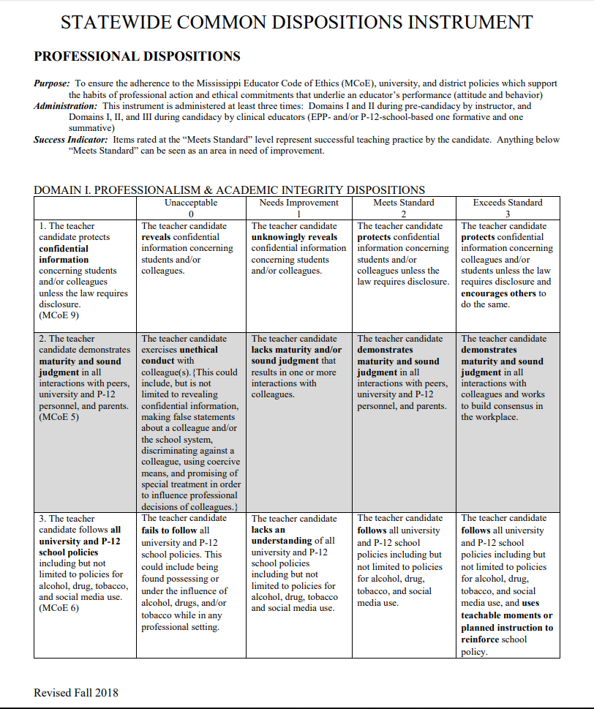
APPENDIX I—Statewide Common Dispositions Instrument

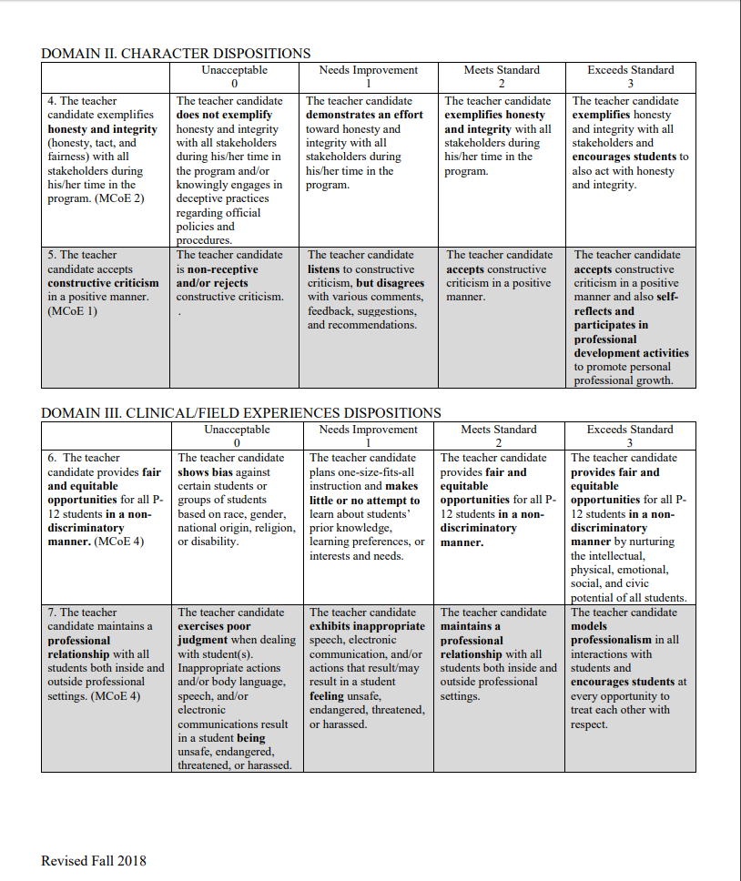
APPENDIX K—University Supervisor Evaluation of Cooperating Teacher
UNIVERSITY SUPERVISOR ANALYSIS OF COOPERATING TEACHER
Name of Cooperating Teacher Semester & Year______________

Above, please indicate the Cooperating Teacher who was responsible for your student teacher. Below, supply the information concerning him/her by responding to each item for which you have a reasonable basis to make a judgment. Circle the appropriate indicator on each scale.

1. How many times did the Cooperating Teacher visit and confer with you during the student teaching experience?
0 1 2 3 4 5 More
Comments

2. To what extent were you satisfied with the assistance provided by the Cooperating Teacher?
Dissatisfied 1 2 3 4 5 6 7 8 Well Satisfied
Comments

3. To what extent did the Cooperating Teacher make instructions clear to you concerning the student teaching procedures?
Poorly Done 1 2 3 4 5 6 7 8 Well Done
Comments

5. Indicate how much assistance you believe the Cooperating Teacher provided the student teacher.
None 1 2 3 4 5 6 7 8 A Great Deal
Comments

6. In as much as you are able, characterize the Cooperating Teacher ability to analyze the teaching-learning situation.
Minimal 1 2 3 4 5 6 7 8 Perceptive
Comments

Thank you for working with our Student Teacher. Feel free to make suggestions and constructive criticisms of the MC student teaching program on the back of this page. Complete and return this form to the above address.

Your name:_____________________________ Date_____________________

APPENDIX L—Cooperating Teacher Evaluation of University Supervisor
COOPERATING TEACHER ANALYSIS OF UNIVERSITY SUPERVISOR
Name of University Supervisor___________________Semester & Year______________
Above, please indicate the University Supervisor who was responsible for your student teacher. Below, supply the information concerning him/her by responding to each item for which you have a reasonable basis to make a judgment. Circle the appropriate indicator on each scale.

1. How many times did the University Supervisor visit and confer with you during the student teaching experience?
0 1 2 3 4 5 More
Comments

2. In terms of clock hours/minutes, how long was the average observation time spent in the classroom by the University Supervisor?
15 minutes 30 minutes 1 hour 1hr.15min. 1hr.30min. More
Comments

3. To what extent were you satisfied with the assistance provided by the University
Supervisor?
Dissatisfied 1 2 3 4 5 6 7 8 Well Satisfied
Comments

4. To what extent did the University Supervisor make instructions clear to you concerning the student teaching procedures?
Poorly Done 1 2 3 4 5 6 7 8 Well Done
Comments

5. Indicate how much assistance you believe the University Supervisor provided the student teacher.
None 1 2 3 4 5 6 7 8 A Great Deal
Comments

6. In as much as you are able, characterize the University Supervisor’s ability to analyze the teaching-learning situation.
Minimal 1 2 3 4 5 6 7 8 Perceptive
Comments

Thank you for working with our Student Teacher. Feel free to make suggestions and constructive criticisms of the MC student teaching program on the back of this page.

Your name:_____________________________ Date_____________________
APPENDIX M—Student Teacher Evaluation of University Supervisor
STUDENT TEACHER ANALYSIS OF UNIVERSITY SUPERVISOR

Name of University Supervisor_____________________Semester & Year___________

Above, please indicate your University Supervisor during student teaching. Below, supply the information requested concerning him/her by responding to each item. Circle the appropriate indicator on each scale.
1. How many total visits did your University Supervisor make to your school while you were student teaching (include conferences, information, observations, TIAI, etc.)?
0 1 2 3 4 5 More
Comments

2. On how many visits did your University Supervisor observe you in a teaching situation?
0 1 2 3 4 5 More
Comments

3. How many times did your University Supervisor confer with you following an observation visit (at school or later)?
0 1 2 3 4 5 More
Comments

4. Did your University Supervisor maintain an attitude of friendly helpfulness and encouragement?
Seldom 1 2 3 4 5 6 7 8 9 Regularly
Comments

5. Did your University Supervisor suggest activities or outline materials that enhanced your student teaching experiences?
Seldom 1 2 3 4 5 6 7 8 9 Regularly
Comments

6. Did your University Supervisor maintain an appropriate personal appearance and professional manner?
Seldom 1 2 3 4 5 6 7 8 9 Regularly
Comments

7. Did your University Supervisor make a fair and continuing assessment of your student teaching?
Seldom 1 2 3 4 5 6 7 8 9 Regularly
You may make additional comments concerning the Mississippi College Student Teaching Program on the back of this sheet. Complete and return this form to the above address.
Your name (optional) Date ________________________
APPENDIX N—Student Teacher Evaluation of Cooperating Teacher
Student Teacher Evaluation of Cooperating teacher
Artifact Details

Directions: Please rate the cooperating teacher using the following scale:
5 – Exceeds Standard: the cooperating teacher performed in a highly consistent manner or demonstrated the item at a very high standard.
3 – Meets Standard: the cooperating teacher usually performed the item and showed no weaknesses.
1 – Below Standard: the cooperating teacher did not perform the item consistently and showed several weaknesses addressed in the item.
Title*
Description
 | 5 – Exceeds Standard | 3 – Meets Standard | 1 – Below Standard
1.The cooperating teacher willingly oriented me to the classroom and took time to explain classroom routines, rules, and teaching practices early in the clinical experience.
2. The cooperating teacher provided guidance with lesson planning.
3.The cooperating teacher reviewed my lesson plans and gave constructive recommendations that were helpful, supportive, and encouraging.
4.The cooperating teacher provided constructive and helpful feedback on the lessons I taught.
5. The cooperating teacher provided a positive role model professionally and personally.
6. The cooperating teacher was available either in person, by phone, or through e-mail for consultations.

This Professional Dispositions Infraction Process was originally developed by the faculty of the Department of Teacher Education at The University of Mississippi. Mississippi College gratefully acknowledges permission received from the Department of Teacher Education at the University of Mississippi to use this process with our teacher candidates in the Department of Teacher Education & Leadership at Mississippi College.

