STEPS FOR STUDENTS TO ACCEPT THEIR LOANS IN BANNER WEB

- Login in to Banner Web and click on the Financial Aid tab.
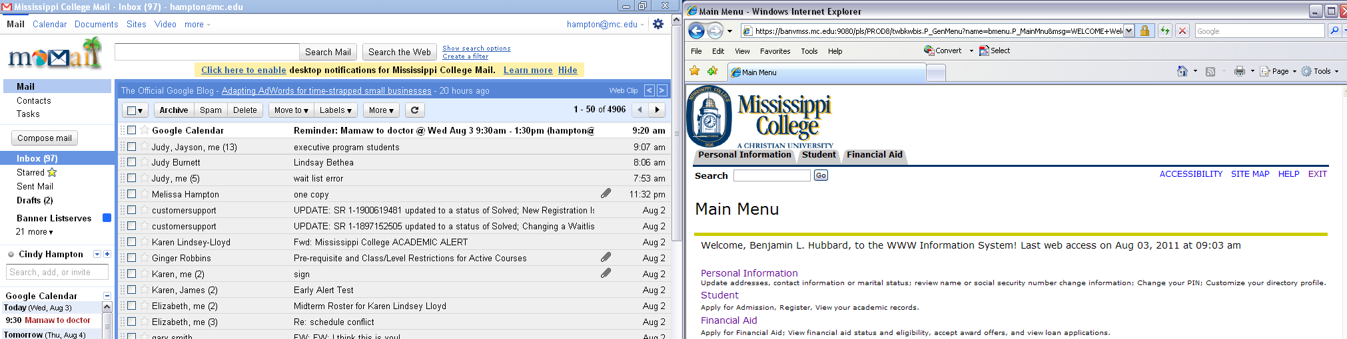

2)Choose the Award option from the menu
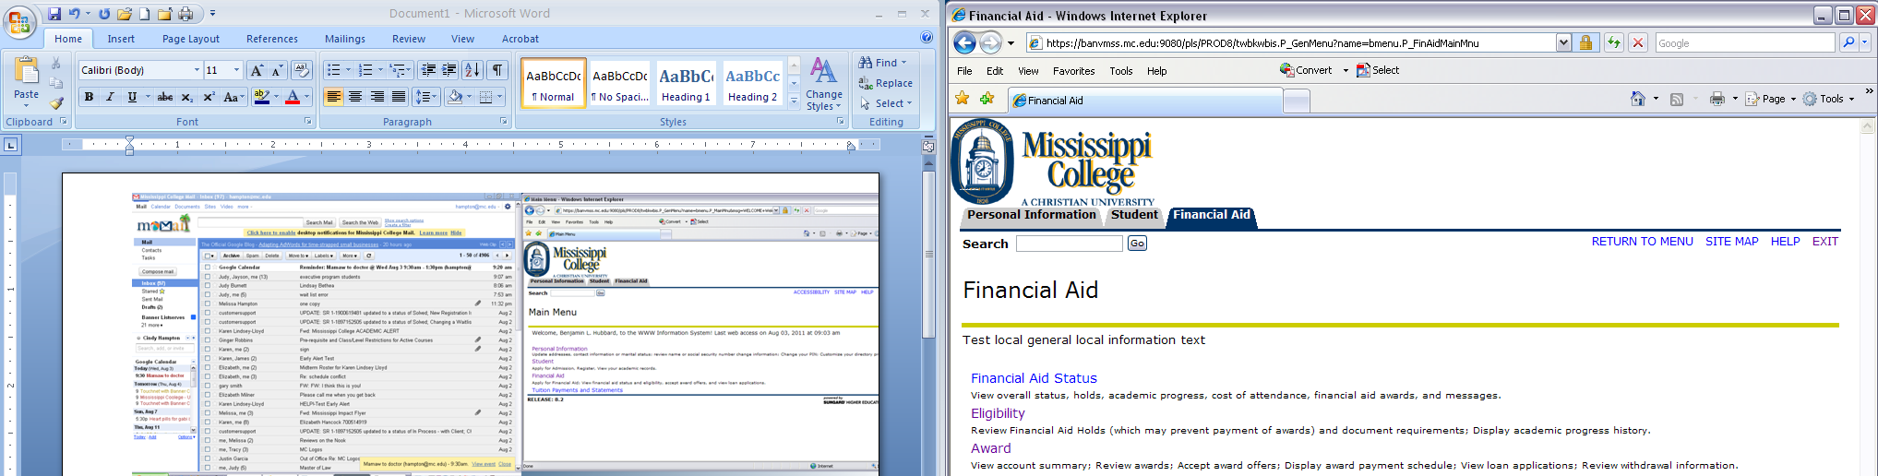

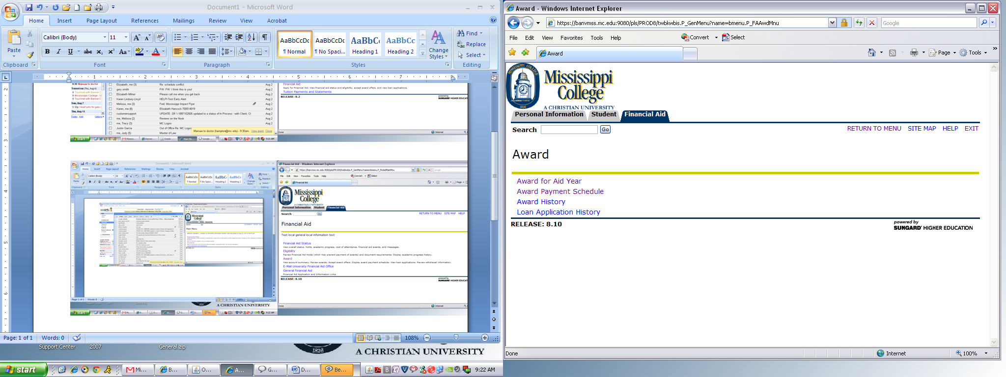
3)Choose the Award for Aid Year option

4)Choose the correct Aid Year from the drop down list. Click Submit button

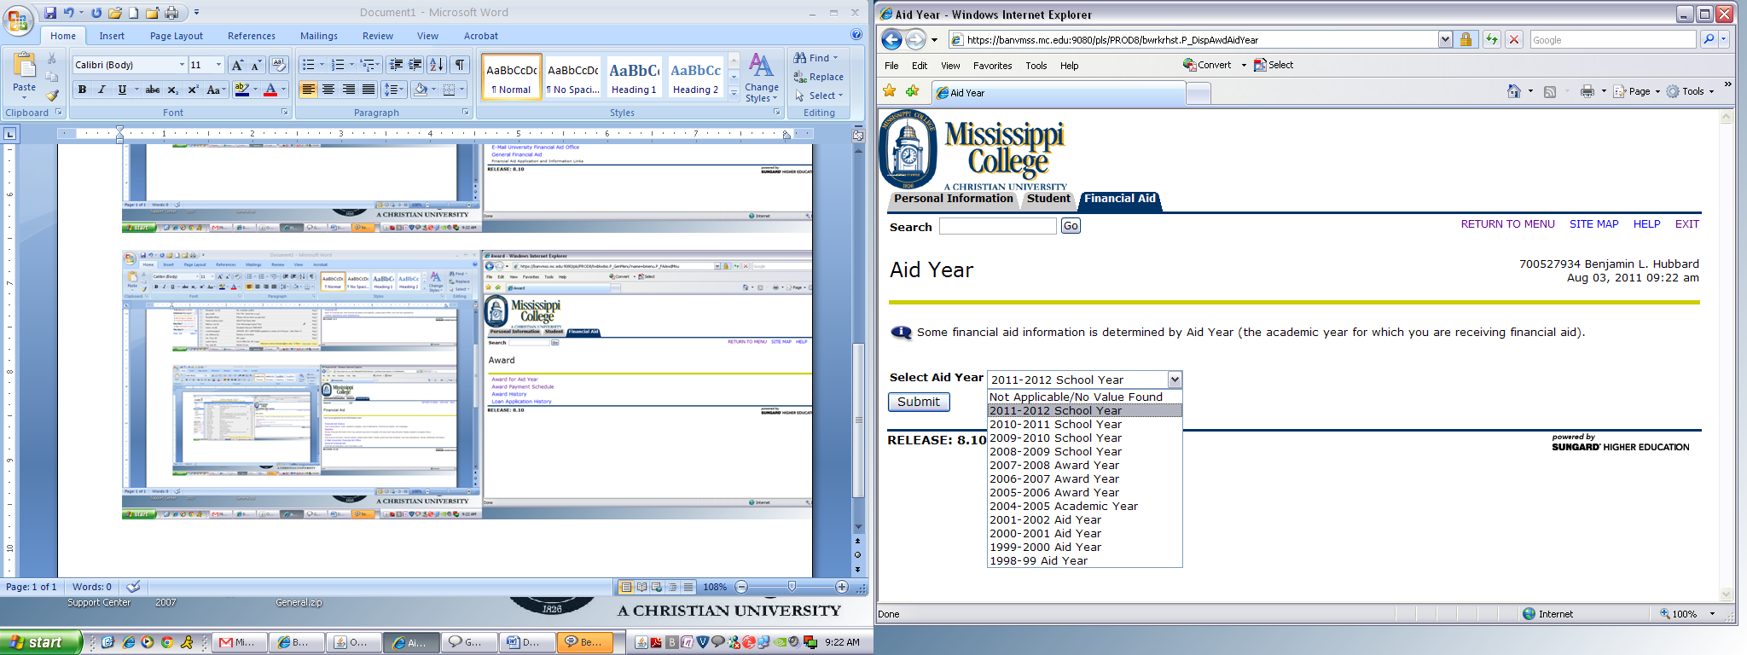

5)Click on the Accept Award Offer tab.
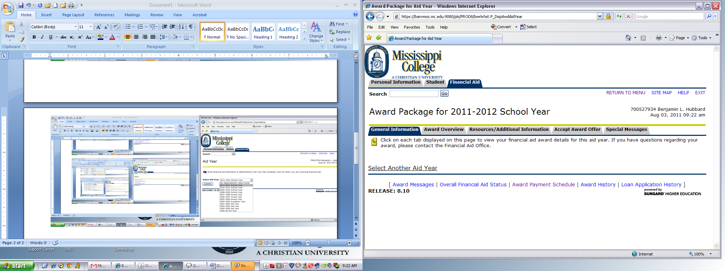

6) Student will be able to Accept or Decline their awards on this screen. Also, can accept only
partial amount if they choose.
