International Student Personal Safety Guide

Contents
General Safety Tips 3
Protect Yourself 3
General Principles 3
Safety when On Foot (Walking, Jogging, Running) 4
SAFETY WHEN ON A BIKE 4
Safety in Your Residence Hall 5
Considering moving off-campus? 5
SAFETY IN APARTMENTS & HOMES 6
If you live off campus and are leaving for vacation 6
SAFETY WITH MOTOR VEHICLES 7
Road Rage 8
SAFETY IN A DIGITAL WORLD 8
Identity Theft 8
If Your Identity Is Stolen 9
How Identity Theft Is Committed 9
CYBER SECURITY 9
Automatic teller machines 10
Computer scams 10
Cell phone protection 10
Con Artists 11
Active shooter 11
IF YOU ARE ATTACKED 11
If you are a victim of sexual assault or rape 12
Dating safety 12
Online dating 12
Helping a crime victim 13
HOW TO DESCRIBE A SUSPECT OR A VEHICLE 13

General Safety Tips

Below are a series of tips designed to limit risk in different situations you may encounter while studying at Mississippi College and living in the Clinton/Jackson Area. If you find yourself in a life-threatening situation, dial 9-1-1 immediately.

Protect Yourself

The best time to plan your response to a crime is before it occurs. Consider your options and abilities; think about how you will act if threatened. What items do you normally carry that have self-defense potential? Remember that nothing you own is worth getting hurt over. If you're in danger, do anything you can to escape and call for help.

If you sense a potential threat, consider your options and take action immediately to get away from danger.
- Yell or scream; attract attention. Yell, "Call the police!" and run toward a lighted public area.
- Go into an open business or building and call for help.
- Call 9-1-1 if you are in immediate danger.
- If you are facing an armed criminal, you may minimize the risk of injury to yourself if you comply with the criminal's demands. However, if your life is in immediate danger, use any defense you can to get away.
- When you're on campus call Campus Security at (601) 925-3911. Program the number into your personal cell phone. Describe what happened and where. Give a detailed description of the suspect, as well as a description of any vehicle involved and its license number. Tell the operator which direction the person went, as well as any other pertinent information.

General Principles

- Always stay alert to your surroundings and avoid locations/situations that make you more vulnerable to crime such as alleys or dark parking lots.
- Avoid distractions that decrease your awareness level, for example, talking on a cell phone or wearing headphones.
- Walk with a purpose to communicate a message of confidence. Make eye contact with people, however do not engage in conversation with strangers on the street.
- Travel with others. Walking in a group decreases your chances of becoming a victim.
- Stay in well-lighted areas and avoid short-cuts through deserted areas.
- Avoid displaying large amounts of cash or other tempting items, such as expensive jewelry and clothing.
- Always trust your instincts. If a person or place makes you uneasy, leave.
- Learn where the campus emergency telephones (Blue Light Telephones) are located on campus and learn how to use them.
- Ensure that you are subscribed to MC Alert, the campus mass notification system on campus.

Safety when On Foot (Walking, Jogging, Running)

- Avoid walking alone at night. On-campus you can call Campus Public Safety at (601) 925-3204 and request a safety escort. Always walk with a friend whenever possible. Keep in mind that, on a small campus like MC, odds are that someone else is leaving within a few minutes and is headed in the same direction. Just ask!
- Routinely change your route and schedule.
- If you think someone is following you, cross the street, walk faster, or even walk down the middle of the street. Try to go to a lighted area, a store, or a group of people.
- Do not overload yourself with packages, books, or other things.
- Walk near the curb, facing traffic, and use the safest, lighted routes to your destination. Avoid alleys, parks, vacant lots, and dark parking areas.
- Wear clothes and shoes that allow you to move quickly.
- Avoid wearing headsets that impair your ability to detect and respond to potentially dangerous situations.
- Walk with purpose, keep your eyes up, and scan your surroundings. Make eye contact with others.
- Carry a noise-making device with you at all times, and use it if you suspect you are in danger.
- Anticipate potentially dangerous situations.
- At night, wear bright colors to improve your visibility. Avoid bushes where a person could hide. Take a key with you; do not leave your house or room unlocked; someone could be watching to see when you are not home. Carry identification. Don't wear jewelry or carry cash.
- If your purse is snatched, don't fight. Give it up rather than risk injury. It won't be a great loss if you carry no more cash than is absolutely necessary and keep a list at home of all credit cards, licenses, etc.

SAFETY WHEN ON A BIKE

- Use a bike light when riding a bicycle at night.
- Wear a helmet at all times when riding a bicycle.
- Obey all traffic laws; you must stop at intersections; pedestrians have the right of way.
- Pay attention to your surroundings; warn pedestrians when you are passing them.
- Take extra care when passing parking lot exits or driving through parking lots.
- Give proper hand signals when turning or stopping.
- Before leaving a lane, give a hand signal. Leave the lane only when safe to do so.
- Secure your bicycle with a heavy duty U-lock or chain. When possible, lock at least your front wheel and frame to a bike rack or other stationary object.
- Do not park your bicycle in a doorway, on stairs, or blocking any handicapped access. Use a bike rack.
- Engrave or permanently mark your bicycle with an identifying number and record that number with University Police.

Safety in Your Residence Hall

- Never let anyone into the hall unless you positively know they are fellow students or are your personal guests.
- Never prop open outside doors. You'll be placing everyone at risk.
- Keep your door locked when you are inside your room, and make sure it is locked whenever you leave, even if it is only for a few moments. It takes approximately eight seconds for someone to walk into an unattended room and remove something such as a purse or jewelry.
- Never leave handbags, billfolds, jewelry, or other valuables unattended in dorm rooms, showers, or lounges. Put them in a safe place in your room (under lock and key, if possible). Most thieves know to look in the top dresser drawer.
- Try not to leave items of value in your room during vacations and long holidays.
- Do not leave messages announcing your absence. This invites theft.
- Tell a roommate or friend if you are planning to be away overnight or for a few days.
- Report lost or stolen residence hall keys, malfunctioning locks, doors or windows to your residence life staff.
- Get to know your RA, residence life staff and neighbors.

Considering moving off-campus?

- How safe will your commute be to campus (personal vehicle, shuttle service, etc.)?
- Do security/police patrol the grounds/buildings?
- Is an intercom system used or are peep holes installed in doors?
- Are there emergency phones?
- Are adjacent properties maintained?
- How secure are the locks/doors?
- How often are the locks changed?
- Are there dead bolt locks on the exterior doors?
- Is parking adequate and safe?
- Are there secluded or dark areas near the buildings?
- Is there an adequate fire safety detection and evacuation system in place?

SAFETY IN APARTMENTS & HOMES

- Lock all doors and windows, even when you are only going to be away for a short while. If at all possible, keep doors and windows closed when home alone, and certainly while asleep. Criminals look for houses with the easiest entry.
- Acknowledge all callers through locked doors. Before opening an exterior door to your home, know who is at the door and do not open the door to an unexpected visitor.
- Do not leave your wallet, purse, credit cards, cash, checkbook, or other valuables in the open.
- Never prop open exterior doors. If you see a door propped, close it.
- Never leave a house key hidden outside your home.
- Don't allow people you do not know to "tailgate" behind you into your apartment building. Every person who is authorized to be in your building should have a key.
- If you see a suspicious person, notify apartment management or dial 9-1-1.
- The most common residential crimes are burglaries. Violence can result when residents return home during a burglary. If you come home and believe someone has unlawfully entered your apartment, DO NOT GO INSIDE. Go to a safe place and call 9-1-1 and then notify apartment management or home owner.
- Immediately report or repair any building security problems (broken locks, burned-out lights).

Remember! Awareness is the key to your safety. A burglary is reported every 15 seconds in the United States. The U.S. Department of Justice defines household burglary as “unlawful entry or attempted entry of a residence.” This crime usually, but not always, involves theft. Of all the major criminal offenses, residential burglary is the most common. By following these simple steps, you can reduce the possibility that your home will be targeted.

Remember:

- Choose a reputable, well established alarm company.
- Set the alarm system at night and when away from your residence.
- Do not write your alarm code or password on or near the alarm keypad.
- Put a warning sign on windows and entrances to notify possible intruders you have an alarm.

If you live off campus and are leaving for vacation
- Lock doors and windows securely.
- Make your house/apartment looks occupied; have a friend or neighbor pick up your mail and newspapers, set televisions and lights on timers, leave your blinds, shades, and curtains in their normal positions, and keep your lawn mowed and watered.
- Leave your vacation phone number, address, and itinerary with a trusted friend so you can be reached in case of an emergency.

SAFETY WITH MOTOR VEHICLES

- Park in well lighted areas, where your vehicle is visible; avoid parking next to vans or trucks.
- Keep all items out of sight, especially valuables. Remove or place CD players/cases, etc. in the truck.
- Service your vehicle regularly to avoid breakdowns.
- Keep your vehicle locked at all times.
- When leaving your car for service, remove your other keys.
- Have your key ready when you approach your car. Before getting in, check inside and under your car to make sure no one is hiding.
- If you believe you are being followed by another car, do not lead them to your residence or parking lot. Attempt to locate an open business, or drive until you see a police car and honk your horn and lights to attract attention. Try to obtain the license number of the other vehicle to give to the police.
- Don’t lose your life or the life of a passenger by becoming involved in ROAD RAGE.
- Carry a cell phone.
- Never let fuel level get below ¼ tank.
- Drive on well-traveled streets and keep your car in gear while it is stopped.
- Allow at least one car length space between your car and the car in front of you so that you can escape should someone try to get into your car.
- Always be aware of your surroundings and check your rear view mirror often.
- Keep doors locked and windows shut and keep valuables out of sight; either covered or in the trunk.
- If your car breaks down, open the hood and stay inside. If someone stops to help, do not open your window or door, but have him or her call for assistance.
- If you do not know the location of your destination, ask someone for specific directions before you leave.
- If you get lost, do not pull over until you find a well-lit public area, and then call the police.
- Always carry an emergency kit in your vehicle with first aid supplies, flares, flashlight, jumper cables, blanket, etc.
- Beware of people who may bump your vehicle from behind; if you think you were bumped intentionally, signal the other person to follow you to the nearest police station.
- If a person with a weapon confronts you and wants your vehicle, give it up. No car is worth being injured or losing your life over.

Road Rage

- Stay cool; don't react to provocation.
- Distance yourself from drivers behaving erratically.
- Be polite and courteous, even if the other driver isn't.
- Avoid all conflict if possible. If another driver challenges you, take a deep breath and get out of the way.
- Lower your stress by allow plenty of time for the trip, listening to soothing music, etc.
- Understand that you can't control the traffic, only your reaction to it.
- Finally, if you are tempted to drive irrationally, ask yourself: "Is it worth being killed? Is it worth going to jail?"

SAFETY IN A DIGITAL WORLD

Be aware of how ID thieves can get your information. They get information from businesses or other institutions by stealing records, bribing employees with access to records, hacking into computers, rummaging through trash, posing as a landlord, employer, or someone else who may have a legal right to the information, stealing credit and debit card numbers as your card is processed by using a special information storage device ("skimming"), stealing wallets and purses containing identification and credit or bank cards, stealing mail, including bank and credit card statements, pre-approved credit offers, new checks, or tax information or completing a "change of address form" to divert your mail to another location.

Identity Theft

- Destroy private records and statements. Destroy credit card statements, solicitations and other documents that contain any private information.
- Secure your mail. Empty your mailbox quickly, lock it or get a P.O. Box so criminals don't have a chance to steal credit card offers.
- Safeguard your Social Security number. Never carry your card with you, or any other card that may have your number, like a health insurance card or school issued ID.
- Safeguard your computer. Protect your computer from viruses and spies. Use complicated passwords; frequently update antivirus software and spyware. Surf the Web cautiously. Shop only at trustworthy web sites and be wary of obscure sites or any site you've never used before.
- Know who you're dealing with. Whenever you are contacted, either by phone or email, by individuals identifying themselves as banks, credit card or e-commerce companies and asked for private identity or financial information, do not respond. Legitimate companies do not contact you and ask you to provide personal data such as PINs, user names and passwords or bank account information over the phone or Internet.
- Guard your personal information. Ask questions whenever anyone asks you for personal data. How will the information be used? Why must I provide this data? Ask anyone who does require your Social Security number, for instance, cell phone providers, what their privacy policy is and whether you can arrange for the organization not to share your information with anyone else.
- Use random letters and numbers for passwords; don't use your mother's maiden name, your birth date, your graduation date, your social security number or any other familiar letters or numbers that can be associated with you as passwords.

If Your Identity Is Stolen

- File a report with the Police in the community where the identity theft took place.
- Get a copy of the police report in case the bank, credit-card Company, or others need proof of the crime.
- Keep records of everything involved in your efforts to clear up fraud, including copies of written correspondence and records of telephone calls.
- Identity Theft is a common term used for all types of crime in which someone wrongfully obtains and uses another person’s personal data in some manner that involved fraud or deception, usually for economic gain. Identity theft is one of the fastest growing crimes in America

How Identity Theft Is Committed

- Shoulder Surfing - Watching you punch in telephone calling card, credit card, ATM numbers.
- Business Record Theft - Stealing personal files from businesses or institutions where you are a customer, patient, employee etc.
- Scamming - Posing as a legitimate company or government agency to obtain your personal information. This often happens through e-mail.
- Phone Fraud - Establishing cellular phone service in someone else's name.
- Skimming - Stealing credit and debit card numbers as the card is being scanned/processed to pay for a purchase, using a special data collection device known as a “skimmer”.
- Dumpster Diving - Going through your trash or the trash of businesses to obtain copies of checks, credit card/bank statements or other records.
- Mail Theft - Stealing mail to get new credit cards, bank or credit card statements, tax information as well as falsifying change of address information.
- Steal Wallet or Purse - Obtaining personal information from the theft of your purse or wallet.
- The Information Highway - Obtaining information that you share over the Internet.
- Spoofing and Phishing - When thieves set up look-alike websites of legitimate businesses and trick consumers into entering their personal information by sending e-mail messages that warn them that their account is about to expire or has been accessed illegally.

CYBER SECURITY

- Never give your password to anyone.
- Change your password frequently.
- Do not allow others access to your email account.
- Monitor your access time; by keeping track of when and how long you were on a computer system, it will be obvious if someone has gained access to your account.
- Be wary of anonymous "re-mailers."
- Do not put personal information or photos on your web page and do not give personal information that can identify where you live to social networking sites.
- Never leave your computer/laptop unattended.
- Engrave markings on your computer.
- Shop online only with companies that you know; check with the Better Business Bureau if unsure.
- Use a secure browser that will encrypt or scramble purchase information or pay with a money order or check.
- Update your virus software regularly, or when new versions are available.
- Do not download files sent to you by strangers or click on hyperlinks from people you don't know.
- Make certain that all your personal information is deleted from your computer prior to disposing of it.
- Monitor your children's internet access and consider installing blocking software.

Automatic teller machines

- Try to use ATMs during daylight hours. If you must go at night, do not go alone.
- Avoid ATMs that are not well lit or clearly visible from the street.
- Be aware of people loitering or sitting in cars around ATMs.
- Prepare your transaction ahead of time. Do not spend much time at the machine.
- Do not give out your Personal Identification Number (PIN) to anyone! Many thieves will attempt to steal your PIN number by calling you on the phone and claiming they are the police, security officers, or bank officers. Memorize it and do not keep a written copy of it in your wallet.
- Either keep your ATM receipt or tear it up and throw it away.
Computer scams
- Computer phishing is a crime. Phishers attempt to fraudulently acquire credit card details and other sensitive personal data via bogus emails or pop-up windows.
- It may look like a legitimate email from a legitimate institution, but beware of unsolicited requests for information.
- Financial or payment institutions will never request that you send them personal sensitive data via email or pop-up windows.
- If you receive a suspicious looking email from any bank, lending, or payment institution, it is best to delete and not respond. If, by coincidence, you have an account with the entity mentioned in the email, call your legitimate institution using the number on your physical bill or via the telephone book or through telephone information.
- Do not call the number that may be listed in the bogus email and do not click on any link listed in the bogus email.

Cell phone protection

- Carry your phone with you whenever possible and make sure it is in a safe place whenever you leave it behind. If you are leaving your phone in your car, be sure it is hidden from view.
- Turn off your phone when you are not using it.
- Use the "lock" feature on your phone.
- Report a stolen cellular telephone immediately to the cellular telephone carrier and Police.
- Check your monthly bills carefully, and report unfamiliar calls to your cellular phone company.

Con Artists

- If a deal sounds too good to be true; it probably is.
- Be wary of any get rich quick scheme that wants you to invest money in advance.
- Never give out your credit card information over the phone unless you made the call.
- Do not buy on the spur of the moment; take time to research the company or product.
- If you are approached by a possible con artist or unauthorized solicitor, report the incident immediately to Public Safety if you are on Campus or to the Police.

Active shooter

One potentially life-threatening situation on college campuses is the possibility of an active shooter. Our Campus Public Safety Officers are trained in responding to this event, and have provided training and information to specifically to respond to the situation. A few key points to keep in mind include:

- Quickly evaluate the situation to decide whether it will be best for you and those who are with you to either run out and get to a safer location or hide out, finding a place in your immediate vicinity that offers more protection as well as options for movement. Leave your belongings behind. Immediately run out or hide out.
- As soon as you are in the safest location possible, call 9-1-1. Tell the dispatcher in as much detail where you are, who and were the shooter is, and any injuries you are aware of.
- If you must hide out, do what you can to stay unnoticed and keep the shooter out: lock the door, turn out the lights, block the door with heavy objects, keep quiet and put cell phones on silent/vibrate.
- If there are two or more people in a space, quickly and quietly plan what to do if the shooter enters your location, and then spread out as much as possible. Do not huddle together. Remain as calm as possible.
- If the shooter enters your space, assume their intentions are lethal and use anything you have at your disposal as a weapon of defense. Yell loudly, throw things at their face, if possible rush the shooter as a group to overcome them.
- Wait for the Police to assist your exit from the building.
a. Follow all instructions by police officers
b. Police may not know if the shooter is hiding among you, therefore police may search you and your belongings and/or do other thing for everyone's safety.

IF YOU ARE ATTACKED

- Go with your instincts, but be realistic about your ability to fight off someone; your instinct may be to run, scream, kick, hit or bite.
- If a weapon is displayed, don't resist. Give up your property and save your life.
- Do what you are told and don't make any sudden moves.
- Try to remember as many details as possible and alert Public Safety or the Police as soon as possible.
- Your goal should be to escape safety and survive; cooperate if you think that resisting may lead to further harm.
- Remember every situation is different; you are the only one who can decide the appropriate course of action.
- Constantly play the "what if" game to think about what you would do in a particular threatening situation. This will help prepare you to respond instinctively when a threat is encountered.
- After an event, never feel guilty about what you did or did not do.

If you are a victim of sexual assault or rape

- Seek help immediately. Do not feel guilty or try to forget what happened; it is a crime and should be reported.
- Get medical attention as soon as possible. Do not shower, wash or change clothing; valuable evidence could be destroyed.
- Seek counseling and support to deal with emotional trauma; Public Safety or the Police will be able to assist with determining the best available resources.
If you think you've been assaulted while under the influence of an unknown drug (GHB, etc.) seek help immediately. Try not to urinate before providing a urine sample and if possible collect any glasses that you drank from.

Dating safety

- Check out a first date or blind date with friends first. Better yet, go with other friends on your first date.
- Carry money for a taxi or public transportation in case your date is cut short; bring a cell phone also.
- Know what you want sexually and don't send mixed messages.
- Trust your instincts about situations to avoid.
- Be clear and responsible in your communications with others.
- Be forceful, firm and assertive.
- If you go out with other friends, don't get separated; watch out for each other.
- Do not lose self control or impair your judgment by the use or abuse of alcohol or drugs. "No" means "NO."
- If someone is unable to give consent it is called sexual assault or rape.
- Never be drawn in to a gang rape situation.

Online dating

- Never give personal information to people that you don't know (name, home address, phone number, etc.).
- If you decide to talk to someone on the phone don't give out your number; call them and use caller ID block.
- Use a nickname in chat rooms or message boards.
- Meet chat friends in public places and with other friends; take a cell phone with you.
- Never go to someone's room, apartment of house that you just met.

Helping a crime victim

- Don't blame or judge the victim.
- Let the victim know that you are sorry for what happened.
- Offer the support of a professional counselor.
- Tend to the immediate physical or emotional needs of the victim.
- Do not disturb any crime scenes.
- Offer to support the victim if they decide to contact the police.
- Listen to the victim if they are willing to talk about the crime.
- Help with transportation, babysitting, cooking or other everyday needs.
- Offer to accompany the victim to the police station, hospital or courts.
- Tell the victim you will continue to be there for support and follow up with him/her later.
Keeping kids safe
- Teach kids how to use the telephone for emergencies.
- Help kids memorize important phone numbers.
- Teach kids to not talk or play with someone they don't know.
- Teach kids to not accept a ride or gifts from someone they don't know.
- Make sure your kids know where to go for an emergency.
- Instruct your kids to tell you if anyone touches or speaks to them in a way that makes them feel uncomfortable.
- Know where your kids are, who they are with, and when they will be back.
- Enroll your kids in a first aid or babysitting course.

HOW TO DESCRIBE A SUSPECT OR A VEHICLE

Date
Time
Location
Direction of Travel
Weapon
Suspect Information:
Male/Female
Adult/Juvenile/Approximate Age
Race
Height/Weight
Hair Color
Eye Color
Mustache, beard, sideburns or other facial hair
Tattoos, scars or other identifying marks
Gait, limp or amputations
Clothing:
Hat
Glasses
Shirt type/color
Pants type/color
Shoes
Automobile Information:
Make/Model
Color
Year
Body style (2-door, 4-door, convertible, truck, etc.)
License plate number
Distinguishing features (spoiler, racing stripes, tinting, damage, etc.)

By practicing these personal safety tips, you will reduce the opportunities criminals look for when targeting a crime victim.
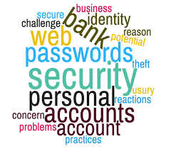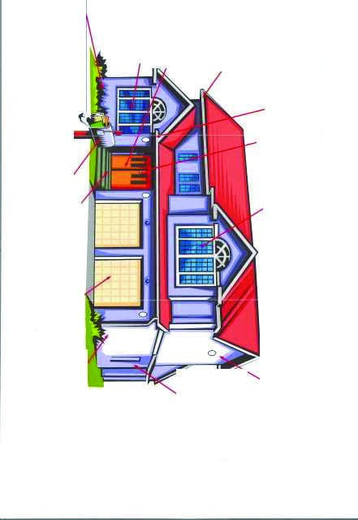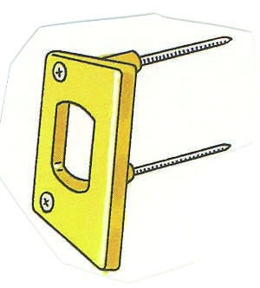

TIP #2 Lighting
Make your house look
“lived in” by keeping
Lights on automatic
timers, especially when
not at home.
Install and use a peep-
hole with a 190-degree
viewing area.
Install another lock
in addition to the
manufacturer’s lock
on ALL
windows
.
Homes with good EXTERIOR LIGHTING will provide
additional protection from intruders. Outside lighting
should be located high and out of reach. A good location
is under the eaves. Inexpensive timers or photoelectric
cells will automatically turn
the lights on and off at dusk
and dawn.
TIP #1 Exterior Doors
All exterior doors
should be equipped
with double cylinder
deadbolt locks having a
minimum one-inch
throw when in the
locked position.
Secure cash and
jewelry in
bonded storage.
TIP #2 Exterior Doors
The deadbolt locks
should use a heavy-
duty strike plate se-
cured with three-inch
steel screws.
Don’t leave ladders
or tools out. Bur-
glars can use these
items to break into
your house. Lock
them in a garage or
tool shed.
Keep garage
doors closed
and locked
even when at
home.
Don’t hide a key
under the door
mat...or anywhere
else! Burglars
know ALL the
hiding spots.
Use initials or just
numbers on your
mailbox.
Check the shrubs and bushes around
the doors and windows. They should
not provide cover for an intruder at-
tempting to force open a door or win-
dow. By trimming shrubs, you will
limit the intruder’s OPPORTUNITY!
Place thorny plants along fences and
near windows.
Close all curtains
or shades at night.
RESIDENTIAL SECURITY
DOES YOUR HOME HAVE THESE SAFEGUARDS?
Tip #1 Lighting
For outside lights, use
photoelectric cell lights
which automatically turn
lights on and off at dusk
and dawn.

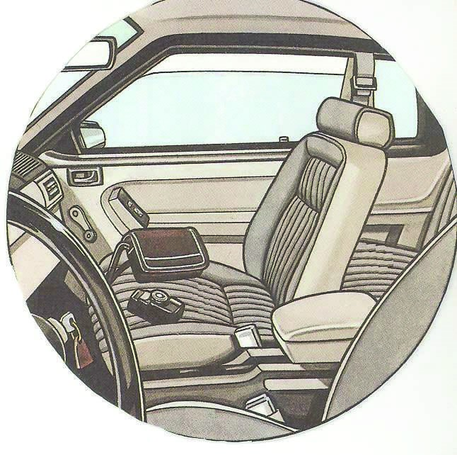

BURGLARY OF MOTOR VEHICLE PREVENTION TIPS
DID YOU FOLLOW THESE TIPS BEFORE LE
AVING YOUR VEHICLE UNATTENDED
Close ALL of your windows.
LOCK your car doors. Even if
you’re only away for a few minutes.
PARK ONLY in well-lighted areas
of a parking lot.
Use Auto Theft Deterrents such as
car alarms, kill switches, steering
wheel and column devices.
DO NOT leave any
valuables or pack-
ages in plain view or
unsecured.
DO NOT leave your
keys in the ignition.
Always take them
with you.

