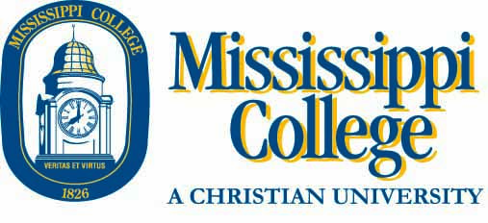

For students who are BIOLOGY majors:

The Biology Department has a set of core classes that all Biology majors must take, regardless if they major in General Biology or Pre-med. Several of these courses are prerequisites to Sophomore level classes, so need to be taken before your second year. Lecture courses and lab courses are co-requisites and must be registered at the same time.
Chapel: First time Freshmen are required to take a total of 4 semesters of chapel. Freshmen are automatically enrolled in Freshman Chapel/Blue & Gold 101 for their first semester.
The following schedule represents what a “TYPICAL” Freshman Biology Major might take.

BIO 111 Biology I Lecture AND Lab 4 hours
CHE 141 General Chemistry I Lecture AND Lab 4 hours
ENG 101 English Composition 3 hours
BIB 110 Old Testament Survey * 3 hours
HIS 211 US History (OR 103: World Civ.)* 3 hours
17 hours

You may have AP credit, dual enrollment, or transfer hours that would change this “typical” schedule. You may be on a varsity sports team or in the choir and may need to adjust this schedule. The truth is that no one is typical, but this schedule is a good place to start. When you meet with your advisor to register, be sure to
Chapel: Freshmen are required to take a total of 4 semesters of chapel. Freshmen are automatically enrolled in Freshman Chapel/Blue & Gold 101 for their first Fall semester.
Chapel: First time Freshmen are required to take a total of 4 semesters of chapel. Freshmen are automatically enrolled in Freshman Chapel/Blue & Gold 101 for their first semester.
tell him/her about your specific set of circumstances
so you end up with YOUR schedule and not just a
typical schedule.

*Other core courses may be substituted.

